
SUBMITTAL DATA SHEET
AUX R32 - Inverter Ducted system Series - AHU60HPV1AO
Job Name | Location Date
Purchaser | Engineer
Submitted to | For □Reference □Approval □Construction
Unit Designation | Schedule #

AHRI No: 216030574
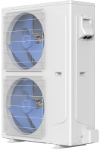
AHU60HPV1AO

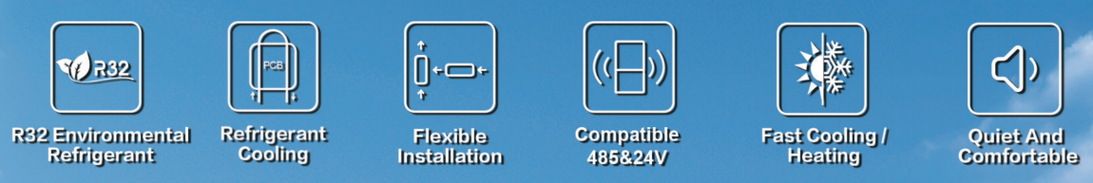

Specifications
Model |  |  |  | AHU60HPV1AO
Electric Data | Power Supply |  | V~,Hz,Ph | 208/230,60,1
Electric Data | Max. Input Consumption |  | W | 7000
Electric Data | Max. Current |  | A | 32
Electric Data | MCA | outdoor unit | A | 34
Electric Data | MAX.Fuse | outdoor unit | A | 50
Electric Data | Recommended Breaker Size |  | A | 45
Air Flow Volume |  |  | CFM | 4000
Noise Level |  |  | dB(A) | 60
Outdoor Unit | Net Dimensions | H | In.[mm] | 51-15/16[1320]
Outdoor Unit | Net Dimensions | W | In.[mm] | 39-13/16[1011]
Outdoor Unit | Net Dimensions | D | In.[mm] | 15-3/4[400]
Outdoor Unit | Package  Dimensions | H | In.[mm] | 56-11/16 [1440]
Outdoor Unit | Package  Dimensions | W | In.[mm] | 42-1/2[1080]
Outdoor Unit | Package  Dimensions | D | In.[mm] | 16-15/16[430]
Outdoor Unit | Weight | Net/Gross | lbs | 204.972/224.9
Refrigerant | Charged Volume |  | OZ | 130.51
Pipe | Liquid(O.D.) |  | In.[mm] | 3/8[Ф9.52]
Pipe | Gas(O.D.) |  | In.[mm] | 3/4[Ф19.05]
Pipe | Max. Length |  | ft[m] | 164[50]
Pipe | Max. Height |  | ft[m] | 98[30]
Ambient Temp Range |  | Cooling | ℉（℃） | 5~125(-15~52)
 |  | Heating | ℉（℃） | 5~75(-15~24)
Connection Wiring  Remarks:  1.All specifications are subject to change by the manufacturer without prior notice.  2.All units are being tested and comply to AHRI210/240.  3.Sound pressure levels are measured in anechoic chamber.  During actual operation, sound pressure level will be higher as a result of room specification condition.  4.Data from AUX lab,30/09/24, Data may change according to test surroundings, AUX reserves right of explanation on data. |  | Power Wiring（Outdoor） | AWG | 8
 |  | Signal Wiring | AWG | 22

Dimensions
Indoor Unit
AHU60HPV1AO



