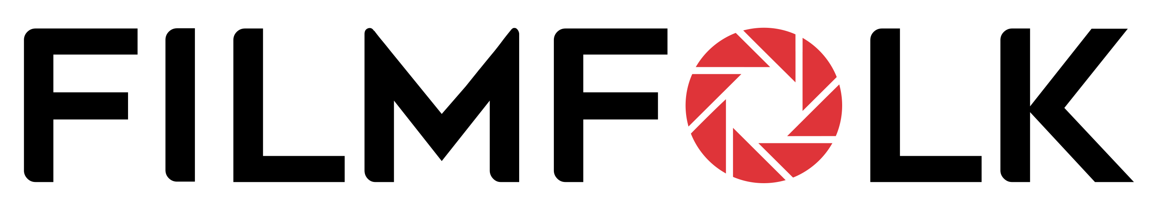

Applicant Questionnaire

Thank you for your interest in joining our team! To help us learn about you and your suitability for our work opportunities, please complete this application and email it to us at info@filmfolk.com.

Please briefly complete every section and ensure samples are your own work. Rest assured, there are no right or wrong answers, we are flexible and will take everything into account!

Your Role
Please choose one of the following to describe your main skill for which you are applying:

Camera Operator | I am an experienced cameraperson/cinematographer. I am focussed on filming, rather than editing. I have all my own kit.
Videographer | I am experienced in shooting and editing video projects with equal proficiency. I have all my own equipment.
Photographer | I am experienced in photography and picture editing. I have all my own camera, lenses and lighting equipment.
Content Creator | I am experienced in creating social media content. I focus on creating reels and image posts. I have my own mobile rig.
Drone Operator | I am a CAA licensed drone operator. I specialise in flying rather than general videography. I have my own drone kit.
Video Editor | I am an experienced video editor. I am purely focussed on editing, rather than shooting. I have all my own facilities.
Photo Editor | I am an experienced photo editor & album designer. I am focussed on this, rather than shooting. I have my own facilities.
If you have a secondary skill for which you wish to apply, please tell us here

Your Details
Name
Please tell us your full name
Date of Birth
Please tell us your DoB
Nationality
What is your nationality?
Location
What is your nearest train or underground station?
Work Permit
Do you have the right to work in the UK? Until when?
Tax Status
Are you registered self-employed?
If so, please provide UTR number
VAT Status
Are you registered for VAT?
If so, please provide VAT number
Drivers Licence
Do you have a driver’s licence? If so, how long have you held it?
Professional Profile
Please provide a link to your main social media profile.
Website
If you have a website, please provide a link here

Training & Experience
Training
Please tell us about any relevant professional training
Accreditations
Please tell about any professional qualifications or accreditations
Employment
What is your current employment status?

Equipment & Facilities
Camera/s
Please list what camera bodies you currently own
Lenses
Please list what camera lenses you currently own
Sound Kit
Please list what mics and sound recording kit you currently own
Tripod & Grip
Please list what tripods, gimbals and other kit you currently own
Lights & Accessories
Please list what lighting kit you currently own
Drones
Please list what drone and accessories you currently own
Studio Facilities
Please list what computer/s and related kit you currently own
Vehicle
Please provide the make/model of any vehicle you own.

Production Experience
Corporate Projects
Please provide links to any corporate projects you have done. Clearly specify your role.
Provide up to 3 links.
Private Events
Please provide links to any private event projects you have done. Clearly specify your role.
Provide up to 3 links.
Weddings
Please provide links to any wedding projects you have done. Clearly specify your role.
Provide up to 3 links.
Other Commercial Work
Please provide examples of any other commercial work you have done. Clearly specify your role.
Provide up to 3 links.
Other Work
Please provide examples of any other relevant work. Clearly specify your role. Provide 3 gallery links.

Professional Skills
Client Relations
What experience do you have in managing clients
Flexibility
Do you have any restrictions on when and where you work?
Preferred Assignments
Do you have any restrictions on the types of project you undertake?
Special Needs
Do you need any special support from us for your employment?
Other Comments
Is there anything you’d like to tell us that we might have overlooked?

Declaration

I confirm that all the above statements are true and correct. All samples provided are my own
work and where collaboration has occurred, I have stated my involvement. I understand that
failure to properly disclose information will result in disqualification.
Signed | Date

© FilmFolk Updated May 2023

