App.uhubs
Web App
Security Assessment Executive Report

Date Created: October 28, 2025

Document History
Document Information
Client | App.uhubs
Document | App.uhubs Security Assessment Executive Report
Status | Controlled
Author(s) | Zaeem Ahmed, Penetration Testing Engineer
Creation Date | October 28, 2025
Disclaimer | This document contains confidential information. Do not distribute this document without prior approval.

Document Revision History
 | Document History
URL |  | Working Days | Date
https://app.uhubs.co.uk/ |  | 02 | October 28, 2025

Contents
1. Executive Summary 3
1.1. Introduction 3
1.2. Scope 3
1.3. Methodology 3
1.4. Risk Calculation 4
1.5. Key strengths 5
1.6. Summary of findings 7
1.7. Conclusion 7
2. Performed Test Cases: 8

Executive Summary

Introduction
An independent security consultant performed an end-to-end assessment of the App.uhubs web app. Application was assessed for not only information security weaknesses but also for the effectiveness of implemented information security controls against a range of attacks performed during vulnerability assessment and penetration testing activity.

Scope
The scope of the assessment was to perform security assessment of the App.uhubs to identify any weaknesses and vulnerabilities in the application logic, flow and associated functionalities. The activity was performed to gain unauthorized access to private information of any client or to perform other unintended actions that may impact on the organization's or end-user’s privacy, confidentiality, integrity or availability of the services to authorized users

Methodology
Penetration testing methodology is intended to serve as a high level directional guide for the development of secure and effective penetration testing. The five-phased methodology is based upon OWASP, PTES & NIST standards. It offers best practices on building penetration testing aligned with App.uhubs. Each phase reflects a portion of mentioned standards. Penetration testing methodology is based upon industry’s best practices and years of excellence particularly in the field of penetration testing especially.

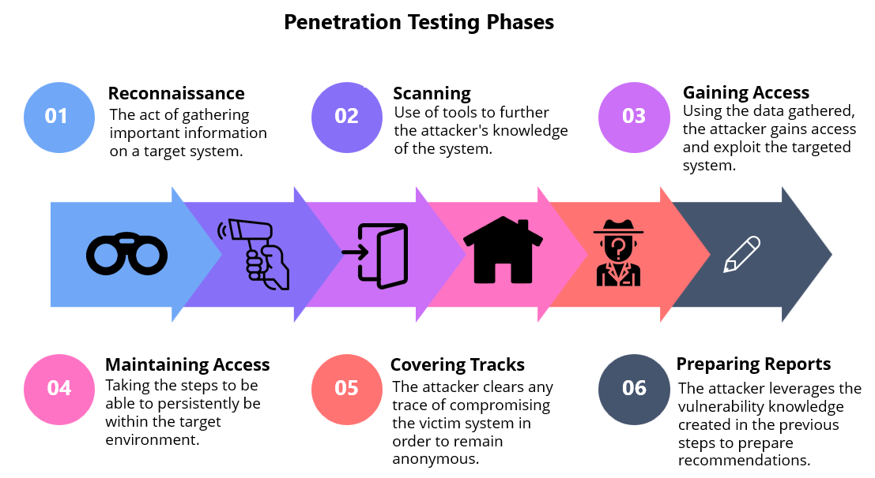

Risk Calculation
The observations in this report are rated with risk rating (where applicable), which should be interpreted as follows:
Rating | Description
Critical | The risk of vulnerability is Critical and can be exploited by an attacker to gain full access to the sensitive information stored in the application/database or its underlying operating system/server. This vulnerability should be fixed on urgent basis.  Popularity: Exploit techniques are well known and the circumstances under which the attack may occur are very common.  Simplicity: Exploit techniques can be easily obtained and executed by unskilled attackers.
High | The risk of vulnerability is High and can easily reveal the information about the application, database and its underlying infrastructure that can be used by an attacker in conjunction with another vulnerability to gain administrative control of the application/database or its underlying operating system/server.  Popularity: Exploit techniques are fairly well known and the circumstances under which the attack may be successful are common.  Simplicity: Exploit techniques can be easily obtained and executed by persons with general computer security knowledge.
Medium | The risk of vulnerability is Medium and can have significant limitations on the direct impact they can cause. Typically, these vulnerabilities would include significant information leakage vulnerability or those that provide significantly limited access.  Popularity: Exploit techniques are widely known and the circumstances under which the attack may be successful are possible.  Simplicity: Exploit techniques are easy to obtain and/or execute and requires detailed expertise and research in penetrating the vulnerabilities.
Low | The risk of vulnerability is Low and can result in enumeration of vital information held by or about the Application or its underlying operating system.  Popularity: Exploit techniques are not widely known and the circumstances under which the attack may be successful are rare.  Simplicity: Exploit techniques are difficult to obtain and/or execute and requires detailed computer security knowledge and experience.

Key strengths
SQL Injection (SQLi)
Test performed: Injected typical SQL payloads into input fields and parameters, monitored responses, error messages, and backend behavior (UNION, ' OR '1'='1, time-based delays).
Result: No exploitable SQLi found — inputs are properly parameterized/escaped and errors do not leak query info.
Server-Side Request Forgery (SSRF)
Test performed: Sent URLs and internal hostnames to endpoints that fetch remote resources (file previews, URL fetchers) and observed server callbacks and response variations.
Result: No SSRF — external fetches are restricted/validated and internal resources are not reachable.
Server-Side Template Injection (SSTI)
Test performed: Submitted template-like payloads to fields rendered by server templates and looked for template evaluation or unusual output.
Result: No SSTI — templates are not rendered with user-supplied template engines or user input is sanitized before rendering.
Request Smuggling
Test performed: Crafted ambiguous/fragmented HTTP requests via proxy to test CL/TE parsing inconsistencies and observed backend behavior.
Result: No request smuggling detected — front-end and back-end consistently parse requests and reject malformed requests.
Directory Brute-Force
Test performed: Ran wordlist-driven directory/file enumeration against the site to find hidden endpoints and admin paths.
Result: No sensitive exposed directories found — common paths are protected or return generic responses.
Login Brute-Force / Account Enumeration
Test performed: Attempted credential spraying and username enumeration via timing, error messages, and response differences.
Result: No successful brute-force or enumeration — rate limiting, account lockouts, or generic error messages prevent abuse.
Host Header Injection
Test performed: Sent manipulated Host headers to check for password resets, redirects, or links generated using the Host value.
Result: No vulnerable behavior — host values are validated or canonicalized before use.
Account Takeover / Response Manipulation
Test performed: Tested session handling, token reuse, and API responses for sensitive info that could enable account takeover.
Result: No takeover vectors found — tokens are scoped, rotation/expiry in place, and sensitive fields are protected.
IDOR (Insecure Direct Object Reference)
Test performed: Iterated numeric/identifier parameters and attempted access to other users’ resources directly via changing IDs.
Result: No IDORs — authorization checks enforce resource ownership on the server side.
Next.js Authorization / Middleware Bypass
Test performed: Manipulated Next.js routes, header values, and middleware behavior to attempt bypassing auth checks.
Result: Middleware and route guards are effective — protected routes require valid auth and cannot be bypassed.
Other common attacks (Open redirect, CSRF, etc.)
Test performed: Standard Open redirect payloads, CSRF checks, and header-based tests (CSP, SameSite cookies).
Result: No critical client-side or CSRF weaknesses — output encoding, CSRF tokens, and secure cookie attributes are present.

Conclusion
Timely fixation of identified issues (file upload, rate limit, PII disclosure) have significantly improved the security posture of the application. The assessment involved test cases mapped across OWSAP top 10 and CWE 25 and by the end of activity the user data management is significantly secured.

Performed Test Cases:
All set of applicable OWASP Top 10 and CWE Top 25 security threats.
S. No. | Vulnerability | Test Case / Attempt | Status
1 | SQL Injection | Union-based SQLi (reflected) | PASS
2 | SQL Injection | Error-based SQLi (reflected) | PASS
3 | SQL Injection | Boolean blind SQLi | PASS
4 | SQL Injection | Time-based blind SQLi (SLEEP) | PASS
5 | SQL Injection | Stacked queries SQLi | PASS
6 | SQL Injection | Out-of-band (OOB) SQLi (DNS/HTTP exfil) | PASS
7 | SQL Injection | Stored SQLi (in comments/fields) | PASS
8 | SQL Injection | Parameterized API JSON ID injection | PASS
9 | SQL Injection | SQLi via HTTP headers (User-Agent, Referer) | PASS
10 | SQL Injection | SQLi via file upload metadata | PASS
11 | Cross Site Scripting (XSS) | Reflected XSS (basic script) | PASS
12 | Cross Site Scripting (XSS) | Stored XSS (comment/description) | PASS
13 | Cross Site Scripting (XSS) | DOM-based XSS (client-side JS sinks) | PASS
14 | Cross Site Scripting (XSS) | Mutation XSS (HTML sanitizers bypass) | PASS
15 | Cross Site Scripting (XSS) | Event-handler XSS (onerror/onload) | PASS
16 | Cross Site Scripting (XSS) | Attribute injection XSS (SVG upload) | PASS
17 | Cross Site Scripting (XSS) | Angular/React template XSS | PASS
18 | Cross Site Scripting (XSS) | Polyglot payload XSS | PASS
19 | Cross Site Scripting (XSS) | HTML attribute encoding bypass | PASS
20 | Server-Side Template Injection (SSTI) | Basic SSTI payload (e.g., {{7*7}}) | PASS
21 | Server-Side Template Injection (SSTI) | Jinja2 sandbox escape attempts | PASS
22 | Server-Side Template Injection (SSTI) | Freemarker template injection tests | PASS
23 | Server-Side Template Injection (SSTI) | Velocity template injection tests | PASS
24 | Server-Side Template Injection (SSTI) | Template engine file read attempts | PASS
25 | Server-Side Template Injection (SSTI) | SSTI to RCE attempt via __globals__ access | PASS
26 | Server-Side Request Forgery (SSRF) | Simple SSRF to external URL | PASS
27 | Server-Side Request Forgery (SSRF) | SSRF to internal metadata (169.254.169.254) | PASS
28 | Server-Side Request Forgery (SSRF) | SSRF OOB detection via DNS | PASS
29 | Server-Side Request Forgery (SSRF) | SSRF with redirect following | PASS
30 | Server-Side Request Forgery (SSRF) | SSRF via open-redirect chained URL | PASS
31 | Server-Side Request Forgery (SSRF) | SSRF via upload/file parser (e.g., remote image fetch) | PASS
32 | Insecure File Upload | Double extension upload (shell.php.jpg) | PASS
33 | Insecure File Upload | Content-type mismatch upload (image/png with PHP) | PASS
34 | Insecure File Upload | Magic-bytes bypass (valid image + appended webshell) | PASS
35 | Insecure File Upload | Executable file upload (PE/ELF) | PASS
36 | Insecure File Upload | Malicious PDF with embedded JS | PASS
37 | Insecure File Upload | Filename path traversal in upload (../../) | PASS
38 | Insecure File Upload | Large file upload to exhaust storage | PASS
39 | Insecure File Upload | Upload and execute in webroot (remote code exec) | PASS
40 | Insecure File Upload | Upload milious SVG | PASS
41 | Path Traversal | Path traversal in download parameter (../etc/passwd) | PASS
42 | Path Traversal | Path traversal via zip extraction filename | PASS
43 | Path Traversal | Bypass naive filter ../...//../ patterns | PASS
44 | Cross Site Request Forgery (CSRF) | CSRF token absence on state-changing POST | PASS
45 | Cross Site Request Forgery (CSRF) | CSRF token predictability test | PASS
46 | Cross Site Request Forgery (CSRF) | CSRF via GET state change attempt | PASS
47 | CSV Injection via File Upload/Export | CSV export with leading '=' formula in cell | PASS
48 | CSV Injection via File Upload/Export | CSV import into spreadsheet to test formula execution | PASS
49 | CSV Injection via File Upload/Export | Multiple column CSV formula payloads | PASS
50 | OS Command Injection | Simple shell injection with ; cat /etc/passwd | PASS
51 | OS Command Injection | Command injection via backticks/$(...) | PASS
52 | OS Command Injection | Command injection via filename passed to shell | PASS
53 | Application-level DOS (Denial of services) | Concurrent large file uploads to exhaust disk/IO | PASS
54 | Application-level DOS (Denial of services) | Repeated expensive DB queries to spike CPU (heavy joins) | PASS
55 | Application-level DOS (Denial of services) | Recursive API triggering background jobs to exhaust workers | PASS
56 | Application-level DOS (Denial of services) | Large CSV import to consume memory and CPU | PASS
57 | Detailed Error Message | Trigger DB error and observe stack trace returned to user | PASS
58 | Detailed Error Message | Cause server exception to display file paths and code snippets | PASS
59 | Detailed Error Message | Trigger input validation error showing SQL or internal queries | PASS
60 | User Enumeration on Forgot Password / Auth Flows | Forgot password differences between existing/non-existing emails | PASS
61 | User Enumeration on Forgot Password / Auth Flows | Registration 'user exists' response timing and text | PASS
62 | User Enumeration on Forgot Password / Auth Flows | Login error messages revealing username validity | PASS
63 | User Enumeration on Forgot Password / Auth Flows | Password reset token reveal/length differences | PASS
64 | Technology / Info Disclosure | Check X-Powered-By and Server headers for version info | PASS
65 | Technology / Info Disclosure | phpinfo page exposure check | PASS
66 | Technology / Info Disclosure | Technology stack fingerprinting via response headers | PASS
67 | Security Headers | Check for Strict-Transport-Security header | PASS
68 | Security Headers | Check for Content-Security-Policy header | PASS
69 | Security Headers | Check for X-Frame-Options / frame-ancestors | PASS
70 | Host/CORS/HTTP Methods/Directory Listing | Host header manipulation to poison links | PASS
71 | Host/CORS/HTTP Methods/Directory Listing | CORS misconfiguration with wildcard or reflected origin | PASS
72 | Host/CORS/HTTP Methods/Directory Listing | HTTP TRACE/PUT/DELETE methods enabled test | PASS
73 | Host/CORS/HTTP Methods/Directory Listing | Directory listing exposure on static directories | PASS
74 | Session & Cookie Security | Session cookie Secure flag present | PASS
75 | Session & Cookie Security | Session cookie HttpOnly flag present | PASS
76 | Session & Cookie Security | Session fixation attempt | PASS
77 | Session & Cookie Security | Session invalidation on logout | PASS
78 | CSV Injection | CSV Injection | PASS
79 | Improper Session Handling | Session is still use after logout | PASS
80 | Brute force | No Rate Limit on send invite | PASS
81 | PII disclosure | Public accessable bucket | PASS

