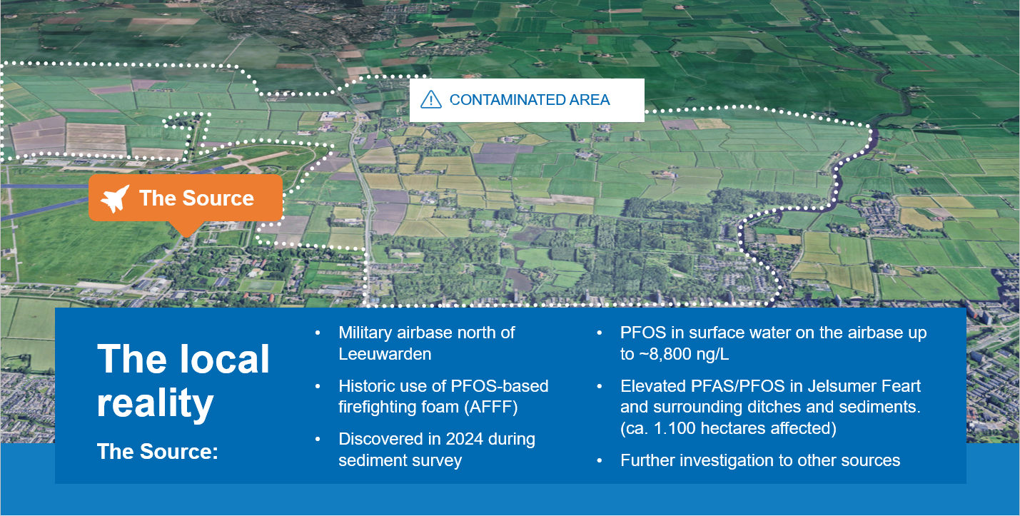
Background information

Leeuwarden is a medium-sized city in the north of the Netherlands, the capital of the province of Fryslân, with about 127,000 inhabitants. It is the main urban centre in a largely rural, agricultural region.
Leeuwarden is also a historic water city, with a dense network of canals and waterways, and it positions itself as the ‘European Capital of Water Technology’. Through WaterCampus Leeuwarden we bring together more than 300 companies and knowledge institutes in water technology, including Wetsus – the European centre of excellence for sustainable water technology – the Water Alliance industry cluster, and the Van Hall Larenstein University of Applied Sciences.
Water, agriculture and innovation are at the heart of this city. That is exactly why PFAS contamination in and around Leeuwarden is such an important issue for us.
There is a military airbase, where PFOS-based firefighting foam was used for many years. In 2023, during sediment investigations for regular dredging in the Jelsumer Feart, our regional water authority, Wetterskip Fryslân, found unexpectedly high PFOS concentrations in the waterbed over roughly two kilometres.
This triggered more detailed investigations. In early 2024, surface water samples from the Jelsumer Feart and from the airbase showed very high PFOS levels. On the airbase itself, PFOS in surface water reached around 8,800 nanograms per litre – roughly 13,000 times higher than the Water Framework Directive standard. GGD Fryslân, our regional public health authority, advised residents not to use this water for drinking, irrigation of vegetable gardens, swimming or fishing for consumption.

