Written Testimony for City of Chicago Committee on Workforce Development
Re: Amendment of Municipal Code Chapter 2-152

Opportunity@Work is a nonprofit social enterprise with a mission to increase career opportunities for the more than 70 million adults in the U.S. who are skilled through alternative routes (STARs) other than a bachelor's degree. For STARs, the American Dream has been fading due in part to an “opportunity gap,” in which access to the good jobs required for upward mobility often depends less on people's skills and more on whether and where they went to college, who they know professionally and socially, or even how they look. We envision a future in which employers hire people based on skills rather than their pedigree. We are uniting companies, workforce development organizations, policy makers and philanthropists in a movement to restore the American Dream so that every STAR can work, learn, and earn to their full potential.
Our research focuses on understanding the potential of workers in the United States who do not have a bachelor's degree but who have instead gained skills through alternative routes — workers we call STARs. These workers, who make up half the workforce, have gained valuable in-demand skills through community college, the military, partial college, training programs, and most commonly, on-the-job. Our work about this population has been published in academic outlets as well as in places like the New York Times. We also work alongside public and private sector leaders as they implement skills-based talent strategies; for example, we are currently working with six states (Arizona, California, Colorado, Connecticut, Louisiana and Utah) to support their advancement of skills-based talent practices in their hiring and advancement practices. From our research and experiences, we would like to share a few insights for you as you give consideration to the ordinance Alderman Gilbert Villegas introduced to amend Municipal Code Chapter 2-152 by adding new Section 2-152-151.
First, STARs — the population without a college degree in the US — have seen an increasing opportunity gap in our labor market: when a STAR enters the labor force, they earn less than a worker with a bachelor's degree. Today, it takes more than 30 years for STARs to earn the wages that a bachelor's degree worker was earning on their first day of work. That stunning inequality is in part because employers have increasingly locked STARs out of the jobs that have historically given them a path to the middle class: jobs like secretaries, nurses, and HR assistants.
In the city of Chicago, there are nearly 2 million STARs who are experiencing this lack of opportunity. What's most frustrating about this is that our analysis of the Chicago workforce suggests that nearly half of Chicago's STARs have skills to do significantly higher wage work if given the opportunity. When employers use unnecessary degree requirements, they automatically screen out the majority of Black, Hispanic, White, female and veteran workers. In the City of Chicago, this translates to the screening out of 61% of Black workers, 54% of Hispanic workers, 39% of White workers, 23% of Asian American Pacific Islander workers, and 54% of veteran workers are STARs.
Among employers, the public sector is losing out on STARs' invaluable skills at the highest rate. Our research shows that government employees hold degrees at a higher rate than the private sector. Among roles, the highest rate of employees with degrees are state and local (59%), as opposed to federal (51%) or even private sector (39%). With government hiring still not reaching pre-pandemic hiring levels, we understand that this slow recovery is affecting the delivery of critical services and operations and considering removing degree requirements for jobs that do not need them could help.
By adopting skills-based hiring, Chicago would be joining a growing nationwide movement to tear the paper ceiling and value STARs for the skills that they possess. Among the biggest advocates of this movement has been the public sector, with the last two federal administrations, 26 states committing to remove unnecessary degree requirements for state jobs through executive orders, administrative actions, and legislation, as well as cities like Philadelphia, St. Paul, New York City and counties like Hennepin County.
The challenges we face today require innovative solutions, especially in workforce development. While effective for many, the traditional educational route may only cater to the needs of some individuals seeking to contribute meaningfully to the city's growth. Hiring STARs offers an exceptional opportunity to tap into latent talent pools, allowing individuals with a strong drive and aptitude for specific fields to share their skills and/or receive targeted training and enter the workforce more efficiently. Our analysis shows that it will require deliberate choices from all of us to recognize skills and provide STARs with opportunity to participate in Chicago's economic future.
We thank you for your commitment to building a thriving economy and workforce in Chicago, including expanding access to city employment opportunities for STARs.
Opportunity@Work
1100 Connecticut Avenue NW, Suite 430
Washington, DC 20036
202.847.4470
opportunityatwork.org
Appendix
Figure 1. Who Are STARs
The majority of US workers are Skilled Through Alternative Routes.
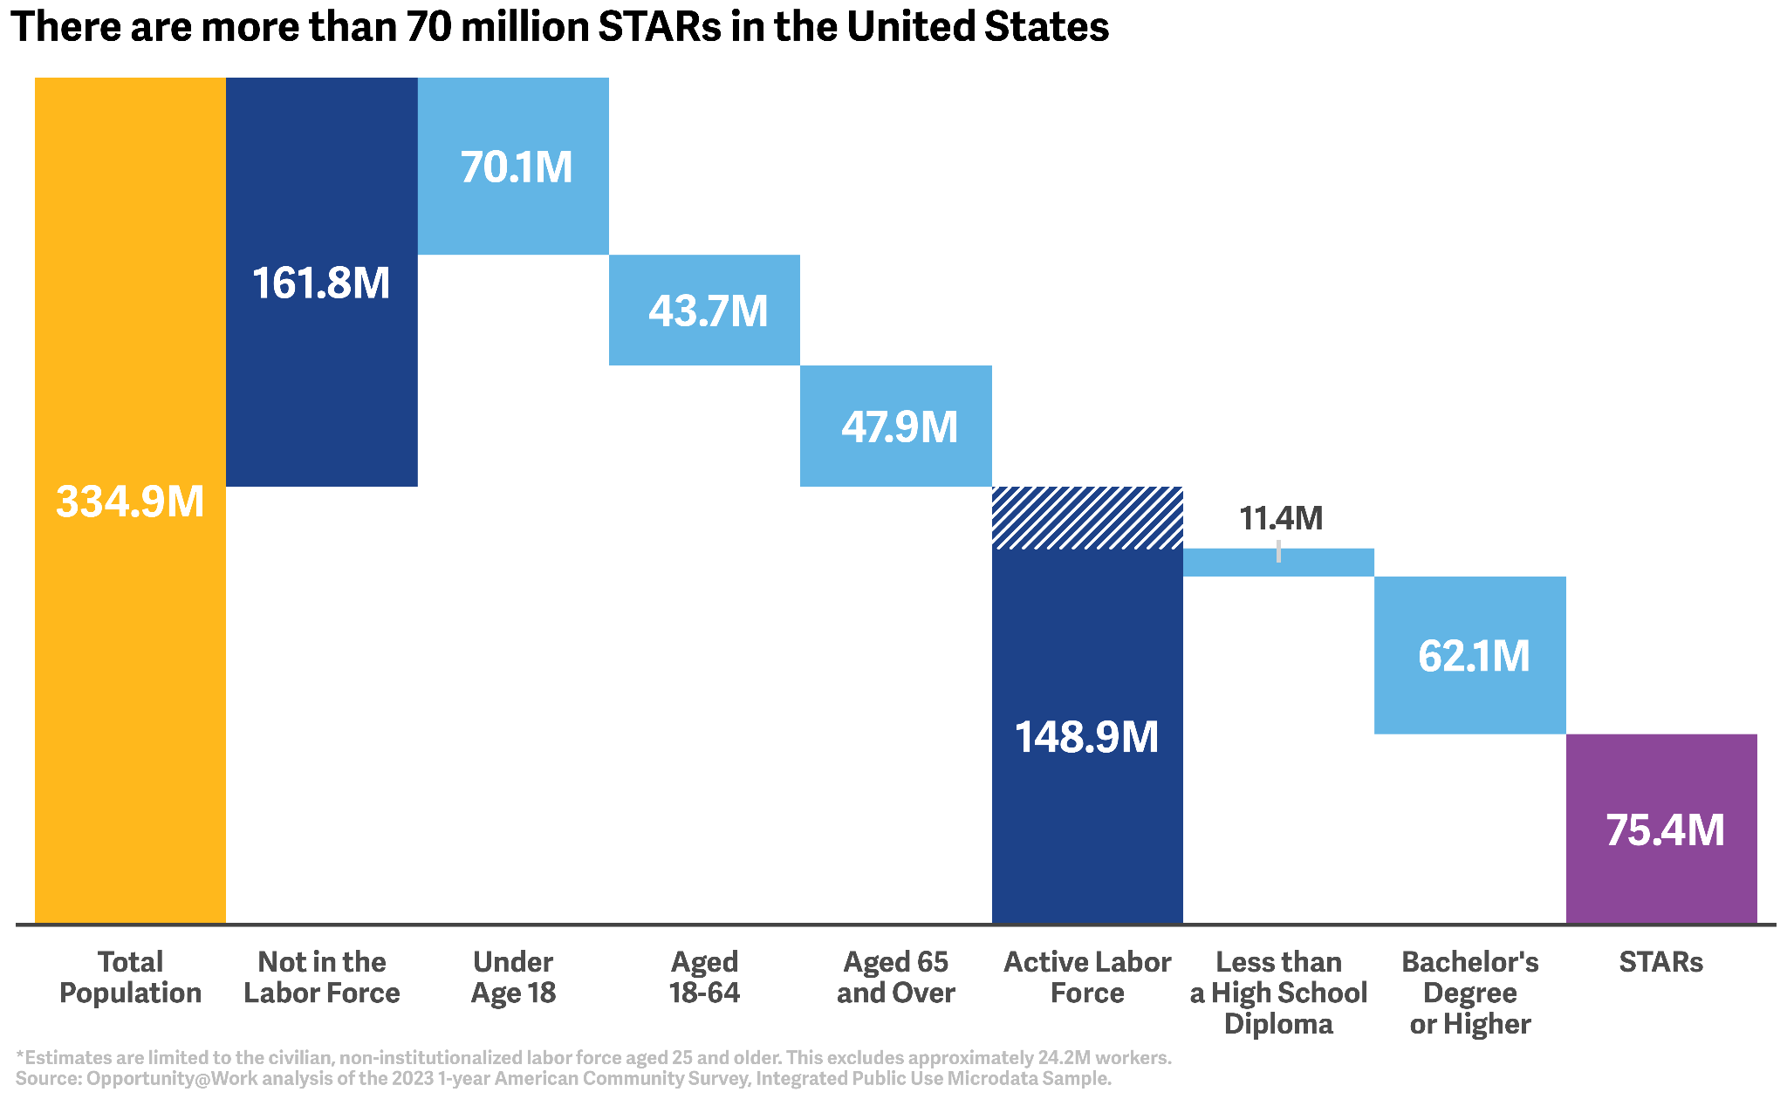
Figure 2. A Generation of STARs Have Lost Mobility
Median wages, Age 25 to 65.
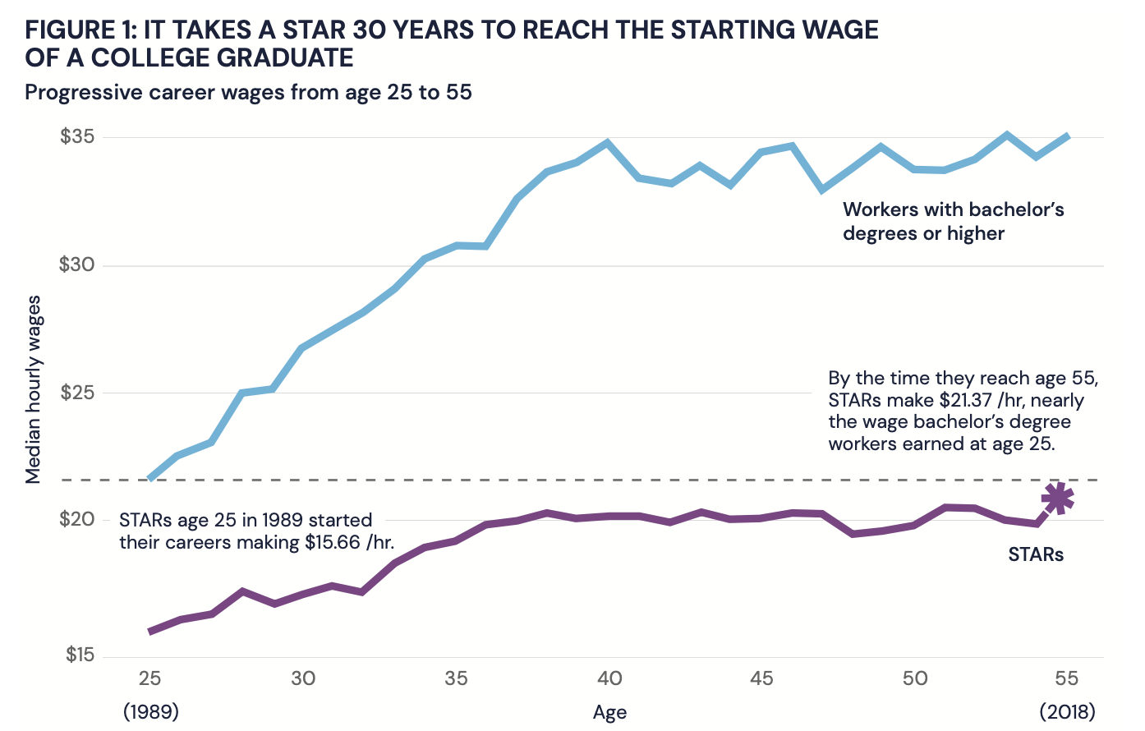
Figure 3. Nearly Half of Workers in Chicago are STARs
There are nearly 2 million STARs in Chicago.
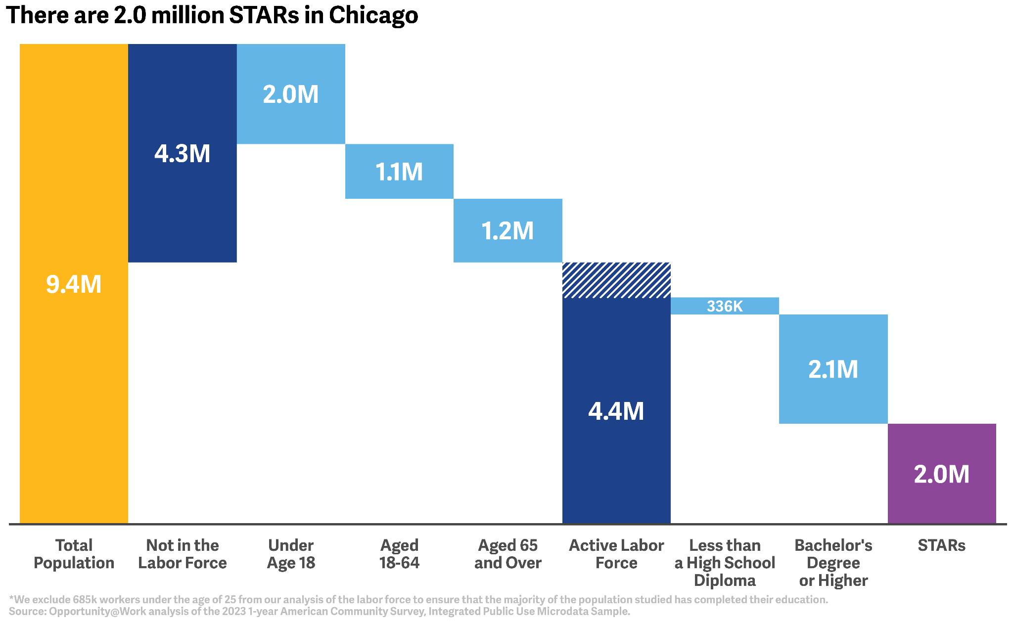
Figure 4. Chicago Has High Racial Diversity, but Low Educational Attainment for Non-White Workers
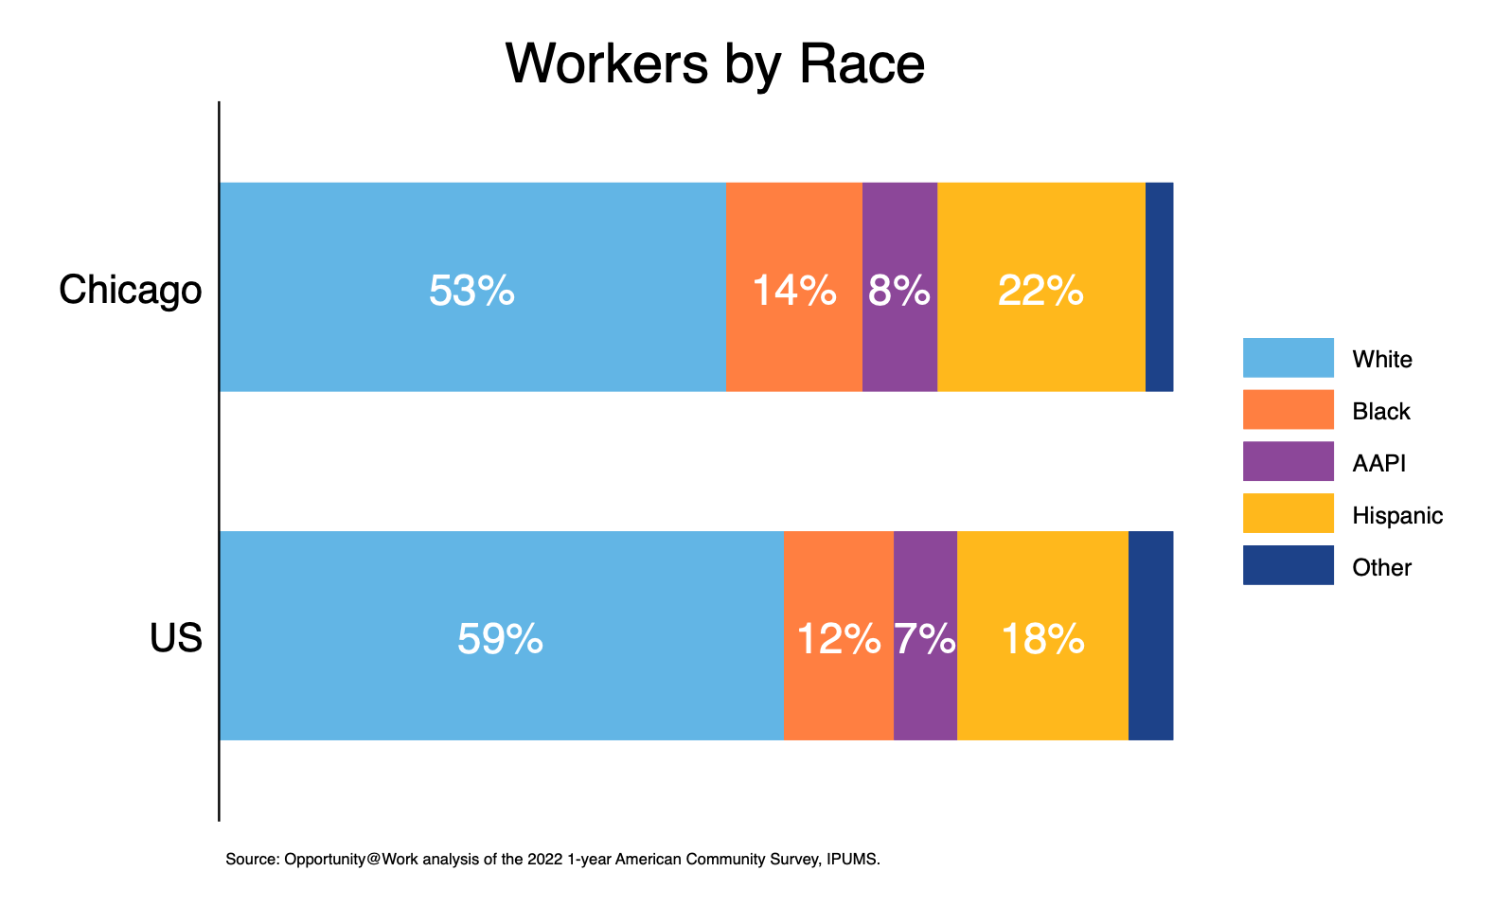
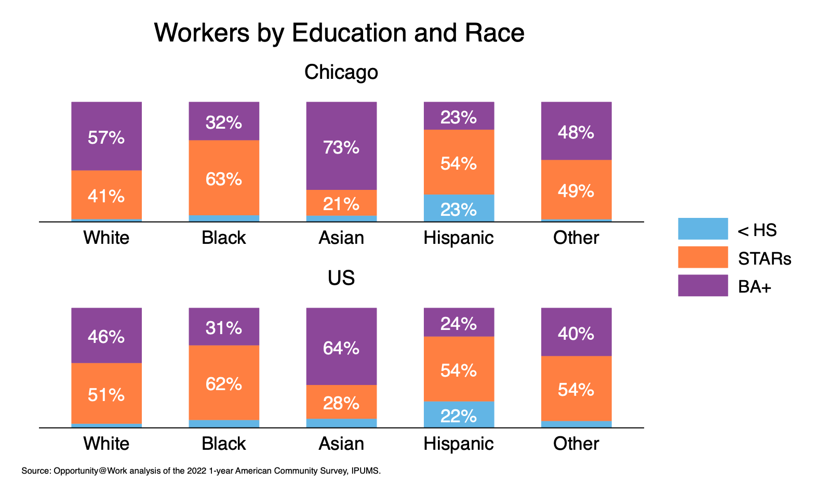
Figure 5. Veteran Workers Are More Likely to Be STARs in the Chicago Metro
Out of the 127K veteran workers in the region, 68K are STARs.
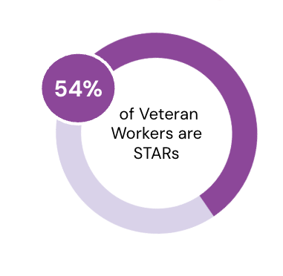
Figure 6. 26 States Lead the Way in Removing Degree Requirements
Potentially unlocking access to 579,000+ good jobs.
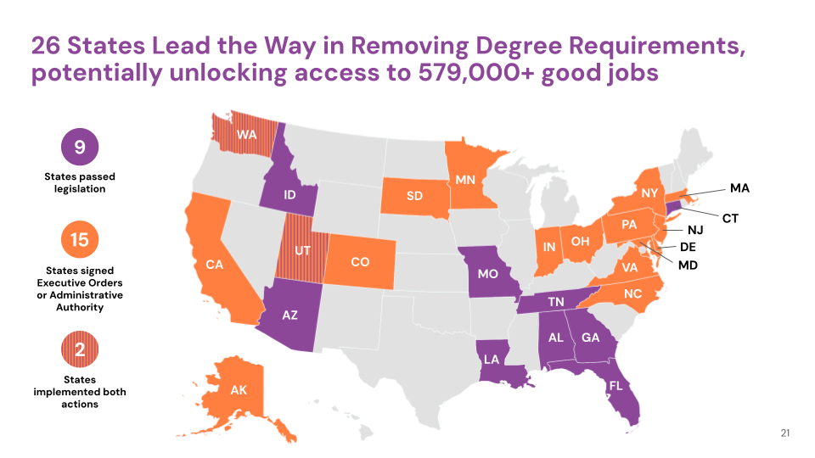

Source: Opportunity@Work analysis of the 2023 1-Year American Community Survey, Integrated Public Use Microdata Sample. Estimates are limited to the civilian, non-institutionalized, labor force aged 25 and older. This excludes approximately 24.2 million workers.
Source: Opportunity@Work analysis of the 2023 1-Year American Community Survey, Integrated Public Use Microdata Sample. See Appendix, Figure 1.
Source: Adapted from Blair, Debroy, and Heck (2021). Data are from the 1989 to 2019 Current Population Survey, Annual Social and Economic Supplement, Integrated Public Use Microdata Series. Median hourly wages in 2019 dollars for workers aged 25 to 29 in 1989. Dotted line indicates median hourly wages for workers with a bachelor's degree at age 15 ($21.59). See Appendix, Figure 2.
Source: Opportunity@Work analysis of the 2023 1-year American Community Survey, Integrated Public Use Microdata Sample. This excludes 685k workers under the age of 25 from our analysis of the labor force to ensure that the majority of the population studied has completed their education. See Appendix, Figure 3.
Source: Opportunity@Work analysis of the 2023 1-year American Community Survey, Integrated Public Use Microdata Sample. See Appendix, Figure 4.
Source: Opportunity@Work analysis of the 2023 1-year American Community Survey, Integrated Public Use Microdata Sample. See Appendix, Figure 5.
Source: Opportunity@Work calculations based on U.S. Census Bureau, ACS 1-Year Estimates Public Use Microdata Sample: YEAR 2023 ANALYZED, available at http://data.census.gov/mdat/#/ (last accessed March 2024).
Executive Order No. 13932, FR Doc. 2020–14337 (2020) and Guidance Release - E.O. 13932; Modernizing and Reforming the Assessment and Hiring of Federal Job Candidates.
Opportunity@Work, STARs Public Sector Hub, https://www.opportunityatwork.org/take-action/psh. See Appendix, Figure 6.

