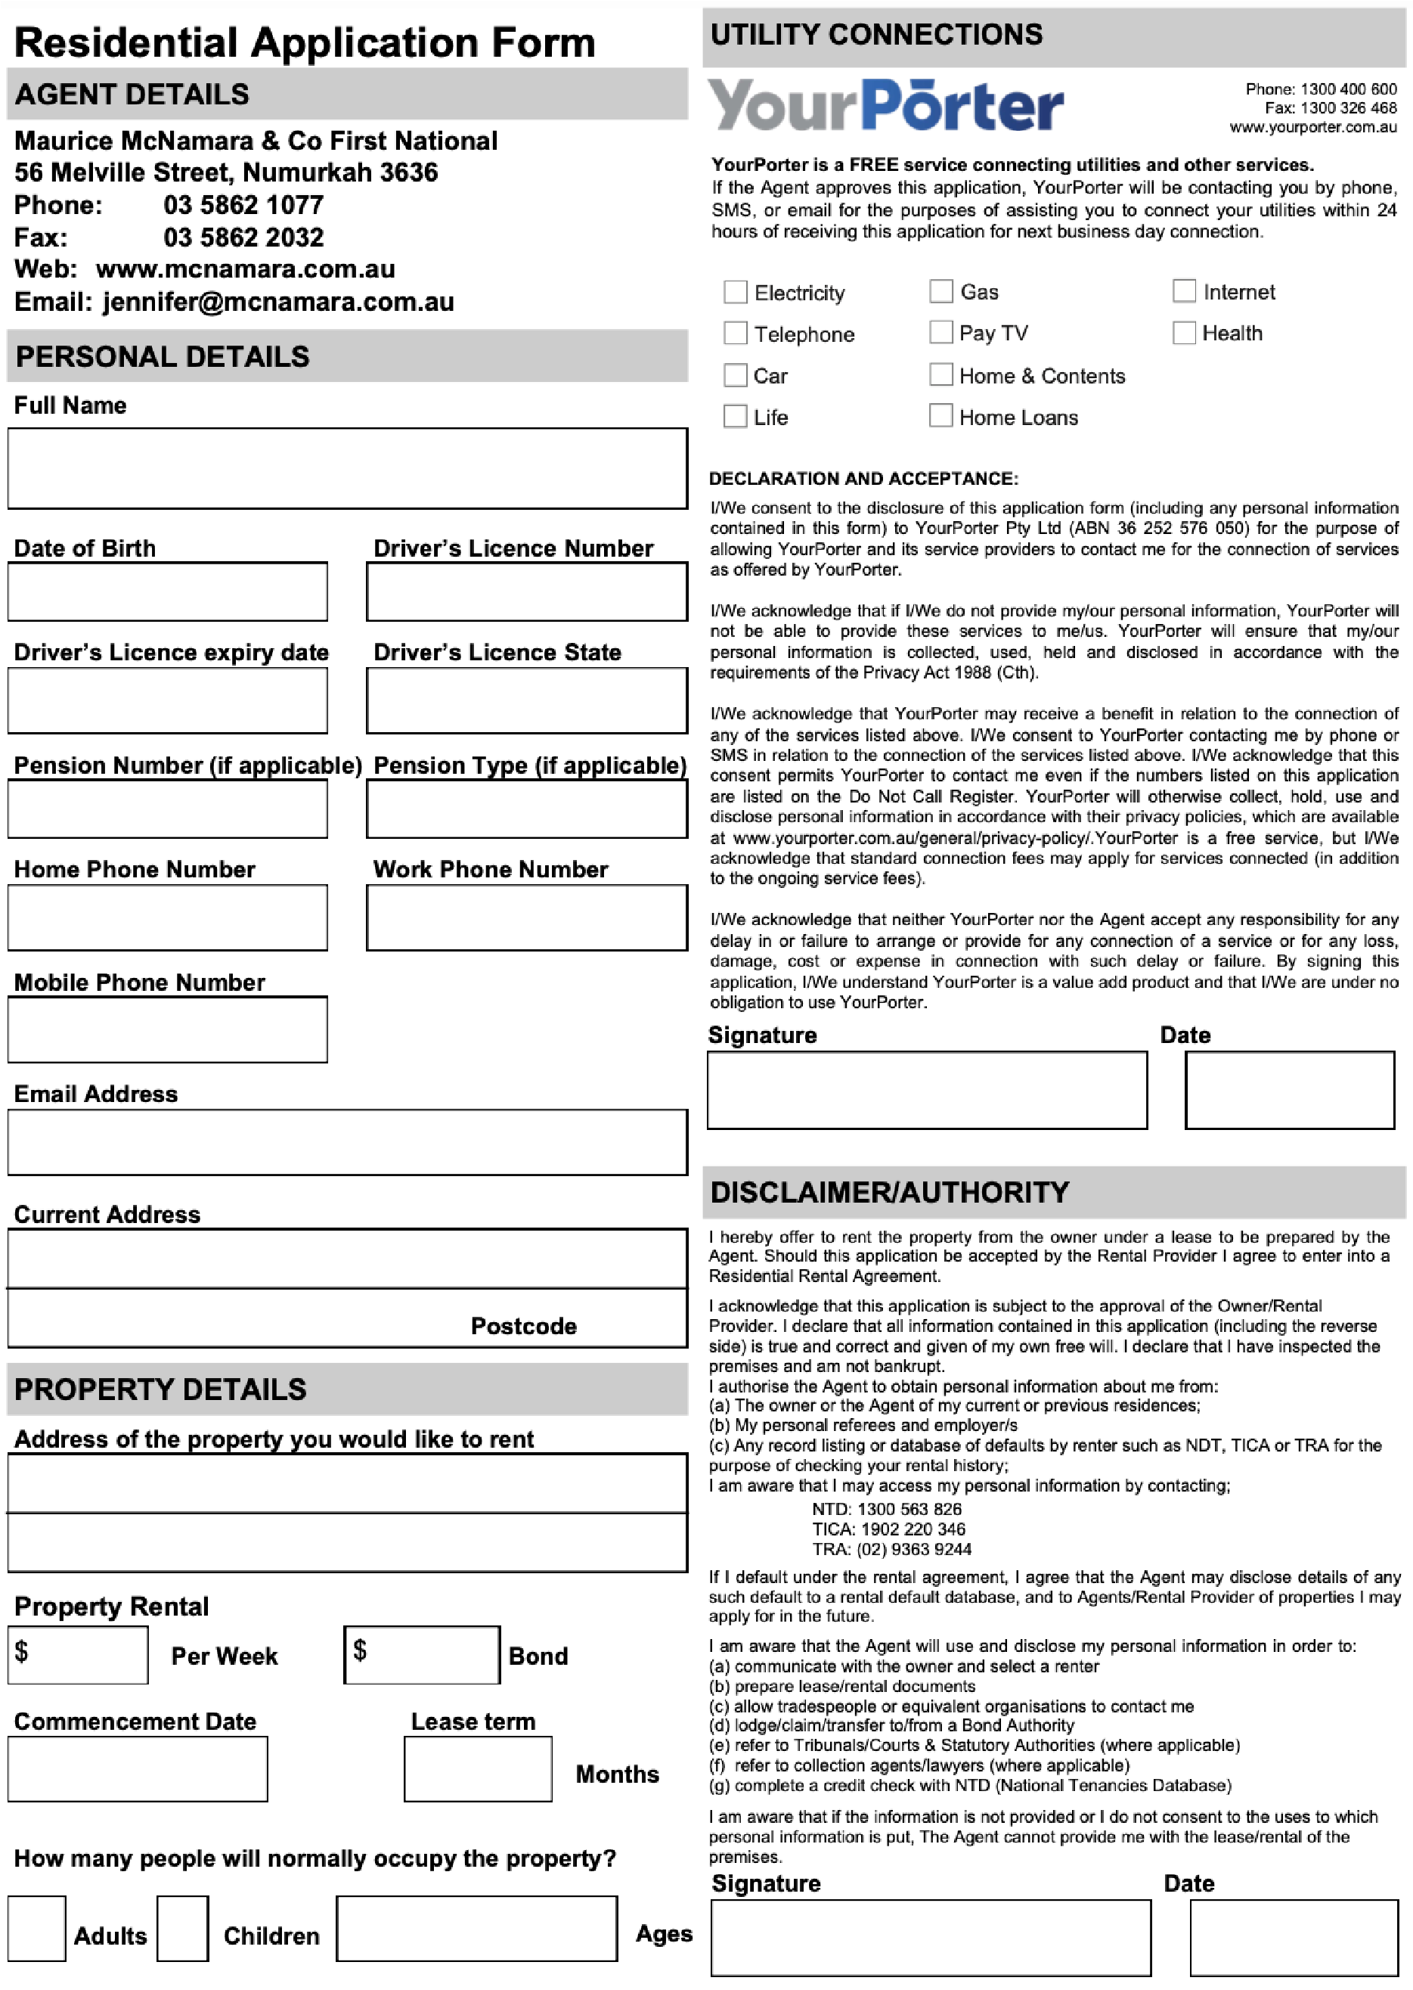

**Phone**

**Number**

**Council**

**Registration/Number**

**Details**

**of**

**Any**

**Pets Breed /Type**

**Relationship to You**

**Please**

**provide**

**Personal**

**2**

**references (not related to**

**you)**

**Relationship to You**

**Phone**

**Number**

**How long**

**did you live**

**at**

**this**

**address?**

**Previous Residential Address**

**Weekly rent Paid**

**Months**

**How long**

**have**

**you**

**lived**

**at your current address?**

**Rental Provider/Agent details of**

**this property**

**(**

**if**

**applicable)**

**Name**

**of**

**Rental Provider or Agent**

**Rental Provider/Agent’s**

**Phone Number**

$

**Postcode**

**Weekly rent Paid**

**Year/s**

**Months**

**Rental Provider/Agent details of**

**this property**

**if**

**(**

**applicable)**

**Name**

**of**

**Rental Provider or Agent**

**Rental Provider/Agent’s**

**Phone Number**

$

**Was Bond**

**refunded in**

**Full?**

**If**

**not**

**why**

**not?**

**EMPLOYMENT**

**DETAILS**

**1.**

**Full**

**Name**

**2.**

**Full**

**Name**

**Phone**

**Number**

**Relationship to You**

**OTHER**

**INFORMATION**

**Car Registration**

**Make/Type**

**PLEASE PROIDE US**

**WITH**

**100**

**POINTS**

**OF**

**ID**

Should

your

application

be

successful,

in

addition

to

the

lease

you

will be

required

to

sign

a

pet

agreement.

**Please**

**provide an**

**emergency**

**contact**

**Full**

**Name**

**Please provide your employment details** Applications cannot be processed unless all questions are

**Occupation** answered and a minimum of 100 check points are achieved by

each applicant.

**What**

**is**

**the**

**nature**

**of**

**your employment?**

**Full**

**time/Part**

**time/Casual**

**Employer’s**

**Name**

**(**

**accountant**

**if**

**self employed or**

**institution if**

**a**

**student)**

Driver s Licence 50 points

Passport 50

Proof of Age Card 50

Student ID Card 50

Copy of Mobile Phone Account 20

Copy of Medicare Card 20

**Employer’s address** Concession/Pension Card 10

|  |  |  |
| --- | --- | --- |
| **RENTAL HISTORY** |  | **CONTACTS/REFERENCES** |

|  |
| --- |
|  |
| **Postcode** |

|  |
| --- |
| **PLEASE NOTE** |

Copy of Gas/Water/Electricity Account 30 each

**Length of**

**Employment**

**Net**

**Income**

**Phone**

**Number**

**Phone**

**Number**

**Employer’s**

**Name**

**Please**

**provide your**

**previous employment details**

**Occupation**

**Net**

**Income**

**Length of**

**Employment**

**Contact**

**Name**

**Year/s**

**Months**

$

$

Initial payments must be made by cash, bank cheque or money order within 48 hours after approval of application.

eys will not be handed over until the rental agreement has been signed by all applicants.

This application is accepted subject to the availability of the property on the due date and no action shall be taken by the applicant against the Rental Provider and the Agent should any circumstances arise whereby the property is not available for occupation on the due date.

**FORM 3**

**Residential Tenancies Act 1997**

**(Section 29C)**

**(Regulation 14)**

**STATEMENT OF INFORMATION FOR RENTAL APPLICANTS**

1. Discrimination is treating, or proposing to treat, someone unfavourably because of a personal attribute. Discrimination is also imposing an unreasonable requirement, condition or practice that disadvantages persons with a personal attribute.
2. In Victoria it is unlawful to discriminate against someone in relation to certain personal attributes. This means that residential rental providers (rental providers) and real estate agents cannot refuse you accommodation or discriminate against you during your tenancy on the basis of personal attributes protected by law. The following is a list of some protected attributes that are sometimes discriminated against in the rental market
   * age;
   * disability (including physical, sensory, intellectual disability and mental illness); • employment activity;
   * expunged homosexual conviction;
   * gender identity;
   * industrial activity (including union activity);
   * marital status;
   * parental status or status as a carer;
   * physical features;
   * political belief or activity;
   * pregnancy or breastfeeding;
   * race;
   * religious belief or activity;
   * lawful sexual activity or sexual orientation;
   * sex or intersex status;
   * association with someone who has these personal attributes.
3. These personal attributes are protected by law and extend to agreements under the **Residential Tenancies Act 1997** (the Act). It is against the law for a rental provider or their agent to treat you unfavourably or discriminate against you because of these personal attributes when you are applying for a rental property, occupying a rental property or leaving a rental property.
4. Discrimination on the basis of any of these personal attributes may contravene Victorian laws including the Act, the **Equal Opportunity**

**Act 2010** (the Equal pportunity Act), and a range of Commonwealth Acts including the Age Discrimination Act 2004, the Disability Discrimination Act 1992, the Racial Discrimination Act 1975 and the Sex Discrimination Act 1984.

1. In some limited circumstances, discrimination may not be unlawful, including accommodation provided for children, shared family accommodation, and student accommodation. or example, a community housing provider who is funded to provide youth housing may positively discriminate to provide accommodation for a young person. or more information, contact the Victorian Equal pportunity and Human Rights Commission (VE HRC).
2. **Scenarios and examples of unlawful discrimination in applying for a property**
   * Refusing or not accepting your application because you have children, unless the premises is unsuitable for occupation by children due to its design or location.
   * Processing your application differently to other applicants and not giving your application to the rental provider because you have a disability or because of your race.
   * ffering you the property on different terms by requiring more bond or requiring you to have a guarantor because of your age.
   * Refusing to provide accommodation because you have an assistance dog.
3. **Scenarios and examples of unlawful discrimination when occupying or leaving a property**
   * Refusing to agree to you assigning your lease to someone else because of that persons personal attributes.
   * Refusing to allow you to make reasonable alterations or modifications to the property to meet your needs if you have a disability.
   * Extending or renewing your agreement on less favourable terms than your original agreement based on your protected attributes (e.g. due to a disability).
   * Issuing you with a notice to vacate based on your protected attributes.

The examples listed and similar actions could contravene the Act, the Equal pportunity Act, or the Commonwealth Acts.

**Getting help**

1. If a rental provider or a real estate agent has unlawfully discriminated against you and you have suffered loss as a result, you may apply to VCAT for an order for compensation under section 210AA of the Act. VCAT may be contacted online at vcat.vic.gov.au/ or by calling 1300 018 228.
2. If you would like advice about unlawful discrimination in relation to an application to rent or an existing agreement you may call Victoria Legal Aid on 1300 792 387.
3. If you feel you have been unlawfully discriminated against when applying to rent, or once you have occupied a property, you or someone on your behalf may make a complaint to VE HRC at humanrightscommission.vic.gov.au/ or by calling 1300 292 153.