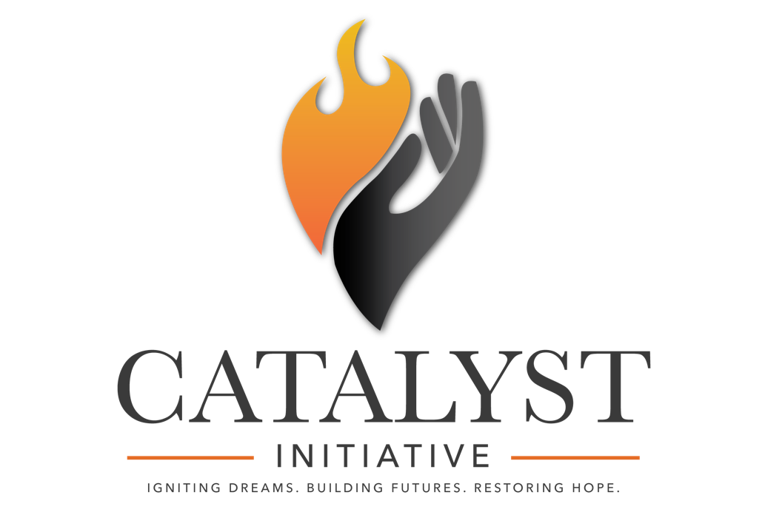

BUSINESS PARTNER COMMITMENT AGREEMENT

Thank you for your interest in becoming a partner for The Catalyst Initiative! Your partnership fuels dreams, revitalizes businesses, and strengthens our community. Together, we’ll create a ripple effect of change, bringing opportunities to life for aspiring entrepreneurs and struggling businesses in McLennan County.

This agreement allows businesses to participate and outline their commitment to contributing time, talents, and resources over the one-year partnership. Please review the levels of participation below and select the commitment that aligns with your goals. Each level offers unique opportunities to contribute while making a meaningful impact.


Levels of Participation

1. THE IGNITION
Description: Every great movement begins with a spark! This level is for those who want to make a financial contribution without direct involvement.
Commitment: Minimum Donation - $2500.00
Perks:
- Recognition on The Catalyst Initiative website and event materials.
- The satisfaction of knowing you’ve ignited a dream.

2. THE SPARK
Description: Be part of the chain reaction! Contribute resources or services to directly support the chosen business.
Commitment: In-kind donations, such as equipment, materials, marketing services, or legal advice.
Perks:
- Recognition as an active contributor.
- Logo placement on program materials.
- Public acknowledgment during events.

3. THE ACCELERATOR
Description: Speed things up by sharing your expertise! Join as a mentor, guiding the selected business through essential areas of growth.
Commitment: Provide hands-on mentorship and your professional services, such as financial planning, branding, or operational strategy.
Perks:
- Recognition as a mentor partner.
- Exclusive networking opportunities.
- A featured spot on our website and promotional materials.

4. THE REACTOR
Description: Fuel the fire! Combine financial support with active involvement in the program.
Commitment: A significant financial contribution ($5,000+) including consistent mentorship and resources.
Perks:
- Premier recognition as a top-tier partner.
- Spotlight at program events.
- Co-branding opportunities.

5. THE FORGE
Description: Be the change! Catalysts are all-in partners who actively shape the success of The Catalyst Initiative.
Commitment: Major financial support ($10,000+) and full participation in mentorship and leadership activities.
Perks:
- Top recognition on all program materials & website.
- VIP access to events and exclusive opportunities.
- Legacy recognition as a changemaker in McLennan County.

6. THE CATALYST (ANGEL INVESTOR)
Description: Light up the future with your investment! Gasoline-level partners provide the critical funding needed to make dreams a reality.
Commitment: A financial investment of $20,000 or more.
Perks:
- Personalized acknowledgment in program materials & website.
- Opportunity to name a specific aspect of the initiative (e.g., a scholarship or project).
- Exclusive invitations to program updates and celebrations.

Your Commitment

*Refer to the above levels, and please choose the level of commitment you & your business pledge to participate in.

Selected Level of Participation:
☐ The Spark
☐ The Reaction
☐ The Accelerator
☐ The Reactor
☐ The Catalyst
☐ Gasoline

How will you contribute? (Check all that apply):
☐ Financial Contribution (amount): $
☐ In-Kind Resources (specify):
☐ Mentorship/Expertise (area of focus):

Your Strengths:
What unique skills, connections, or resources do you bring to The Catalyst Initiative?

Please be specific as to what your company is willing to give to the selected nominees of the Ember Award and the Phoenix Award. (Ex. 40 hours labor toward renovation project, one 30 second commercial, one website up to 5 pages, etc.)

Acknowledgment:
By signing below, I commit to fulfilling the selected level of participation for one year, understanding that my contribution plays a vital role in transforming lives and businesses in our community. I recognize the importance of collaboration, transparency, and dedication in achieving our shared mission.

Signature:
Date:
Name (Printed):
Business Name:
Contact Information:

Thank you for being a part of this transformative journey! Your support is the fuel that keeps dreams alive.
TO DO: Please send the following to connect@catalystinitiativewaco.com
☐ Business Name
☐ Business address & phone number
☐ Name of Point of Contact for all communication & scheduling
☐ POC’s phone number & email address
☐ Logo (High resolution PNG format logo with transparent background)
☐ Website URL
☐ Facebook URL
☐ Instagram URL

