Sparrow Link Protocol Templates for IRB

- Sparrow Link Device Description
Sparrow Link is an extension of the FDA-cleared Sparrow Ascent wearable neurostimulation device (K230796). Sparrow Link is an investigational platform that allows researchers to customize the stimulation parameter output by the Sparrow Link Pulse Generator for use in studies using non-invasive transcutaneous auricular neurostimulation (tAN) therapy.

The Sparrow Link Platform is comprised of the Sparrow Link Pulse Generator, Sparrow Link Mobile App, Sparrow Link Hub, and Sparrow Link Application Programming Interface (API) (Figure 1). Researchers may customize the Sparrow Link Pulse Generator’s device settings and stimulation output parameters by using the Sparrow Link Mobile Application of Sparrow Link Hub with the Sparrow Link API developed by Spark Biomedical, Inc.

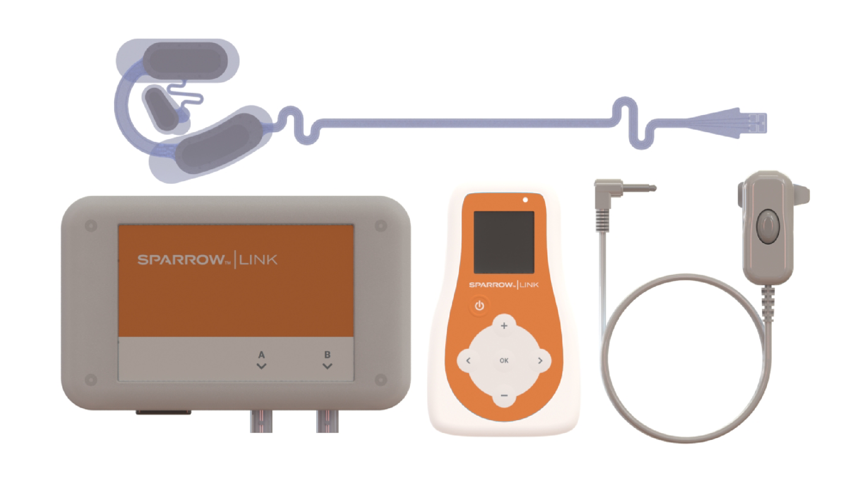
Figure 1: Sparrow Link System. Earpiece (top), Hub (bottom left), Pulse Generator (middle), Cable (bottom right)

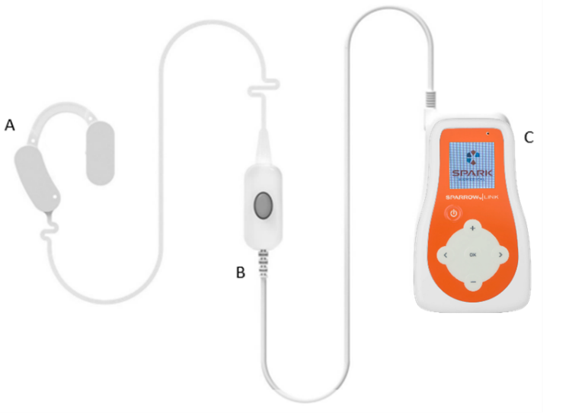
Figure 1: Alternate (without Hub and with Mastoid Earpiece): The Sparrow Link System: (A) Earpiece (Model 510), (B) Cable, and (C) Patient Controller

  - Sparrow Link Pulse Generator (Model 910)
The Sparrow Link Pulse Generator is a hand-held, battery-powered, bi-phasic pulse generator designed to be carried or stationary while receiving tAN therapy. The Sparrow Link Pulse Generator is compatible with Sparrow Ascent components and accessories. The Pulse Generator delivers adjustable stimulation to the Sparrow Ascent Earpiece via the Sparrow Ascent Cable. The Pulse Generator has a physical user interface comprised of a 6-button keypad with a 1.5” LCD screen display and is powered by three standard Alkaline AAA batteries. The membrane keypad allows users the ability to power the device on and off, adjust stimulation intensity, and use an optional therapy timer. The 1.5” screen display allows users to navigate these settings easily while also displaying system status and battery life. The Pulse Generator also indicates to the user alerts and notifications.
  - Sparrow Ascent Earpiece (Model 210/211)
The Earpiece is an ergonomically designed wearable stimulation interface designed to be worn around the left (Model 210) and right (Model 211) ear for up to 24 hours. Both the outer and inner parts are designed to be flexible and adjustable to fit various sized ears. The disposable component is designed to stay adhered to the skin and provide electrical connectivity up to 24 hours. The component is comprised of a printed circuit board embedded into polyethylene terephthalate (PET). The skin-facing surface of the Earpiece contains conductive ink covered with hydrocolloid medical grade adhesive to ensure sufficient skin contact (Figure 2A). The adhesive is water based and can be easily removed as desired. The Earpiece is worn on and around the auricle. The Earpiece is applied for each participant to position the electrodes to stimulate three key dermatome regions (Figure 2B). These regions are adjacent to several cranial nerve branches (V, VII, IX, X) and occipital nerves. In particular, the electrodes are located on the cymba concha (Figure 2B, Region 1), on the temporomandibular joint region, just anterior to the tragus (Figure 2B, Region 2), and behind the auricle (Figure 2B, Region 3).

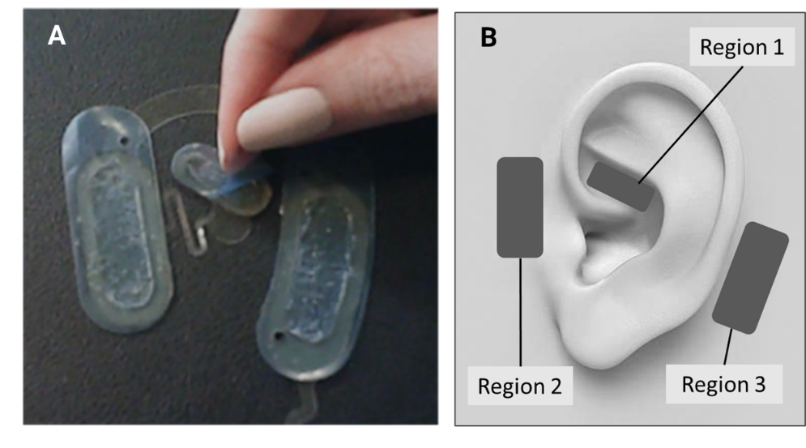
Figure 2. A) Sparrow Ascent Earpiece with Medical Grade Adhesive, B) Sparrow Ascent Placement on Dermatome Regions

As shown in Figure 2B, the three electrodes are placed in three different regions. Each dermatome is targeted specifically based on the subcutaneous nerves that run through or terminate in each region, as outlined below.

Region 1 - ABVN
The subcutaneous tissue in Region 1 is innervated by the auricular branch of the vagus nerve (ABVN), also known as Arnold’s nerve. Arnold's nerve arises from the superior vagal ganglion and is joined by a branch from the inferior ganglion of the glossopharyngeal nerve.

Region 2 - ATN
Subcutaneous to the electrode located in Region 2, ascends the auriculotemporal nerve (ATN), which is a branch of the mandibular division of Cranial nerve V (Trigeminal nerve). The ATN arises from the mandibular nerve, it also communicates with the facial nerve (Cranial nerve VII).

Region 3 - Mastoid
Branches from the posterior auricular nerve (arising from Cranial nerve VII) and branches of the lesser occipital nerve terminate behind the auricle. As shown in Figure 2B, the electrodes in Region 3 are located such that the branches of both the lesser occipital nerve and posterior auricular nerve are subcutaneous to the electrodes.

  - Sparrow Left Earpiece (Model 510) (New FDA-cleared Mastoid Earpiece)
The Earpiece is an ergonomically designed wearable stimulation interface designed to be worn around the left ear for up to 24 hours. The earpiece is designed to be flexible and adjustable to fit various sized ears. The disposable component is designed to stay adhered to the skin and provide electrical connectivity up to 24 hours. The component is comprised of a printed circuit board embedded into polyethylene terephthalate (PET). The skin-facing surface of the Earpiece contains conductive ink covered with hydrocolloid medical grade adhesive to ensure sufficient skin contact. The adhesive is water based and can be easily removed as desired. The Earpiece is worn around the auricle. The Earpiece is applied for each participant to position the electrodes to stimulate three key dermatome regions (Figure 2B). These regions are adjacent to several cranial nerve branches (V, VII, IX, X) and occipital nerves. In particular, the electrodes are located on the mastoid (Figure 2B, Region 1), on the temporomandibular joint region, just anterior to the tragus (Figure 2B, Region 2), and behind the auricle near the mastoid (Figure 2B, Region 3).

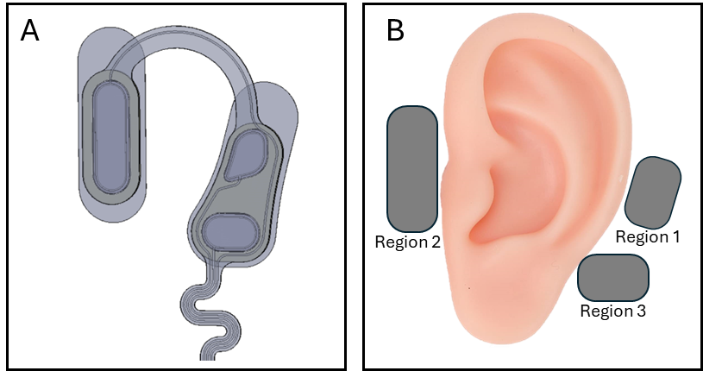
Figure 2. (A) Sparrow Left Earpiece (B) Target Dermatome Regions
As shown in Figure 2B, the three electrodes are placed in three different regions. Each dermatome is targeted specifically based on the subcutaneous nerves that run through or terminate in each region, as outlined below.

Region 1 Electrode
The subcutaneous tissue in Region 1 is innervated by the auricular branch of the vagus nerve (ABVN)¹⁶. The ABVN arises from the superior vagal ganglion and is joined by a branch from the inferior ganglion of the glossopharyngeal nerve¹⁶. The temporal bone provides passage for the ABVN via the mastoid canaliculus allowing the nerve to innervate the mastoid region of the temporal bone¹⁷.

Region 2 Electrode
The subcutaneous tissue in Region 2 is innervated by the auriculotemporal nerve (ATN), which is a branch of the mandibular division of the trigeminal nerve. The ATN arises from the mandibular nerve allowing the nerve to innervate the region anterior to the tragus^{18–20}.

Region 3 – Return Electrode
The return electrode in Region 3 located behind the auricle.

  - Sparrow Ascent Cable (Model 810)
The Cable is 37 inches long and connects the Pulse Generator to the Earpiece and is designed to be long enough to enable the user to wear the Pulse Generator on a belt or similarly located area without constricting mobility. A built-in retention clip allows the patient to clip the Cable to their clothing to relieve cable strain.

The Earpiece connects to the Cable via the Cable Button (Figure 3). Press fully down on the Cable Button and fully insert the end of the Earpiece into the Cable Connector. The Cable Connector is then connected to the Pulse Generator via a 3.5mm cable jack.

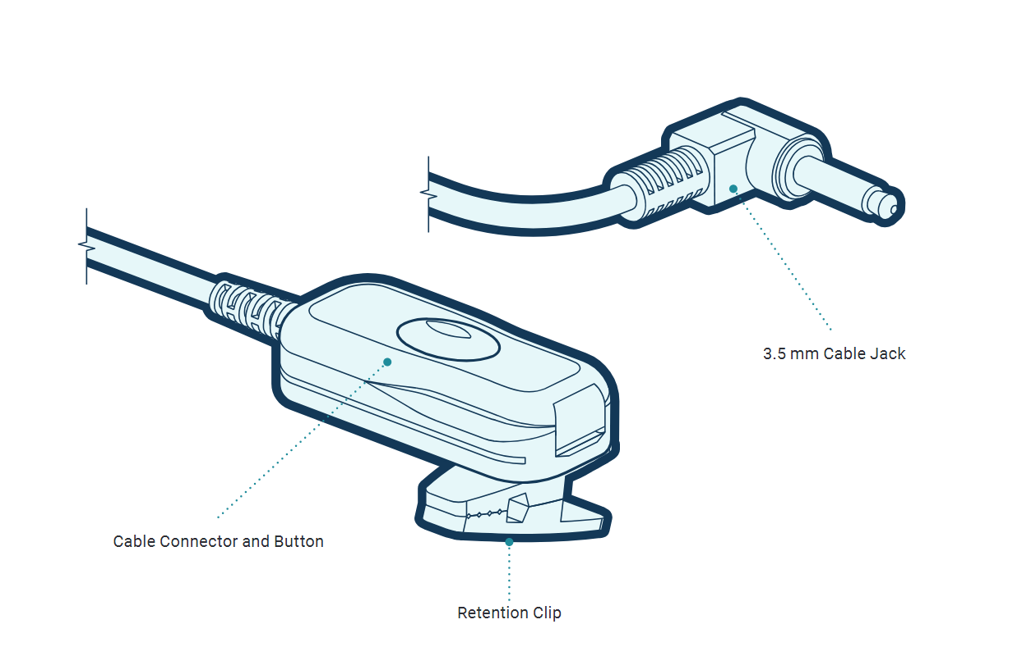
Figure 3. Cable (Model 810)

  - Sparrow Link Mobile App (Model 930-S)
The Sparrow Link Mobile Application is an application that can be used to connect with a Sparrow Link Pulse Generator to view or modify device behavior and stimulation parameters. The Sparrow Link Mobile Application is only available for Android platforms and is compatible with the Sparrow Ascent Patient Generator (Model 110) and Sparrow Link Pulse Generator (Model 910).

  - Sparrow Link Hub (Model 940)
The Sparrow Link Hub has an onboard Bluetooth Low Energy (BLE) chip, one USB-C input for serial communication to a PC, and two BNC connections to receive input signals for stimulation triggering (Figure 4). Users can connect the Hub to a PC and pair the Hub to the Sparrow Link Pulse Generator using the Sparrow Link API. Once paired, the API can be used to modify the Pulse Generator stimulation parameters and enable triggering.
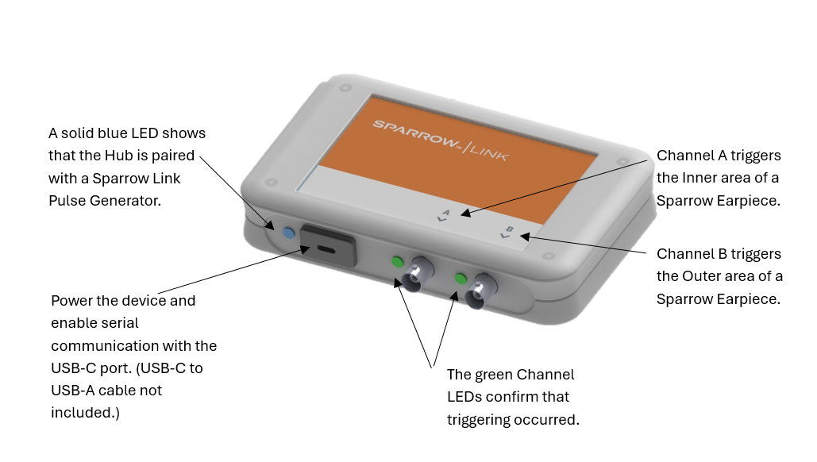
Figure 4: Sparrow Link Hub

The Sparrow Link Hub pairs with the Sparrow Link Pulse Generator via BLE to:
- Modify stimulation output parameters, including amplitude, pulse width, frequency, duty cycle, and ramping duration
- Enable or disable error notifications on the Sparrow Link Pulse Generator
- Factory reset the Sparrow Link Pulse Generator
- Enable or disable the Sparrow Link Pulse Generator lock screen
- Programmatically modify stimulation output by the Sparrow Link Pulse Generator
- Enable trigger mode, which allows external signal inputs into the Hub to trigger stimulation at the Inner or Outer areas of the Sparrow Ascent Earpiece when paired with the Sparrow Link Pulse Generator.

- Labelling, Packaging, Storage, and Return or Disposal of Study Devices
The Sparrow Link Pulse Generator will be labeled “for investigational use only.” The Sparrow Link box and instructions for use will be labeled “CAUTION - Investigational device. Limited by Federal (or United States) law to investigational use”. All devices will be stored and maintained in accordance with the corresponding Instructions for Use. All unused investigational devices will be returned to the Sponsor at the end of the study.

- Regulatory Status
The Sparrow Link is based on the Sparrow Ascent, which is a regulated medical device (FDA-cleared K230796). For the purposes of this clinical trial the device is considered investigational in relation to outcomes not covered by the FDA indication for use statement.

- Anticipated Adverse Events
No device-related serious adverse events are anticipated with the use of the Sparrow Link. Furthermore, no serious adverse events are anticipated from the study procedures. Examples of potential adverse events include:
- Dermal (skin) irritation
- Erythema (redness where device is touching the skin)
- Paresthesia (tingling, prickling or numbness)
- Allergic contact dermatitis (red, itchy rash due to allergy)
- Transient (temporary) pain or discomfort due to stimulation
- Transient pain or discomfort due to device malfunction
- Otalgia/otodynia (earache)
- Muscle twitching during stimulation
- Failure of a device component resulting in loss or decrease of therapeutic effect

