Date: |  |  |  | 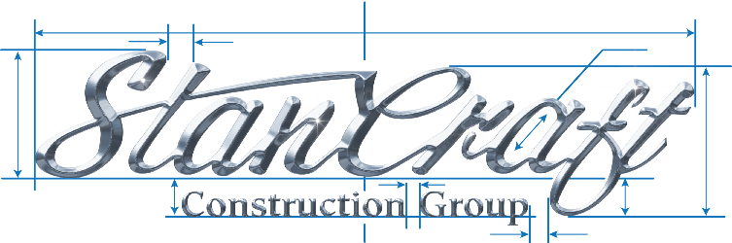  HAZARD ASSESSMENT  Job:
Rev Date: |  |  |  | Completed by (Name/Position):
 | Task/Activity | Hazard  What is the source of harm? (i.e., sharp blade of a knife) |  |  | Assess Risk |  | Controls  Consider the Hierarchy of Controls Current and Recommended (formal and informal) | Evaluate Next steps?
 |  |  | Likelihood |  | Consequence | Rating
Current Controls:
Recommended Controls:
Current Controls:
Recommended Controls:
Assess Risk | Rating | Hierarchy Of Controls
Likelihood: Is the hazard likely to cause injury Y/N  Consequence: Can the hazard cause serious injury or illness Y/N | High Risk = 2 Yes’s  Medium Risk = 1 Yes, 1 No Low Risk = 2 No’s | Elimination ⇨ Substitution ⇨ Engineering ⇨ Awareness ⇨ Administration ⇨ PPE
Hazard Categories: 1. Safety 2. Musculoskeletal Diseases 3. Biological 4. Chemical 5. Physical 6. Psychosocial
HAZARD ASSESSMENT
Task/Activity | Hazard  What is the source of harm? (i.e., sharp blade of a knife) |  | Assess Risk |  | Controls  Consider the Hierarchy of Controls Current and Recommended (formal and informal) | Evaluate Next steps?
 |  | Likelihood | Consequence | Rating
Current Controls:
Recommended Controls:
Current Controls:
Recommended Controls:
Current Controls:
Recommended Controls:
For any recommended controls identified, consider creating an action plan with listed actions to be taken, who will be responsible and target date.
Ensure hazard assessment is reviewed and updated as necessary (i.e., new processes, new hazards, risk changes, new controls implemented).

