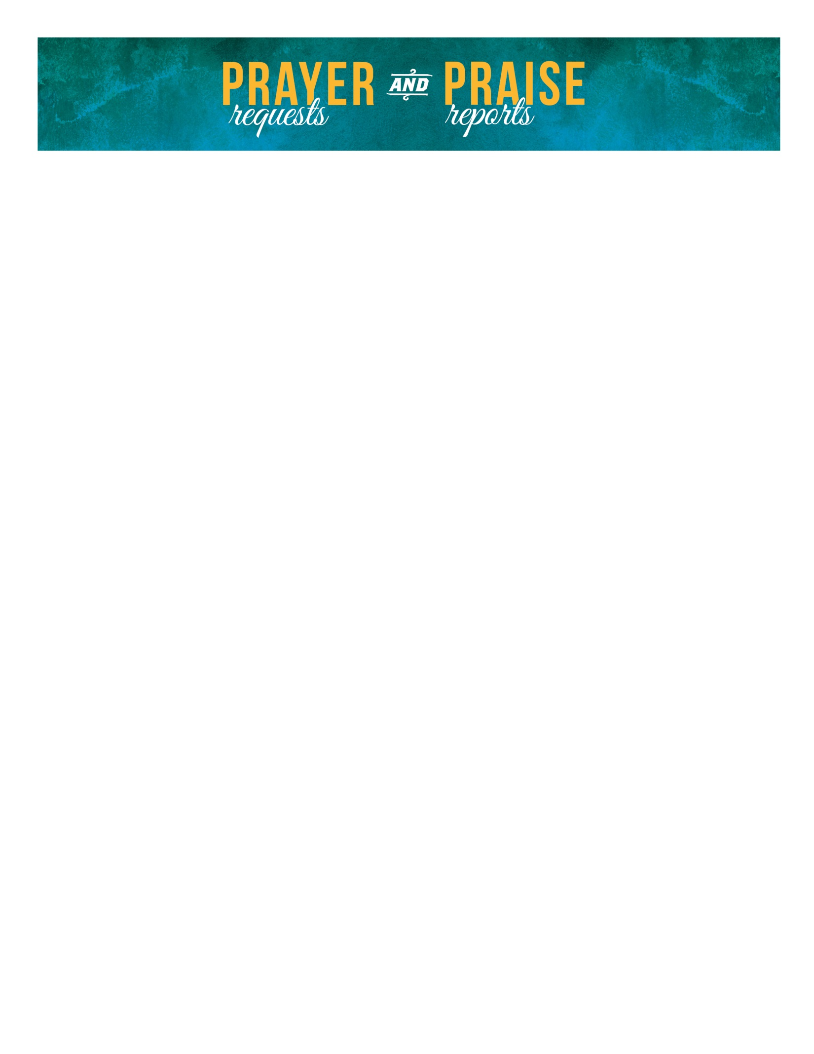

September 14, 2025

Mike - Cancer needs - Phil, Dona, Cathy...need strength, comfort & healing.

Christina - I had a cardiac procedure last week. I have been having frequent PVCs causing a high heart rate and shortness of breath. They did an electrophysiology study to try to locate the source in my heart then ablate the area. Pray this is successful without any complications.

La Croix Ministries and Missionaries

- Madison Marshall, Paraguay
- International Cooperating Ministries, Jeff Scott
- Well of Hope Timbtutini 2, eSwatini
- New Life Children’s Home (Wendy & Kendon Wheeler), Guatemala
- Chad and LaChandra Roark, Thailand
- Seeds of Dignity, Philippines
- Molly Kinder, Haiti (The Bridge)
- Hannah Stucker, Haiti (The Bridge)
- Jim Vinton, Wycliffe Bible Translators
- John and Megan Walden, The Balkans
- Inga May & Niklas Biklas – The Balkans
Please pray the following scriptures over La Croix Church
Prayer is:
- A hedge of protection from the evil one (John 17:15)
- A hunger for God and His Word (Matthew 5:6)
- Spiritual health and spiritual growth for each person (2 Thes. 1:3)
- The church to be a house of prayer (Matthew 21:13)
- The church body to live in harmony with one another (1 Peter 3:8)
- Godly wisdom for the church staff and leadership (James 1:5)
- God to be honored and glorified through the church (Daniel 4:34)
Sympathy
Derek (Natalie) Riordan on the September 9 death of his father, Matthew Thomas Riordan, of Cape Girardeau. Mr. Riordan was also the grandfather of Davina and Divinity Riordan.

