EGGLESTON PARISH COUNCIL ANNUAL MEETING – WED 23rd MAY 2018

Agenda
1) Attendees

2) Apologies for absence

3) Election of Chair and Vice Chair

4) Minutes of the last Annual Meeting held on 17th May 2017.

5) Finance – Presentation of accounts to year ending 31st March 2018.

6) Chairman’s Annual report

7) Adoption of revised standing orders.

8) Nomination, voting and election of council members for various committees and leads.

9) Diary dates. Council to decide how many times (minimum 3 plus Annual Parish meeting plus Annual Meeting) and on what day and time Council wish to meet over the next 12 months.
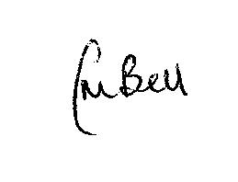
Clerk to Eggleston Parish Council
16th May 2018

