Myatt’s Fields Park Project (MFPP)

HIRE AGREEMENT TO USE THE MULBERRY CENTRE
IN MYATT’S FIELDS PARK
12a CALAIS STREET
LONDON SE5 9LP
IN THE LONDON BOROUGH OF LAMBETH

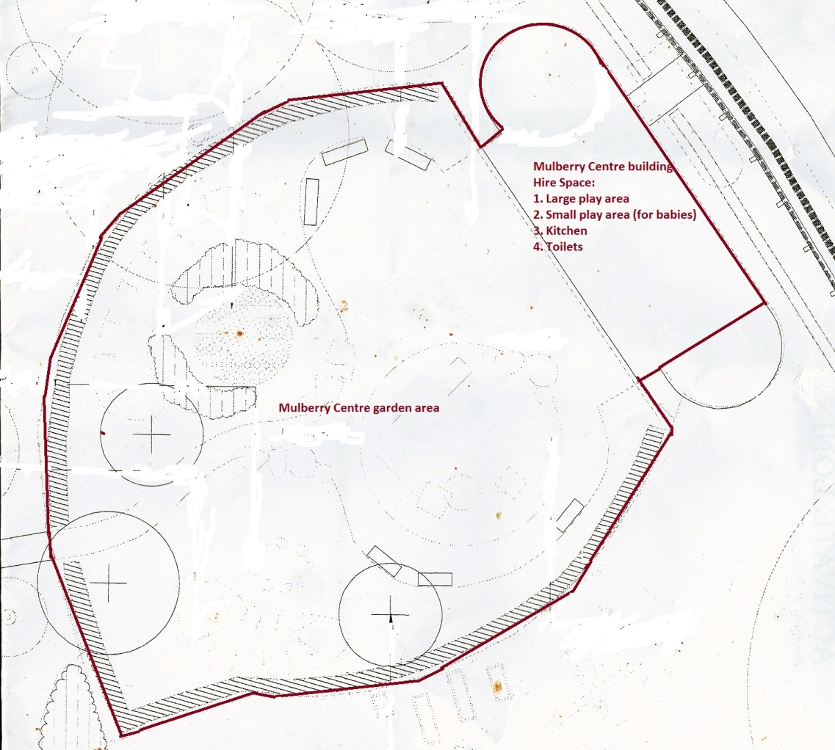

- Particulars

In this agreement the following expressions shall have the following meanings:

1.1 | The Licensor: | Myatt’s Fields Park Project, Myatt’s Fields Park, Old Park Depot, Cormont Road, London SE5 9RA
1.2 | The Hirer: | Name:…………………………………………………………………  Address:………………………………………………………………  ……………………………………………………………………..  Telephone: ………………………………………………………..  Email:…………………………………………………………………
1.3 | The Site: | The premises known as the Mulberry Centre of Myatt’s Fields Park in the London Borough of Lambeth (12a Calais Street, London SE5 9LP)
1.4 | The Hire Space: | The hire space allocated to the Hirer being part of the Mulberry Centre of Myatt’s Fields Park shown edged red on the attached plan (Page 1)  - Large play area  - Small play area (Baby room) – if requested-  - Kitchen  - Toilets  - outdoor Garden Area
1.5 | The Permitted Use | Children’s Parties  A children's party is defined as a party organised for children aged under 12 and their family and guests.
1.6 | Designated Times: | Saturday and Sunday mornings from 10am until 1pm and Saturday and Sunday afternoons from 2pm until 5pm
1.7 | Hire Period: | Day…………………………………Times:………………
1.8 | Hire Fee | £35.00 per one hour / Saturday and Sunday slot fee of £105.00 per 3 hours
1.9 | Hirers Liability Insurance | Limit of indemnity £2,000,000. Excess £100 (each and every claim for damage to the premises or contents caused other than by fire or explosion) see Part F of Tennyson Insurance Policy Schedule
1.10 | Deposit | A payment of Sixty pounds (£60) made payable to Myatt’s Fields Park Project (included in online payment). Subject to conditions 3 and 5 of this hire agreement, the deposit is refundable
1.11 | Notice Period | Cancellations of bookings must be received by MFPP up to 21 calendar days in advance in order to get a full refund of the booking fee and deposit. For cancellations within the period 7-21 calendar days prior to the booking date a 50% refund of the booking fee and 100% refund of the deposit will be received and for notices received within less than 7 calendar days in advance of the Hire Period the booking fee will be withheld in full but you will receive a 100% refund of the deposit.

- The Hire Agreement

Subject to Clauses 3 and 4 the Licensor gives the Hirer permission to use the Hire Space in common with the Licensor and all others authorised by the Licensor during the Hire Period for the Permitted Use.

- Hirer’s Undertakings

The Hirer agrees and undertakes:

3.1 | To pay the Licensor the Hire Fee and Deposit together with acceptance of this Contract (either signed hard copy or accepted online) in advance of the Hire Period
3.2 | Not to bring any equipment or goods onto the Site without the consent of the Licensor except as may be necessary for the exercise of the rights given in Clause 2
3.3 | To keep the Site clean and tidy and clear of rubbish and to leave the same in a clean and tidy condition and free of the Hirer’s goods and signs at the end of the Hire Period. See Appendix 2 for our usual room arrangements.
3.4 | Not to attach to the walls and ceilings anywhere in the premises any decorations of a permanent or semi-permanent nature
3.5 | Not to display any signs or notices at the Site and park’s notice boards without the prior written consent of the Licensor save for signs and banners advertising the Permitted Use
3.6 | The Hirer is only permitted use of the Licensor’s equipment as shown on the resource check list attached
3.7 | To comply with all fire and safety requirements and provisions relating to the Site
3.8 | Not to assign or underlet or share or part with possession of the Site or any part thereof
3.9 | Not to damage the Mulberry Centre or any facilities, fixtures or fittings
3.10 | Not to park or allow to be parked any vehicles at the Site. The Hirer can park vehicles outside the park on residential roads as there are no parking restrictions. The Hirer may unload goods by entering the park through the Cormont Road gate, driving on the tarmac paths with their hazard light on observing the 5m/h speed limit and stop opposite the gate to Mulberry Centre garden. If the Hirer wishes to enter the park to unload goods they must notify the Licensor in advance of this, and remove all vehicles from the Site as soon as possible once the unloading is complete.
3.11 | Not to use the Site for any illegal or immoral purposes
3.12 | Comply with all directions from the Licensor relating to the security of the Premises
3.13 | Not to use or allow the Site’s facilities or fixtures or fittings to be used in such a way as to cause any nuisance damage, disturbance, annoyance, inconvenience or interference to the Site or adjoining or neighbouring property or to the owners occupiers or users of such adjoining or neighbouring property  Hirers using amplified music are required to keep the volume to an acceptable level to avoid causing nuisance to neighbours  Hirers are requested to keep all unnecessary noise down to a minimum when leaving the premises
3.14 | The Site caretaker shall attend the Hire Space at the end of the Hire Period and the Hirer shall inspect the Site with the caretaker and together complete the check list annexed to this contract at Appendix 2. Breakages must be reported to the Caretaker at that time and Hirers must indemnify the Licensor for any damage, however caused, arising during, or in respect of the Hire Period.
3.15 | The Licensor will return the Deposit to the Hirer within 7 days if there are no breakages or damage and if they keep within the times of the booking.
3.16 | Not to do any act matter or thing which would or might constitute a breach of any statutory requirement affecting the Site or which would or might vitiate in whole or in part any insurance
3.17 | To indemnify the Licensor against all losses, claims, demands, actions, proceedings, damages, costs or expenses or other liability arising in any way from this licence or any breach of any of the Hirer’ undertakings contained in this Licence
3.18 | To observe such rules and regulations as the Licensor may make and of which the Licensor shall notify to the Hirer from time to time governing the Hirer’s use of the Site
3.19 | Not to carry out any alterations to the Mulberry Centre
3.20 | Not to impede in any way the Licensor or its officers servants or agents in the exercise of the Licensor’s rights of possession and control of the Site

- General

4.1 | The rights granted by this Hire Agreement shall end (without prejudice to the Licensor’s rights in respect of any breach of the undertakings contained in clause 3):
 | 4.1.1 | On the expiry of the Hire Period
 | 4.1.2 | Immediately on notice given by the Licensor at any time following any breach by the Hirer of the undertakings required by this contract
 | 4.1.3 | On not less than the notice specified in the Notice Period given by the Hirer to the Licensor
4.2 | The benefit of this licence is personal to the Hirer and is not assignable and the rights given in Clause 2 may only be exercised by the Hirer and its employees, visitors and customers
4.3 | The Licensor gives no warranty that the Premises are legally or physically fit for the purposes specified in Clause 2
4.4 | The Licensor shall not be liable for any loss, claims, expenses or any other liability suffered by the Hirer
4.5 | The Licensor shall not be liable for the death of or injury to or damage to any property or for any losses claims demands actions proceedings damages costs or expenses or the liability incurred by the Hirer, employees, visitors or customers to the extent that the law allows
4.6 | All notices given by either party pursuant to the provisions of this Agreement shall be in writing and shall be sufficiently served if delivered by hand or sent by recorded delivery if to the Licensor at; Myatt’s Fields Park Project, Myatt’s Fields Park, Old Park Depot, Cormont Road, London SE5 9RA or if to the Hirer at their address at clause 1.2 above
4.7 | On determination of the Hire Agreement the Licensor will be under no obligation whatsoever to renew the Hire Agreement or provide alternative accommodation
4.8 | The Hirer may use toys and similar items left out in the Hire Space at their own risk

- Requirements and obligations

5.1 | User Requirements for Site:  - Access to Site – Site will be open for the Hire period and locked afterwards by a caretaker appointed by the Licensor
5.2 | User Health & Safety Obligation:  - The Hirer must obey no smoking policy in the Mulberry Centre and the Garden  - No alcohol may be consumed on the Site, the deposit will be withheld in full if alcohol or alcohol containers are found on site.  - The hirer shall not bring or permit any other person or agent to bring articles of an inflammable or explosive nature, which could cause damage or injury, onto the premises. This includes, but not limited to, bangers, sparklers and fireworks.  - No cooking facilities e.g. BBQ may be brought into the building by the hirer or by any person on their behalf without the prior agreement of the Licensor.  - All seats are to be arranged with sufficient gangways to afford proper means of exit and all passages and fire exits must be kept free from obstruction.  - Caterers, contractors and persons employed by the hirer to supply refreshments will be required to observe all hygiene regulations.  - The Hirer will ensure that there is a minimum ratio of one adult to eight children. Failure to abide by this will lead to termination of this contract immediately.  - The Hirer will ensure that there are no more than 30 attendees at the Hire Space at any time.  - When tidying up, the Hirer must use pink recycling bags for any glass, paper, plastic litter that can be recycled. Bags are supplied by the Centre.  - Any used nappies must be taken home and not disposed of in the Centre.  - Balloons are to be popped over the bin only as small bits of bust balloon can litter the Park and cause damage to the wildlife. If any balloon bits are found outside, 50% of the deposit will be withheld. Helium balloons are not allowed on site.  - If music is played, the volume must be kept at a reasonable level so it doesn’t disturb the neighbours and other users of the park.  - Disabled toilet alarm information - the alarm from disabled toilet at the playground is connected to the Mulberry Centre. It happened once that alarm started to ring during a party. To reset it, please go to toilet for disabled children on the park’s playground and press red reset button. Usually no-one needs assistance; kids just pull the alarm cord for fun. If disabled person needs assistance, please ring 999.  - Toilet alarm in Mulberry Centre – can be re-set by pressing a button in the room near the adult toilet.  - The Hirer must vacate the Hire Space without delay at the expiry of the Designated time or pay £20 for each additional 20 minutes after the hire period. This will be taken from the deposit as required.

 | For the Licensor: | For the Hirer:
 | Signed:  Name:  Date: | Signed:  Name:  Date:

Appendix 1

END OF HIRE PERIOD CHECKLIST

INDOOR PLAY AREAS | Tick |  | TOILETS | Tick
Tables wiped clean |  |  | Toilets free of blockage, flushed and clean
Sink free from blockage and clean |  |  | Sink cleaned
Tables and chairs cleaned and put away neatly |  |  | Baby changing area cleaned
All equipment returned back to allocated area |  |  | GARDEN AREA
Floor free of debris (swept and mopped) |  |  | Toys and equipment stored in designated areas
Rubbish bins EMPTIED and relined |  |  | Sandpit free of debris
KITCHEN |  |  | Garden free of litter
Rubbish bin EMPTIED and relined |  |  | Shutters and gate secured
Worktop surface wiped clean and clear |  |  | DAMAGE – please state details
Sink free from blockage and clean |  |  | First Aid Kit used | Yes  No
Floor swept & mopped |  |  | First Aid Kit used | Yes  No
Cooking equipment switched off at the mains |  |  | First Aid Kit used | Yes  No

Check carried out by

Caretaker Name…………………………………………… Sign………………………………………..

Hirer
Name……………………………………………………… Sign………………………………………….

Date………………………… Date…………………………

Appendix 2

END OF HIRE PERIOD: ROOM LAYOUT

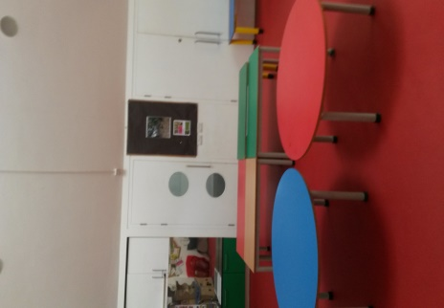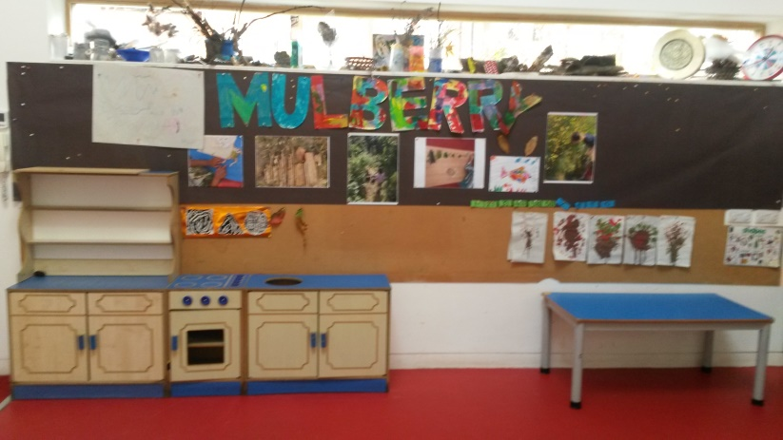

Please arrange tables and chairs in large playroom as shown on the pictures. Please
carry the tables to arrange them rather pulling them across the floors as the feet can mark
the floor.

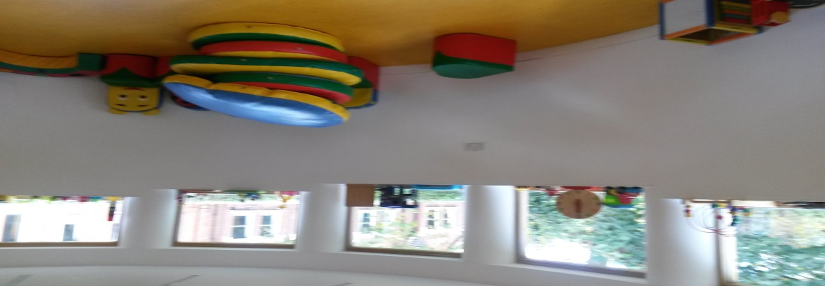
Please leave the baby room tidy arranging small toys on the windows sills.

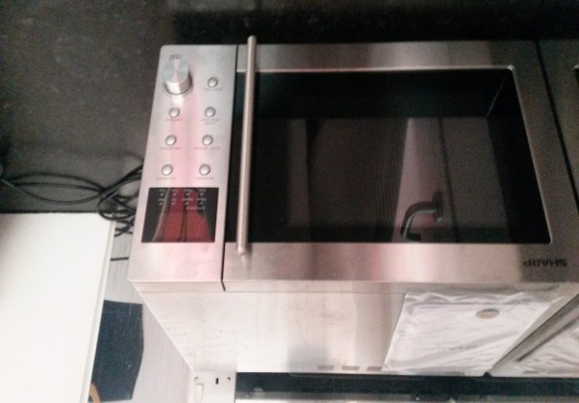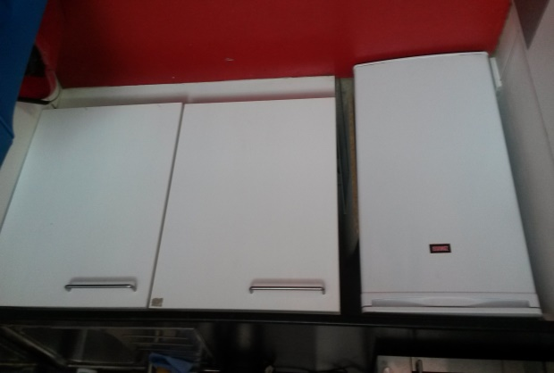

Please leave the kitchen tidy.

