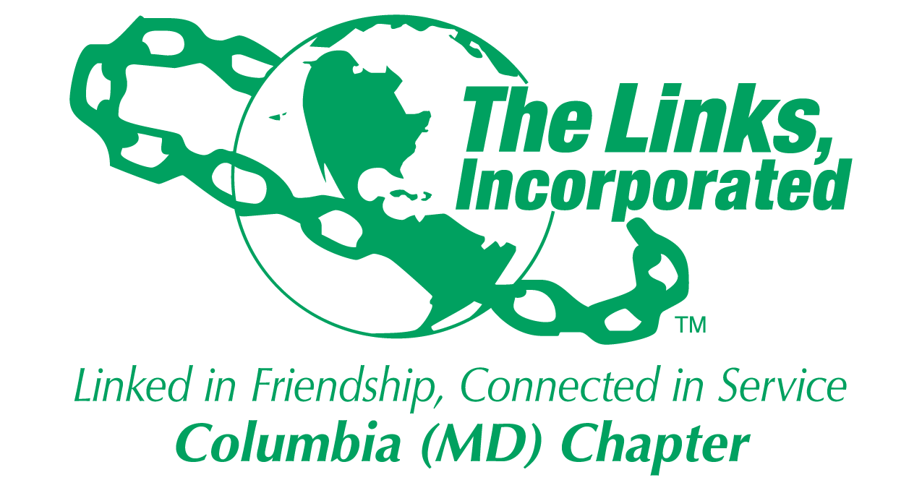
Membership Committee Report
Name of Facet/Committee: Membership Committee
Date/ Time/Location of Meeting: August 27, 2018
6328 Daring Prince Way, Columbia, MD. 21044

Members Present: Regina Clay, Laura Crandon, Jewell Debnam, Jules Dixon, Jo Emily Knox, Lisa Loury Lomas, Rochelle Michaux-Conway, Tanya Sellers-Hannibal, Grayce Simmons, Robin Steele
Summary of Meeting: Much discussion around the lack of cohesiveness within the Chapter and our Link sisters not knowing one another. To this end, the Membership Committee will recommend to the Executive Board not to have New Member Intake during 2018-2019. The committee will be working diligently during the year to get our Link sisters more connected through various activities. In addition to looking at opportunities to continue including Alumnae and add Connecting Links. Our goal is to have the Chapter Directory by the September Chapter Meeting.
Welcome & Linkspiration: Link Rochelle
Membership Updates:
- Platinum Status- Our Link Sisters were recognized at the National Assembly. Link Zola, Link Shirley and Link Alma received their awards in person.
- Alumna Membership Request- Received approval for Link Leila Potts Campbell
- Year In Review- We took a pause to discuss what went well and areas of improvement.
- Membership -A Year In Review- We reflected on what went well and areas of improvement 2017-2018.
      - Successes/What went well
        - Member Induction/Orientation Workshops. Link Jewell thought the Induction was very nice and welcoming.
        - Meeting location. Link Lisa shared that having at my home provided a safe environment to be transparent.
        - We were able to engage the Alumnae in more activities
        - Eight Link Sisters were recognized with Platinum Status
      - Areas of Improvement
        - Link Robin and other shared that we need more Chapter participation at New Orientation Workshops and Induction. It is an opportunity to bound with new members.
        - Lack of participation at Memorial Services. Both Link Robin and Link Jo Emily shared that it is embarrassing not have our Link sisters in attendance to bring support to the family. Link Tanya suggested the possibility of having a Bereavement Committee.
        - Link Rochelle shared that we are not as connected in friendship and service as we need to be as a Chapter. Other comments:
          - When you become a member, one needs to buy into it – Link Jo Emily
          - Link sisters must be all in or not. Are you a member for status or purpose of the organization – Link Regina
          - When Chapters grow too fast it makes it harder to connect – Link Robin
          - We have to set the tone and expectation to increase participation – Link Lisa
          - Why Are We Here? – Link Rochelle
        - Link Jo Emily shared that we did not have any activities where we brought the Connecting Links together as a group.
      - New Member Intake – Link Rochelle shared the timeline and asked the committee for recommendations. Based upon the items from Areas of Improvement, Link Jo Emily moved that The Columbia (MD) Chapter of the Links Incorporated not have Member Intake during 2018-2019. Link Robin seconded. The motion carried unanimously.
New Chapter Directory:: Link Germaine has committed to having available by the September 7th Chapter Meeting. Link Rochelle will follow up.
Calendar of Events : “Sisters Linking Up In Friendship”
  - October
  - November Friendship Month- Jazz Brunch Sisters Linking Up Homecoming Weekend, Saturday, November 11th (Link Jo Emily investigate venue)
  - December Holiday Celebration – Saturday, December 8th, (Link Rochelle/Link Tanya investigate venue)
  - March Link Spring Fling – March Madness Event (Link Jewell/Link Robin)
  - April – Eastern Area Conference, Atlantic City, NJ, April 24th – 28th
  - May Celebration – Potential picnic (Include Connecting Links)

Strategic Plan
Goal  (Specify if Short, Mid or Long Term) | Activity Progress with Completion date | Assumption/ Changes-  Committee Effort | Progress /Update/ Evaluation | Resource Requirements (Both Internal and External) | Action Items (Please Specify If Chapter Vote Is Required)
Increase membership to enhance and sustain chapter program and fill skill gaps of current members by at least 10%. | - Link Leila Potts Campbell alumnae status approved.  -. | -Membership Committee will be recommending to the Executive Board that we do not take in New Members during 2018-2019 | - | - | - Chapter will need to vote on taking in new members or not during 2018-2019.
Create an environment that promotes enduring relationships among chapter members. | 2018-2019 Calendar Events underway. | -October  -November Friendship Event: Sisters Linking Up Homecoming Weekend, Saturday, November 10th.  -December  Sisters Linking Up During Holiday Celebration on Saturday, December 8th  -March  March Madness Event  - May  End of Year Event (TBD) |  |  | - TBD  -November: Link Jo Emily investigate venue  -December: Link Rochelle and Link Tanya investigate venue  -March: Link Jewell and Like Robin work on event.  -May: TBD
Maintain Good Relationships with Alumna members | -. | -Committee members provided assistance and guidance to alumnae for each event. |  | -Ensure alumnae members receive calendar of events, receive event invitations and are connected to the Chapter.

Signature of Facet/Committee Chair:
Rochelle A. Michaux-Conway
_____________________________________________________________________________________________________
Date: _____August 29, 2018_______________________________________________________
Please Email to Chapter President, Chapter Vice President, Chapter Recording Secretary and Chapter Program Coordinator prior to Chapter Executive Committee Meeting

