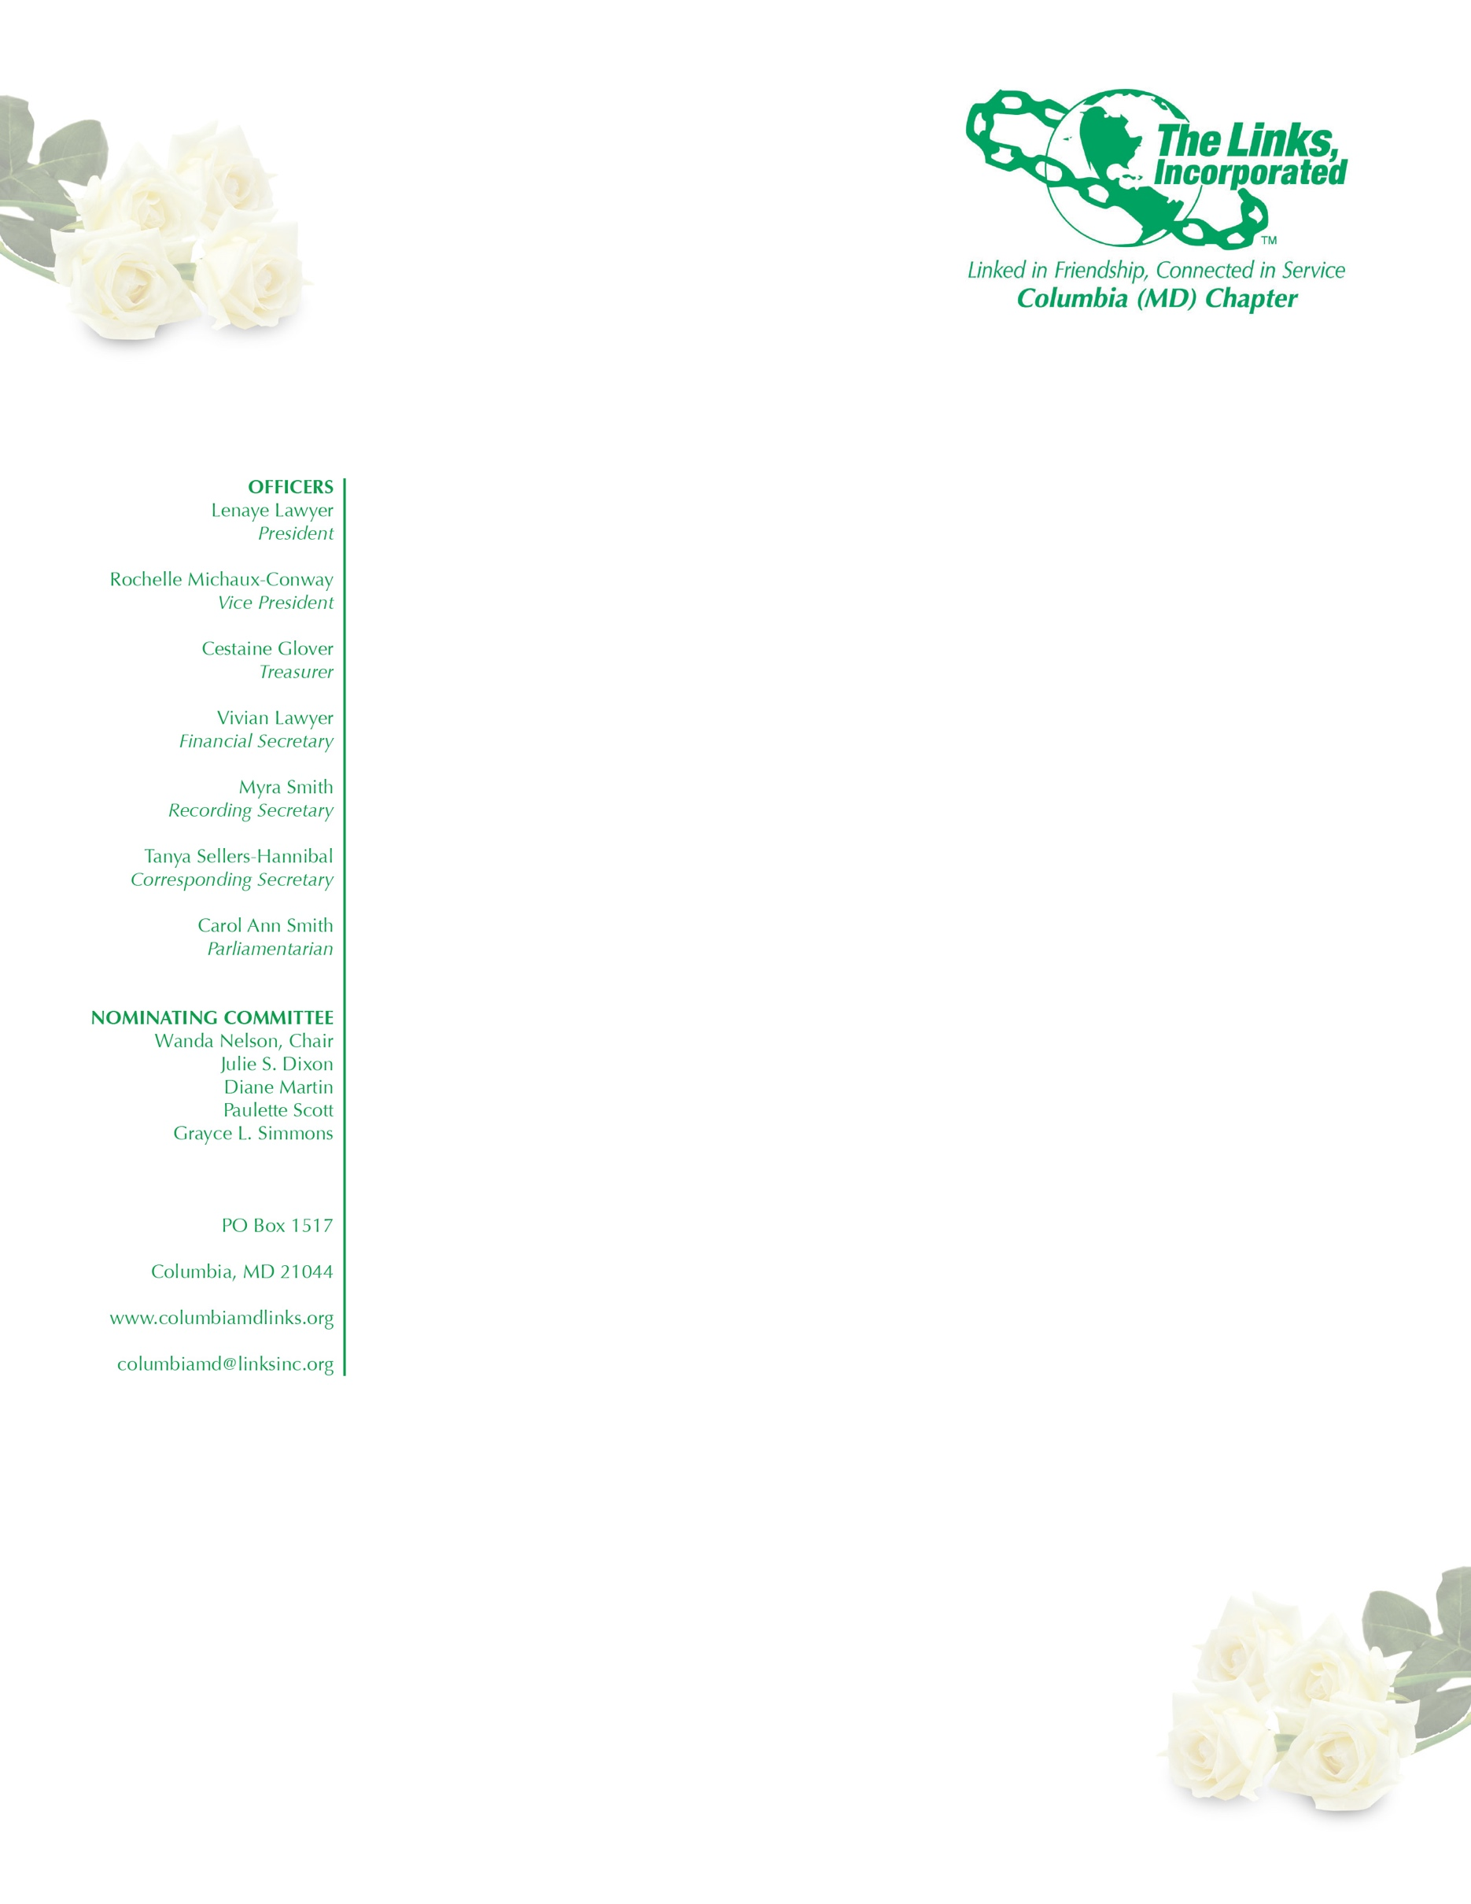
AGENDA

October 3, 2018
Executive Committee Meeting

Adoption of the Agenda

Approval of the Minutes of the August 29, 2018 Meeting

Correspondence

President’s Report

Vice President’s Report

Financial Secretary’s Report

Treasurer’s Report

Audit Committee

Fundraising Committee

Strategic Planning Committee

Services to Youth

National Trends

The Arts

Health and Human Services

International Trends and Services

New Business

