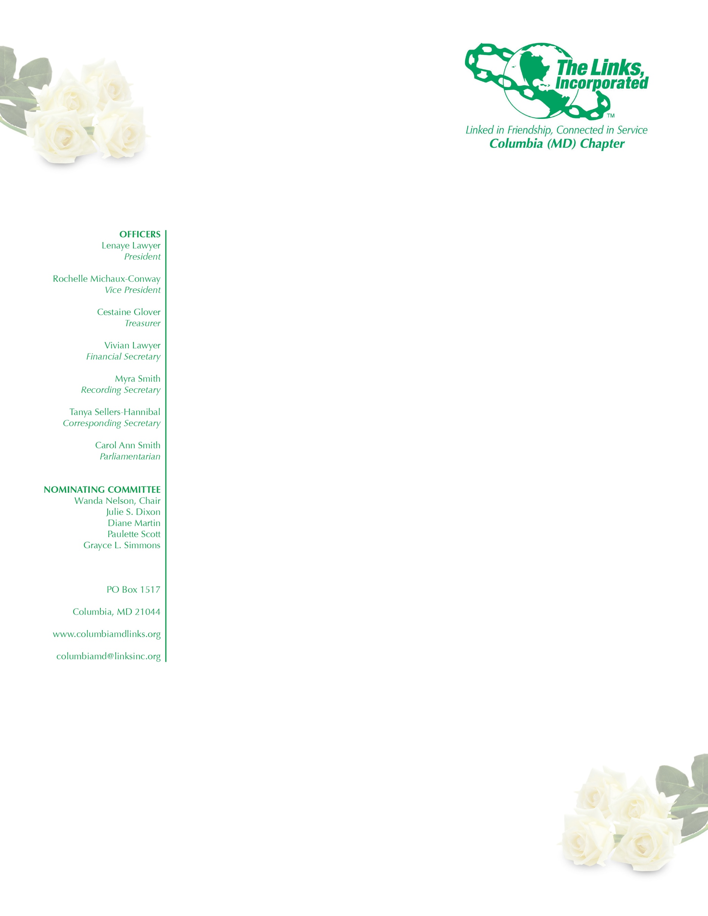
AGENDA

January 3, 2018
Executive Committee Meeting

Adoption of the Agenda

Approval of the Minutes of November 1, 2017 Meeting

Correspondence

President’s Report

Vice President’s Report

Financial Secretary’s Report

Treasurer’s Report

Fundraising Committee

Strategic Planning Committee

Archives Committee

Services to Youth

National Trends

The Arts

Health and Human Services

International Trends and Services

New Business

