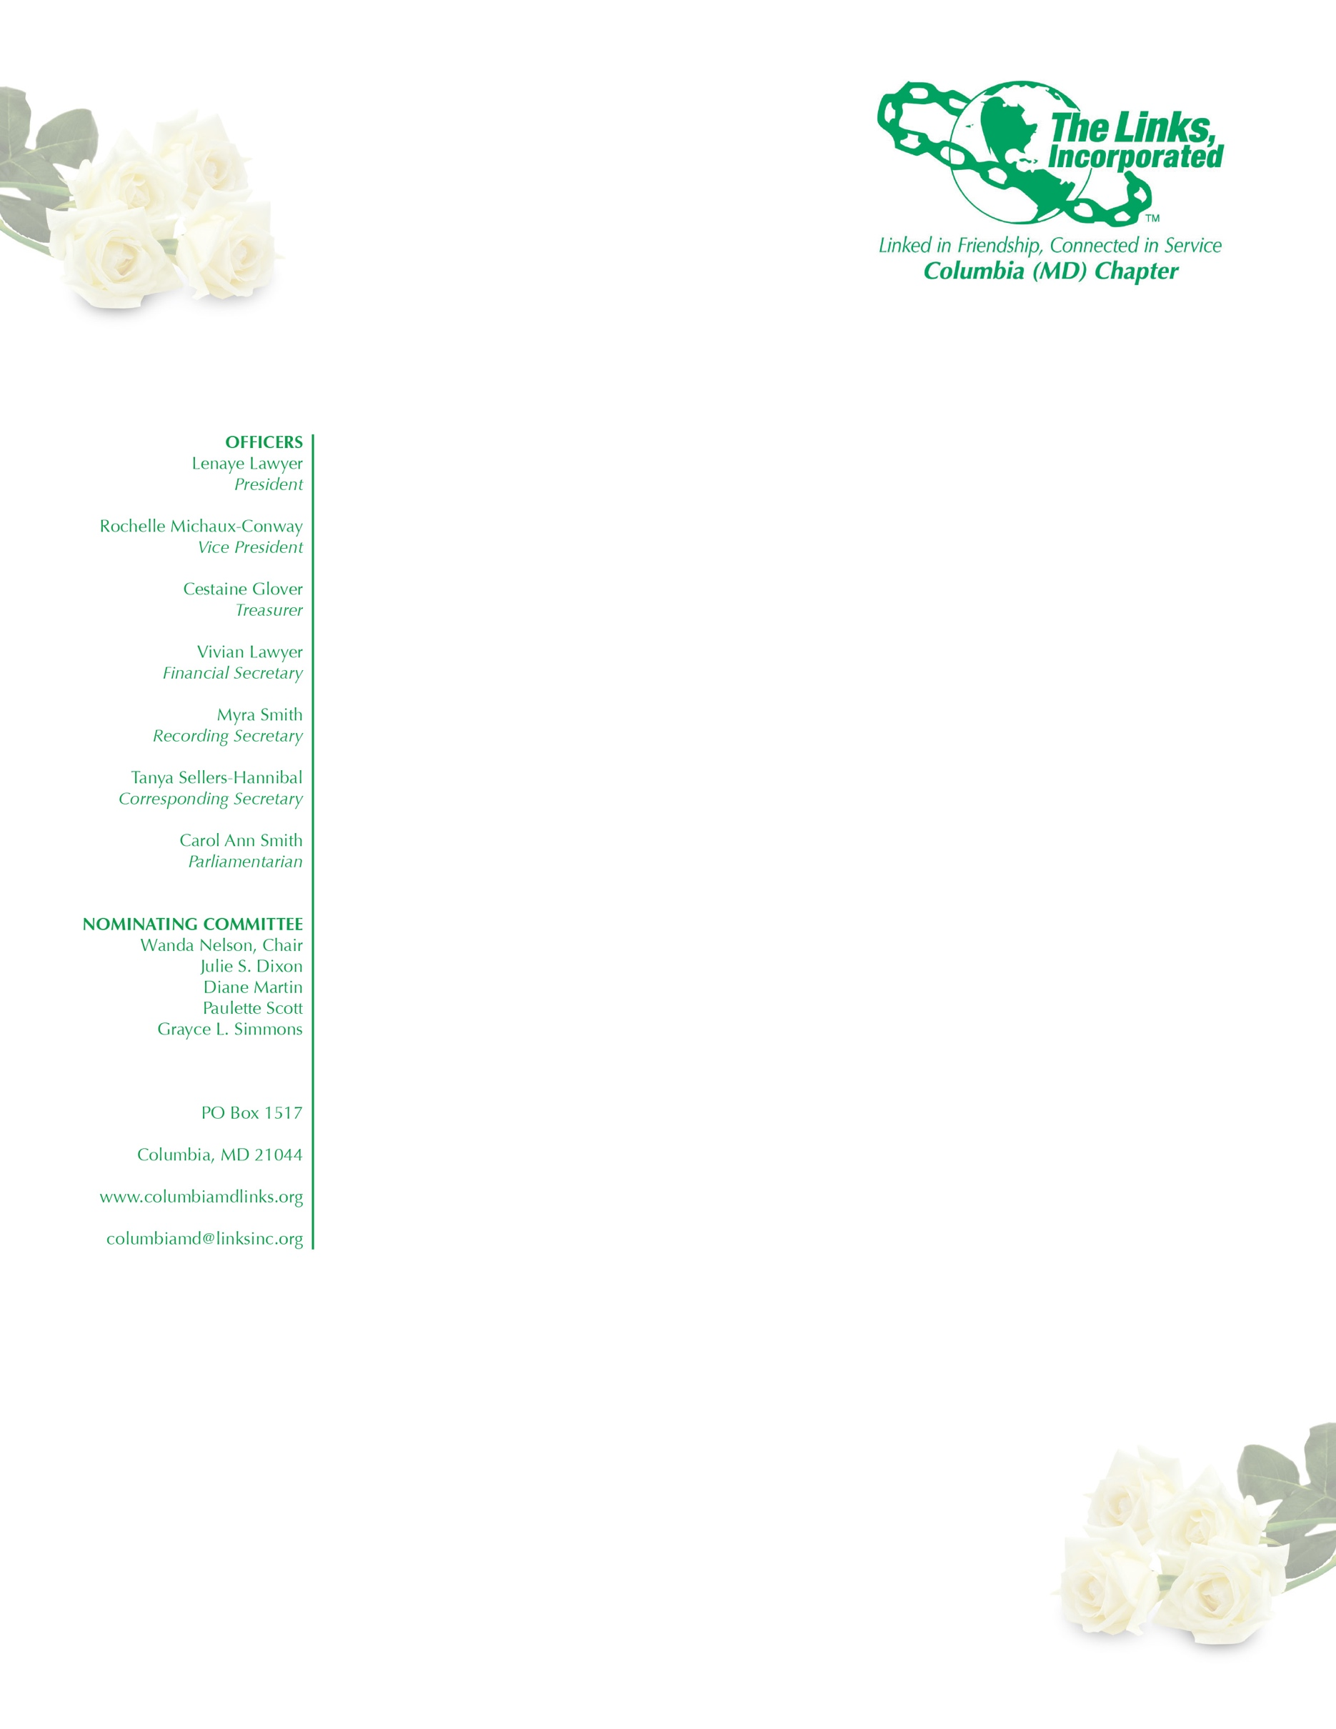
AGENDA

October 4, 2017
Executive Committee Meeting

Adoption of the Agenda

Approval of the Minutes of August 30, 2017 Meeting

Correspondence

President’s Report

Vice President’s Report

Financial Secretary’s Report

Treasurer’s Report

Audit Committee

Ethics Committee

Fundraising Committee

Services to Youth

National Trends

The Arts

Health and Human Services

International Trends and Services

New Business

