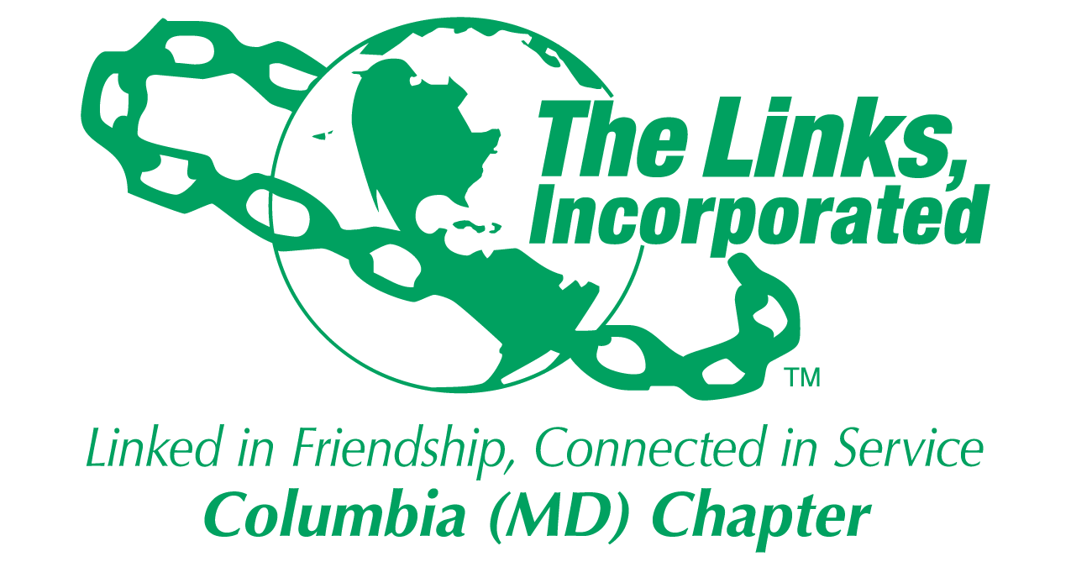
Facet/Committee Reporting Form
Name of Facet/Committee: HHS Facet
Date/ Time/Location of Meeting: December 17, 2019
Members Present:
Attendees Laura Crandon, Lenaye Lawyer, Jessica Lucas, Rebecca Reed, Rhonda Ricks, Tanya Sellers-Hannibal,

Summary of Meeting (Dot Points):
- 4/18/2020 is confirmed for Colgate Bright Smiles Bright Future Dental Screening Van to be at our event. Expand event beyond Oral Health to include health day for the whole family with Oral Health for children 12 years old and younger. Our target is to impact 150-200 children (dental screenings and education).
- Three collaborating partners have been identified: HCPSS (including Cradlerock ES and Lake Elkhorn MS), Jack & Jill (Columbia) and HCLS
  - HCPSS: Oral health aligns with their priority to enroll children in Healthy Smiles program. HCPSS will help promote the event.
  - HCLS: Location for the van plus 2-3 rooms to conduct other screenings and educational workshops. Promote event.
  - Jack & Jill: Teens to facilitate 1-2 educational workshops
  - UnitedHealthcare: Dental health education
- Location solidified: HCLS East Columbia Branch located within a community of need and next to CES and LEMS (Title I schools)
- The Facet will pursue an integrated program, working with NTS (Link Jean has been attending HHS planning meetings) and STY (Link Jessica will serve as liaison).
  - Explore with NTS and STY to host oral health education sessions which would count toward our community impact metrics.

- Focus from now to April 18th
  - Develop and execute Marketing and PR Plan
  - Secure and specify partner participation (Link Laura, Link Jean, Link Lenaye, Link Rhonda)
  - Define and Secure Incentives to draw community to the event (e.g. gift cards, food, giveaways, prizes)
  - Define and finalize activities (Link Jessica)
  - Define event workshops and educational activities for the family (Link Rebecca)
  - Set up Registration (Link Regina Clay)
  - Develop and manage budget for event (Link Rhonda and Link Jessica)
  - Develop NTS and STY oral health programs (Link Jean and Link Jessica)

Goal  (Specify if Short, Mid or Long Term) | Activity Progress with Completion date including Budget | Assumption Changes | Progress on evaluation | Needs - Specify or Update on Resource Needs (Both Internal and External) | Action items/ Items (Please Specify If Chapter Vote Is Required)
Identify Leads for each major category | Completed 12/17/19 |  |  | Determine how to best run an integrated program
Conduct Monthly Planning Meetings | Jan – April | Each Liaison will report on progress
Meet with Partners to solidify participation
Define Program Logistics
Signature of Facet/Committee Chair: Laura Crandon
Date: December 31, 2019
Please Email to Chapter President, Chapter Vice President, Chapter Recording Secretary and Chapter Program Coordinator prior to Chapter Executive Committee Meeting

