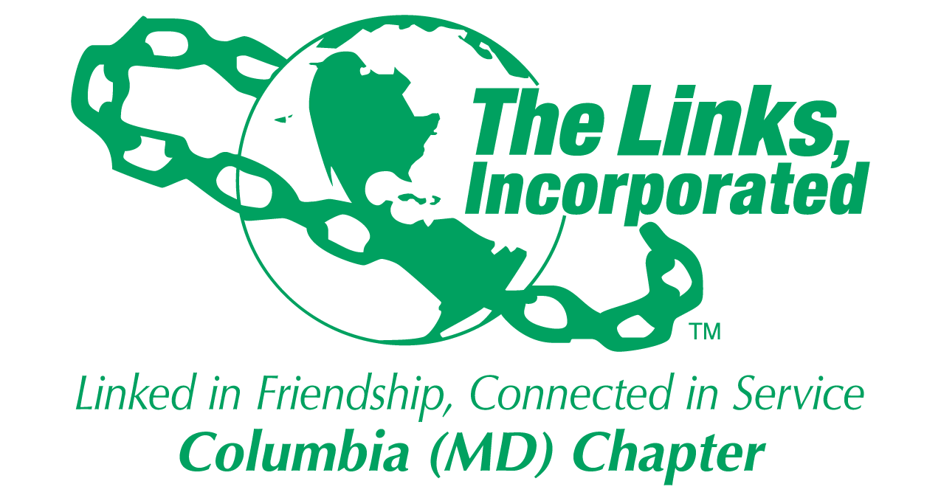
Facet/Committee Reporting Form
Name of Facet/Committee: Audit Committee
Date/ Time/Location of Meeting: August 5,2019 7PM, Telecon
Members Present:
- Rochelle Michaux-Conway, Vivian Lawyer, Wanda Nelson, Lisa Harbour-Carter and Judy L. Smith

Summary of Meeting (Dot Points):
- We discussed the following items:
  - Internal Audit Report
  - External Audit Report
  - Form 990
- Internal Audit Report
  - We reviewed the Internal Audit report
    - No Potential Risks
    - There was some exposure related to documentation supporting wages and taxes paid to the Howard County Public School System for the MESA program
    - There were 19 suggested recommendations to consider that could be beneficial. These are categorized as follows:
      - Return Check Policy
      - Documentation
      - Timeliness of remittances and printing system reports
      - Voucher Form enhancements
      - Consistency of reporting month over month
    - Began the process to file the Internal Audit report to National but need two outstanding pieces of data: total expenditures and total revenue.
      - Must file on or before September 15th
      - Do not see a problem with meeting the deadline.
- External Audit Report
  - Our auditor requested information in writing on August 9th
  - Our initial set of data was sent to the Auditor from August 10th through August 13th
  - He made an additional request for updated documentation on August 31st
  - That information was provided on September 1, 2019
  - Goal is to have the draft External Audit Report on September 4, and the Form 990 shortly thereafter.
  - I let a message requesting a status update on September 4, 2019.
  - The plan is to review the External Audit report by the end of September 6, 2019 and to review the Form 990 shortly thereafter
  - Still on plan to meet the September 15, 2019 deadline.
  - If anything changes, I will update the Executive Committee immediately
- Form 990
  - The Form 990 is to be completed on September 4, 2019
  - The plan is to review if and provide feedback to the Auditor by September 6, 2019
  - Goal is to finalize the Form 990 by September 10, 2019
  - Still on plan to meet the September 16, 2019
  - If anything changes, I will update the Executive Committee immediately
- Focus from now to October 1st
  - Submit the internal, external and form 990 by September 15, 2019
  - Finalize the Audit Committee members
  - Conduct the first Audit Committee meeting
  - Begin September 2019 audit

Goal  (Specify if Short, Mid or Long Term) | Activity Progress with Completion date including Budget | Assumption Changes | Progress on evaluation | Needs - Specify or Update on Resource Needs (Both Internal and External) | Action items/ Items (Please Specify If Chapter Vote Is Required)
Stand Up Committee | 10/15/2019 | Need 4 committee members | Currently one Committee member Shaydra | 3 additional members | Contact Chapter members who previously showed an interest
Conduct Monthly Audits | 04/30/2019 | Each committee members will be repsonisble for pertain potions of the audit process | Need to review the current process and make member assignments | Review the process | Hold a meeting
Using 2018-2019 Audit Recommendations, Improve Audit Process | 12/31/2019 | Process is documented | Begin task week of September 10 | The process | Update the process based on 19 suggestions
Signature of Facet/Committee Chair: Judy L. Smith
Date: September 4, 2019
Please Email to Chapter President, Chapter Vice President, Chapter Recording Secretary and Chapter Program Coordinator prior to Chapter Executive Committee Meeting

