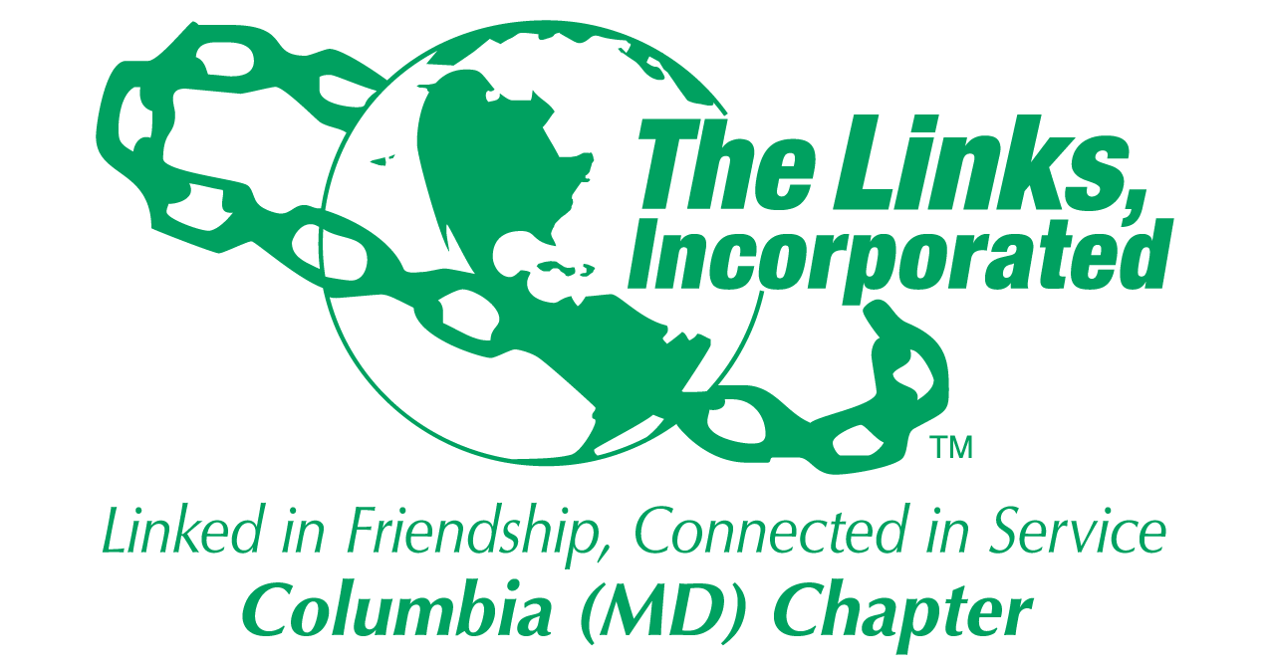
Facet/Committee Reporting Form
Name of Facet/Committee: HHS
Date/ Time/Location of Meeting: 9/24/2019, 7pm ET, Home of Laura Crandon
Members Present: 3
Summary of Meeting (Dot Points):
- Our chapter successfully participated in The September 28, 2019 DMV Walk for Healthy Living at Hains Point along with 18 other chapters. We donated 232 pairs of thermal socks. 4 Link Sisters attended the event.
- Horizon Foundation Mental Health Film Festival.
Link Robin has brilliantly secured a partnership with the Horizon Foundation where we can serve the community, help destigmatize mental health in the African American community and get be visible as we serve. Yay!

Below are the particulars. Please review and let me know your edits and when it's OK for me to send out to HHS Facet members.

Date: Wednesday, October 23, 2019
Time: 5pm - 9pm for volunteers; the event is 6p-9p
Where: Regal UA Snowden Square Theater
What:
- 2019 Mental Health Film Festival with feature 4 films to build awareness and compassion for members of our community living with mental health challenges. Attend one of four FREE films (tickets required) followed by a time for attendees to reflect, ask questions and connect with others. Films feature teens, post partum moms, veterans and parents--all of whom have been impacted by mental health.
- Link Lisa Cooper Lucas and Link Lisa Loury-Lomas will serve on panel discussions after films are shown.
Volunteers Needed: 6 Link Sisters needed from 5pm - 9pm on October 23 to set up and help with registration, greeting and showing people to the right theater. Let Link Robin Steele know by Friday, October 4, 2019, if you will volunteer: rsteele510@aol.com

Marketing: Link Tanya volunteered to work on marketing the event once a flyer is created and approved. We need Link Sisters to spread the word through social media and other organizations to ensure African Americans attend and are represented at the event.

Free Tickets (select only 1 movie): https://thehorizonfoundation.us17.list-manage.com/track/click?u=ba1865e768d42f109d9907512&id=2b7ea30142&e=c99e9b7fd3
- Oral Health partnership with Jack & Jill Dental Van
    - Jack and Jill Colubmia chapter has agreed to partner with us for their December 13th Corduroy Closet event.
    - Link Tanya is submitting the request for a dental van to The Links corporate office.
- At our September Meeting, Link Robin led a conversation about mental health and suicide and distributed self-care resources.
- In September, Link Deidre and Link Sharon posted about Suicide Awareness month and will do the same for October’s Breast Cancer Awareness month, on social media.
- The Eastern Area is asking the HHS Facets to become HEAL(formerly HEA) certified

Goal  (Specify if Short, Mid or Long Term) | Activity Progress with Completion date | Assumption Changes | Progress on evaluation | Needs - Specify or Update on Resource Needs (Both Internal and External) | Action items/ Items (Please Specify If Chapter Vote Is Required)
Short | Mental Health Partnership with Horizon Foundation Mental Health Film Festival |  |  | Need 5 additional volunteers to serve on 10/23/19 from 5-9p ET | No Vote required
Short | Oral Health Partnership with Jack & Jill |  | Dental Van request submitted for 12/13. Awaiting corporate response. |  | If approved, will need volunteers to serve on 12/13.
Long | HEAL Certification |  | Not Started

Signature of Facet/Committee Chair:
Laura Crandon
________________________________________________________________________________________________________
Date: _____10-11-19_______________________________________________________
*Please email to Chapter President, Chapter Vice President, Chapter Recording Secretary and Chapter Program Coordinator prior to the Chapter Executive Committee Meeting.

