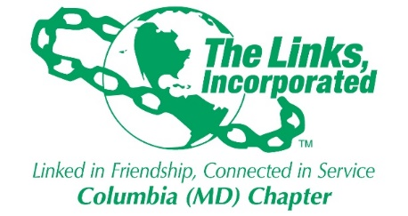
Services To Youth (STY) - Scholarship Committee Report
10/2/2019
- Crystal Otubu - $2,500 per year – Scholarship paid in full in September 2019
2016 HBCU Scholarship Recipient (UM Eastern Shore)

- *K. Purdue – $2,500 for four years
2017 HBCU Scholarship Recipient

- Kafayat Alli – $2,500 for four years
2018 HBCU Scholarship Recipient

- *Sofeeyah Lloyd - $2,500 for two years
2018 HCC Scholarship Recipient

- Morgan Young - $2,500 per year for 4 years
2019 Non-HBCU Scholarship – Mt. St. Mary’s
4 year Scholarship Recipient; paid out the 1st year in 2019

- David Gordon - $2,500 per year for 4 years
2019 HBCU Scholarship Recipient – FAMU
4 Year Scholarship Recipient; paid out the 1st year in 2019

*We have not heard from the following students: S. Lloyd at Howard Community College and K. Purdue – HBCU Scholarship. I will work with Rochelle to get a letter to the students so that we fulfill our obligation. I think we need to put a date every year in which students need to supply their documentation (transcript) to the committee. Also the students have an obligation to supply video on their status. Since we do not have Jazz Brunch we still need to get the videos.

Robin Steele
April 14, 2018
Sofeeyah Lloyd
10227 Rutland Round Road
Columbia, MD 21044

Dear Sofeeyah,
Congratulations on being selected as a 2018 Columbia Links, Incorporated $2,500.00 scholarship recipient! As outlined in our 2018 Scholarship Application’s Selection Conditions, you must attend Howard Community College to receive the above-mentioned scholarship award. Documentation of enrollment must be submitted by June 1st, 2018. If there is a problem meeting this deadline, please contact Mrs. Robin Steele, Scholarship Chair at 443-956-4642 to notify her of the date the documentation will be received.
Please mail documentation of enrollment to:
The Columbia (MD) Chapter of The Links, Incorporated
P.O. Box 1517
Columbia, MD 21044
ATTN: Scholarship Committee
You will also be eligible for a scholarship for a subsequent year if you meet all of the conditions established in the application. You must maintain a 3.0 or higher grade point average, display high moral character and provide documentation of grades as requested. Also, you must provide a 10-30 second video describing your major, your plans for the future and how the scholarship has assisted you. The video should be emailed to columbiamd@linksinc.org by October 8, 2018.
Mrs. Diane Martin will present at Oakland Mills High School Senior Awards assembly to present this letter to you on stage.
Please know that the members of The Columbia (MD) Chapter of The Links, Incorporated are excited about getting to know you and building a lasting relationship of support with you by maintaining communication and inviting you to events held by the Chapter. We hope that this scholarship will support you in your educational pursuits. Have a great school year!
Sincerely,
Lenaye Lawyer, MD
President
Diane B. Martin,
Services to Youth Chair

