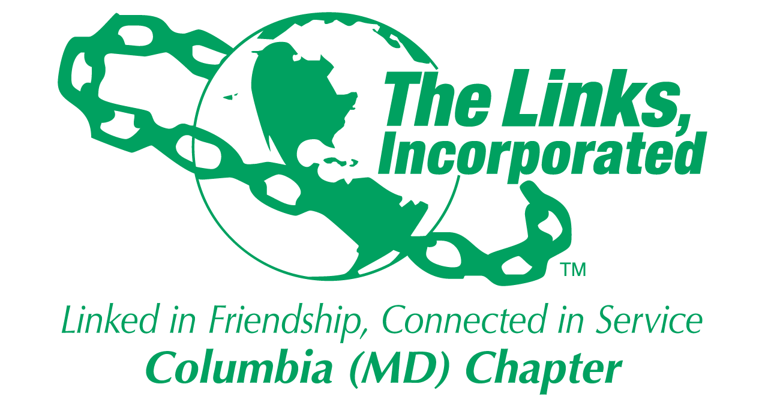
AGENDA
May 11, 2019
Chapter Meeting

Linkspiration
Adoption of the Agenda
Approval of April 13, 2019 Minutes
Correspondence
President’s Report
Vice President’s Report
Financial Secretary’s Report
Treasurer’s Report
Ethics Presentation
Friendship Ceremony
New Business

