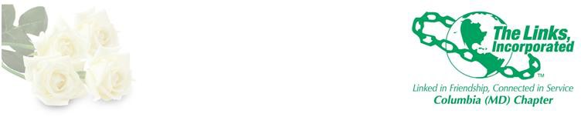

OFFICERS
Lenaye Lawyer
President

Rochelle Michaux-Conway
Vice President

Myra Smith
Recording Secretary

Tanya Sellers-Hannibal
Corresponding Secretary

Cestaine Glover
Treasurer

Vivian Lawyer
Financial Secretary

FUNDRAISING COMMITTEE
Shanna Travis, Chair Judy Smith, Co-Chair Elizabeth Clark Adams Kathy Adams Seay Shavon Arline-Bradley
Germaine Bolds-Leftridge Gail Clark
Regina Clay
Lisa Cooper-Lucas Cestaine Glover Regina Little Hollis Lisa Loury-Lomas Veronica Morrow Sharon Pinder Myra Smith

AGENDA

November 27, 2018
2018 Fundraising Committee Meeting

- Adoption of the Agenda (Link Judy)

- 13th Annual Jazz Brunch “Hot Wash”

- Fundraising Next Steps

  - Process for Moving Forward
  - Review and Comments from Chapter Meeting Exercise
  - Review of Proposed Fundraising Activities

- New Business

- Adjourn

PO Box 1517
Columbia, MD 21044 www.columbiamdlinks.org columbiamd@linksinc.org

