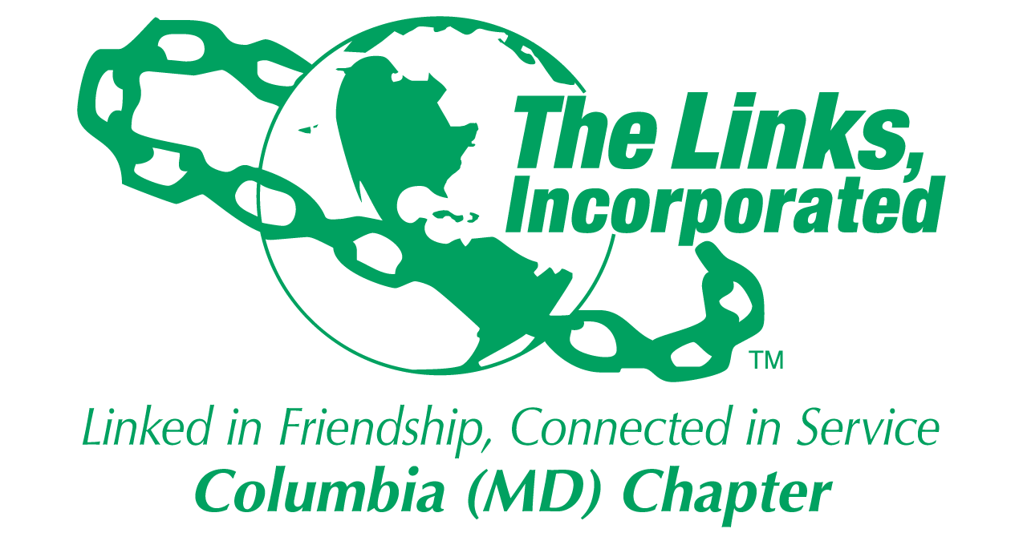
Facet/Committee Reporting Form
Name of Facet/Committee: Services To Youth Committee
Date/ Time/Location of Meeting: Conference Call held on March 4, 2019 at 6:30 pm
Members Present: Carolyn Brown-Jackson, Shaydra Robinson, Muriel Mitchell, Robin Steele, Lisa Carter-Harbour, Harriet Lee, and Diane B. Martin
Summary of Meeting (Dot Points):
Goal  (Specify if Short, Mid or Long Term) | Activity Progress with Completion date | Assumption Changes | Progress on evaluation | Needs - Specify or Update on Resource Needs (Both Internal and External) | Action items/ Items (Please Specify If Chapter Vote Is Required)
Provide mentoring support to students at Jeffers Hill MESA | Meet with 25 students on a weekly basis on Mondays from 3:30 to 5:30 pm to support MESA |  | Can You Imagine Me? is scheduled for April 8th  Closing ceremony for students and families is scheduled for April 15th. | Link Sisters are asked to  attend the MESA competition on April 2th at the Oakland Mills Interfaith Center and support our MESA students.
Provide tutoring and reinforce social skills at Hammond Middle School | Program meets on Wednesdays from 3:00 to 4:30 pm. Snacks will be shared by Links. | The Health Facet will do a presentation on April 3rd with# Girls Magic. | Next meeting date is Wednesday, March 6th from 3:00 -4:30 pm. | Looking for a closing activity for the # Girls Magic! Date we are looking at are April 29th | We are investigating whether or not to visit the National Museum of African American History and Culture or see a play at the Fords’Theater.
Scholarship Applications have been duplicated and have been placed in pony envelopes and distributed to all twelve high schools. We have some copies for you to distribute to churches, and community organizations. | Qualifications – 2.5 grade point average.  Signed application  Two letters of recommendation  Current high school transcript  Signed by parent and applicant  Essay of 500 words or less  Along with a resume | One combined application for both a Historically Black College or University Applicant or an applicant for Howard Community College has been developed, printed and distributed. | Deadline for submission is April 1, 2019. | Applications will be reviewed after our next Links meeting scheduled for April 13th.  Where? The place is to be determined.
 |  |  |  |  | .
Signature of Facet/Committee Chair:
Dr. Abbie Diane Martin, STY Committee Chair _______________________________________________________________________________________________________ Date: February 9, 2019
*Please submit this report at Chapter Executive Committee Meeting
Or
Email to Chapter President and to Chapter Recording Secretary

