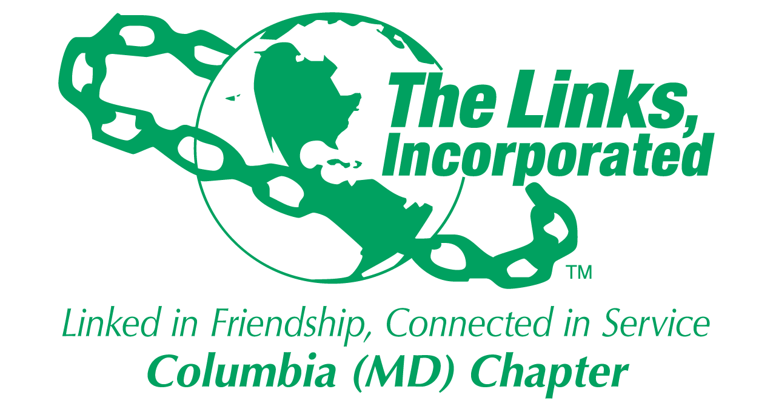
Membership Committee Report
Name of Facet/Committee: Membership Committee
Date/ Time/Location of Meeting: September 27, 2017
6328 Daring Prince Way, Columbia, MD. 21044

Members Present: Cathy Bell, Roslyn Brock, Carolyn Brown-Jackson, Valda Christian, Julie Dixon, Lenaye Lawyer, Lisa Loury Lomas, Rochelle Michaux-Conway, Muriel Mitchell, Avolon Moses, Wanda Nelson, Rhonda Ricks, Tanya Seller-Hannibal, Grayce Simmons, Robin Steele
Summary of Meeting:
Membership Updates-
  - New Member Intake: We received 10 Candidate for Membership Forms by the September 25th midnight submission time frame. Two candidates are daughters of links.
    - Candidate/Sponsor: Elizabeth Victoria-Ellen Adams/ Gail Clark, Schedana Lisa Bindra/ Donna Robinson, Lisa Harbour Carter/ Lenaye Lawyer, Laura Crandon/ Rebecca Reed, Jewel C. Debnam/ Robin Steele, Deidre Carr Johnson/ Cestaine Glover, Regina Little-Hollister/ Kathy Seay, Jessica Lucas/ Lisa Cooper-Lucas, Shaydra T. Robinson/ Yvette Rooks, Tracye Lynne Smith-Williams/ Diane Martin.
    - Timeline: October 14th – Candidates names will be presented to the Chapter. November 11th – Sponsor will have 2 minutes to present information on their candidate. January 13th - the Chapter will vote on perspective candidates.
  - New Chapter Directory: Link Cathy and Link Roslyn working on this initiative and will provide plan to Madame President and Link Rochelle.

  - Links Resume: The Links Resume forms are still outstanding. Email was sent out to Chapter. Link Robin and Link Valda will be contacting our Link sisters to get their surveys.

Calendar of Events-
  - Social Calendar – 2017-2018: Link Roslyn and Link Cathy are working on this initiative. They will provide a listing of potential activities to Madame President and Link Rochelle by Friday, October 13th.
  - November Friendship Activity: The order to have the Jazz Brunch Listening Party on Saturday, November 11th as our friendship activity, the Membership Committee is asking the Chapter for $3,500 to cover the cost of food and DJ. This would cover the cost for 100 attendees. Rationale – Opportunity for Links sisters to mix and mingle, in addition to entertainment for out of town guests, and an opportunity to put folks in a giving spirit for our mobile giving on Saturday. If this event is at no cost. If opt to charge the cost would be approximately $35/person.
  - December Holiday Event: There was much discussion regarding the December Holiday Event. Link Rochelle did share that Seasons 52 is available on Saturday, December 9th. No decision was made on if, when or where the event would take place. Committee members felt that the Jazz Brunch is not the ideal forum to introduce perspective membership candidates due to the size of the event. We need an event which would allow for candidates to be introduced to Chapter Members.
Link Cathy is to provide additional recommendations.

Upcoming Meetings: Wednesday, October 25th, November 29th 6:30 pm at my home.

Goal  (Specify if Short, Mid or Long Term) | Activity Progress with Completion date | Assumption/ Changes-  Committee Effort | Progress on evaluation | Needs - Specify or Update on Resource Needs (Both Internal and External) | Action items/ Items (Please Specify If Chapter Vote Is Required)
Increase membership to enhance and sustain chapter program and fill skill gaps of current members by at least 10%. | -Received 10 Candidate For Membership Forms for 2017-2018 with 2 being Daughters of Links.  -Identified four members eligible for Platinum status-  -Links Resume | -Eligible Links include Link Zola Boone, Shirley Colvin, Alma Moss, and Iola Smith. | -Sponsors will present information on their candidate on November 11th  -Link Zola securing additional information other Links who may be eligible. | -Provide Links Resume Form to be completed by October Chapter Meeting. This will provide information regarding talent in the Chapter. | -Chapter will vote on candidates for membership on January 13, 2018  Have Links complete electronic copy of resume
Create an environment that promotes enduring relationships among chapter members. | 2017-2018 Calendar Events underway. | - November Friendship Event: Potential Listening Party on Saturday, November 11th  -December Holiday Event opportunity. Activity TBD | -This will be an opportunity to socialize with Links sisters  - Opportunity for Alumnae to participate | -Upcoming activities will be shared and put on website. For standing activities, a team leader will need to coordinate. | -Links Cathy Bell, Germaine Bolds-Leftridge and Roslyn Brock will create social calendar for 2017-2018 with activities to promote sisterhood and friendship.
Maintain Good Relationships with Alumna members | -Invite Alumnae members attended the 12th Annual Jazz December Brunch Holiday Event and Peabody Concert. | -Committee members provided assistance and guidance to alumnae for each event. | -Alumnae members enjoy the opportunity of being included with our activities and assisting as needed. | -Ensure alumnae members receive calendar of events, receive event invitations and are connected to the Chapter.

Signature of Facet/Committee Chair:
Rochelle A. Michaux-Conway
_____________________________________________________________________________________________________
Date: _____October 3, 2017_______________________________________________________
Please Email to Chapter President, Chapter Vice President, Chapter Recording Secretary and Chapter Program Coordinator prior to Chapter Executive Committee Meeting

