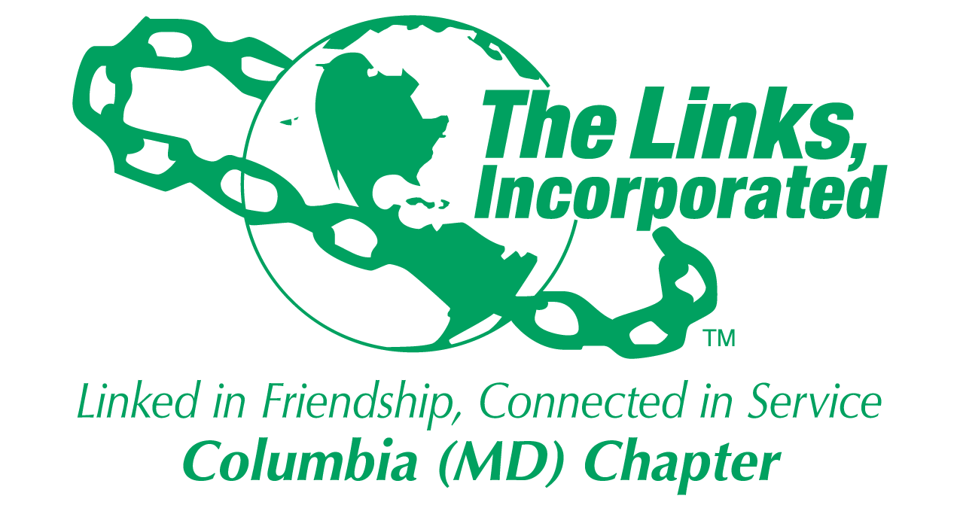
Facet/Committee Reporting Form
Name of Facet/Committee: National Trends
Date/ Time/Location of Meeting: September 26, 2017/8:30 – 9:15 p.m./Conference Call
October 1, 2017/8:30 -9 p.m./Conference Call
Members Present: 6 / 4
Summary of Meeting (Dot Points):
- Facet members would like to continue our program with seniors in our community.
- Facet members would like to initiate a new program that addresses trafficking in Howard County.
- Facet members would also possibly like to explore the feasibility of partnering with the Health and Human Services Facet to plan, develop, and implement a campaign on better sleep hygiene for the black community. (This project was down voted unanimously on October 1st by the 4 attendees so time and resources can be devoted to our seniors and the issue of trafficking).

Goal  (Specify if Short, Mid or Long Term) | Activity Progress with Completion date including Budget | Assumption Changes | Progress on evaluation | Needs - Specify or Update on Resource Needs (Both Internal and External) | Action items/ Items (Please Specify If Chapter Vote Is Required)
Caring for Our Seniors –  Short Term:  -Identify a facility  -Conduct a needs assessment. | 11/15/17 | TBD | TBD | TBD based on the needs assessment. | -Get information from Link Jean on the facility she has in mind.  -Schedule a meeting with the Director, tour the facility, get anecdotal stories of residents’ needs.  -Develop a needs assessment.
Mid Term:  -Plan, develop, & implement activities from the needs assessment.  -Develop an evaluation tool to determine the effectiveness of meeting the needs of the residents. | 12/15/17 | TBD | TBD | -Arts and Crafts materials.  -Other resources TBD once activities are identified. | -Develop a schedule of activities with facet members.  -Identify holidays that may be important to residents and plan activities accordingly.  -Celebrate birthdays of residents.  -Create a user-friendly tool to evaluate the success of the program individually and for the facility as a whole.
Long Term:  -Establish a long term and sustainable relationship with a facility for the Columbia Chapter of the Links Inc.  -Contribute to the general health and well-being of the residents in the facility to reduce:  -stress  -isolation  -depression. | 4/30/18  Budget=$700 | TBD | TBD |  | -Maintain open and constant communication with the director.  -Incorporate the positive feedback and constructive criticism into a plan for the next program year.

Goal 2  (Specify if Short, Mid or Long Term) | Activity Progress with Completion date including Budget | Assumption Changes | Progress on evaluation | Needs - Specify or Update on Resource Needs (Both Internal and External) | Action items/ Items (Please Specify If Chapter Vote Is Required)
Education & Outreach on Trafficking in Howard County  Short Term:  -Educate the Chapter on Trafficking | 11/15/17 | TBD | TBD | Speaker Fee | -Identify a speaker to give a 30 min-60 min presentation to the chapter.  -Schedule for a chapter mtg
Mid Term:  -Plan, develop, & implement an education and outreach strategy for the community.  -Develop an evaluation tool to determine the effectiveness of the trainings. | 12/15/17 | TBD | TBD | TBD | -Develop a schedule with facet members to attend at least 3 local community meetings, e.g., Jack and Jill, HCCC, AKA Teen Summit, our STY facet attendees.  -Create an evaluation that indicates the training (s) increased the attendee’s knowledge about trafficking.
Long Term:  -Make more Howard County residents aware of the perils of trafficking.  -Provide young girls and boys with tools to reduce the likelihood of being approached by traffickers. | 4/30/18  Budget = $250 | TBD | TBD |  | -Develop relationships with local, state, and national allies on a coordinated community response.  -Collaborate with the Trafficking program with Links, Inc.

Signature of Facet/Committee Chair:

________________________________________________________________________________________________________
Date: ____________________________________________________________
Please Email to Chapter President, Chapter Vice President, Chapter Recording Secretary, and Chapter Program Coordinator prior to Chapter Executive Committee Meeting

