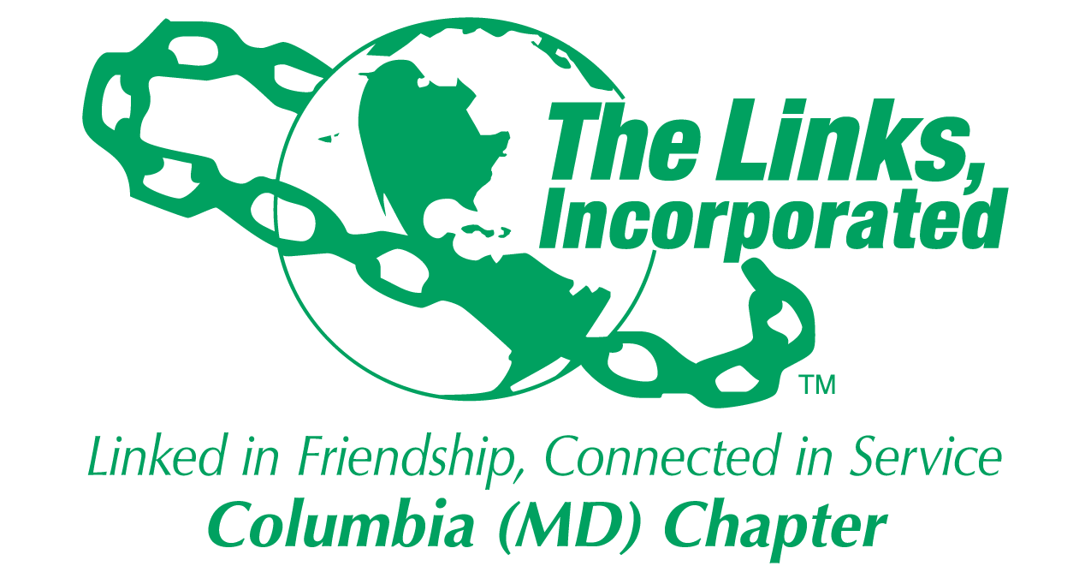
Facet/Committee Reporting Form
Name of Facet/Committee: Fundraising Committee
Date/ Time/Location of Meeting: March 12, 2019 Executive Committee Report (ref: March activities)
Members Present:
- March 12, 2019 Meeting
Regina Clay, Lisa Loury-Lomas, Germaine Bolds-Leftridge, Elizabeth Clark-Adams, Gail Clark, Lenaye Lawyer, and Judy L. Smith

Summary of Meeting (Dot Points):
- We summarized the March Chapter meeting as relates to the Fundraising Committee’s tasking:
  - The Chapter voted to
    - A $750 Fundraising Assessment due in October 2019 (assume that means by October 31, 2019)
      - Only Fundraisers that occurred before October 31, 2019 could have the “tax deductible” portion (per ticket) applied to decrease the member’s assessment
- The Committee’s identified and the Chapter voted on the following two events for Chapter fundraising:
  - Merriweather event (July 6,2019) featuring Soulful Symphony and Darin Atwater (Assuming 200 tickets sales, the following is a breakdown of the $160 per ticket price: $60 for the actual cost of the seat, $46 (really $45.09 rounded up) for the reception, and $54 for proceed to the Chapter – total funds (after expenses) raised with selling 200 tickets $10,982.00)
  - 18th and 21st (still unconfirmed with the owner) with estimated proceeds of somewhere between $11,000 and $12,000
  - There was a significant amount of discussion on Merriweather event to include:
    - Discussion on the reception details (location, food, etc.)
    - Whether Darrin Atwater would be attending the reception (we believe yes but will confirm)
    - To be a viable fundraiser, we discussed that a minimum of 100 tickets should be sold (total event profit estimated to be $5,491).
      - We have to ensure that we do not put the Chapter in any financial risk
        - Contracts written so all deposits to Merriweather are due after (on or after June 1, 2019) we have had time to collect the funds
        - We tentatively set the date for all ticket purchase monies to be paid by May 31, 2019:
    - “Stay at Home” Tea
- The Committee is turning its attention to the fundraising Goal #2 - Support Chapter Efforts to Create a Culture of Giving. Periodically conduct mini-seminars on fundraising, leadership and how to create a culture of giving.
  - We discussed having sessions on the following:
    - Fundraising roles
    - Diversity in activities aimed at increasing our visibility in the community
    - Establishing relationships with potential sponsors
  - We discussed having a joint meeting with the Strategy Committee. The objective of the meeting would be to discuss how to better align Strategy and Fundraising to ensure:
    - Facet and Committee plans are aligned with fundraising goals and objectives
    - Incorporated higher community visibility into our Chapter programs and activities
    - Develop alternative methods to engage members in volunteerism
  - We discussed also establishing a better alignment with the Communications Committee in reference to:
    - Press Kits
    - Marketing Collateral
- Focus from now to May 1st
  - Finalize 2019-2020 fundraising activities if possible
  - Set up joint meetings with Communications and Strategy Committees and begin work on mini-presentation for the Chapter to encourage a “culture of giving”
  - Continue to work on transition planning

Goal  (Specify if Short, Mid or Long Term) | Activity Progress with Completion date including Budget | Assumption Changes | Progress on evaluation | Needs - Specify or Update on Resource Needs (Both Internal and External) | Action items/ Items (Please Specify If Chapter Vote Is Required)
Transition Planning | Continue collecting lessons learned and material to complete transition plan checklist and standard file-structure | None | Collected some material but still have to collect for all fundraising functions | Time | No Chapter Vote required
Encourage a “Culture of Giving” | Engage both Strategy and Communications Committee | None | Need to develop mini-seminars to present to chapter | Time | No Chapter Vote Required
Information and Collateral Identification and Generation | Work with STY and Communications to create fundraising collateral | None | Need to determine what information we have and what information we need to collect | Time | No Chapter Vote Required
Finalize Fundraising Activities | What Now? | Assessment will be needed no matter what the fundraising option will be | Is a “Stay at Home” Tea Viable? | Time | Chapter Vote required  Judy to Research Elements of a Stay at Home tea
Signature of Facet/Committee Chair: Judy L. Smith
Date: March 31, 2019
Please Email to Chapter President, Chapter Vice President, Chapter Recording Secretary and Chapter Program Coordinator prior to Chapter Executive Committee Meeting

