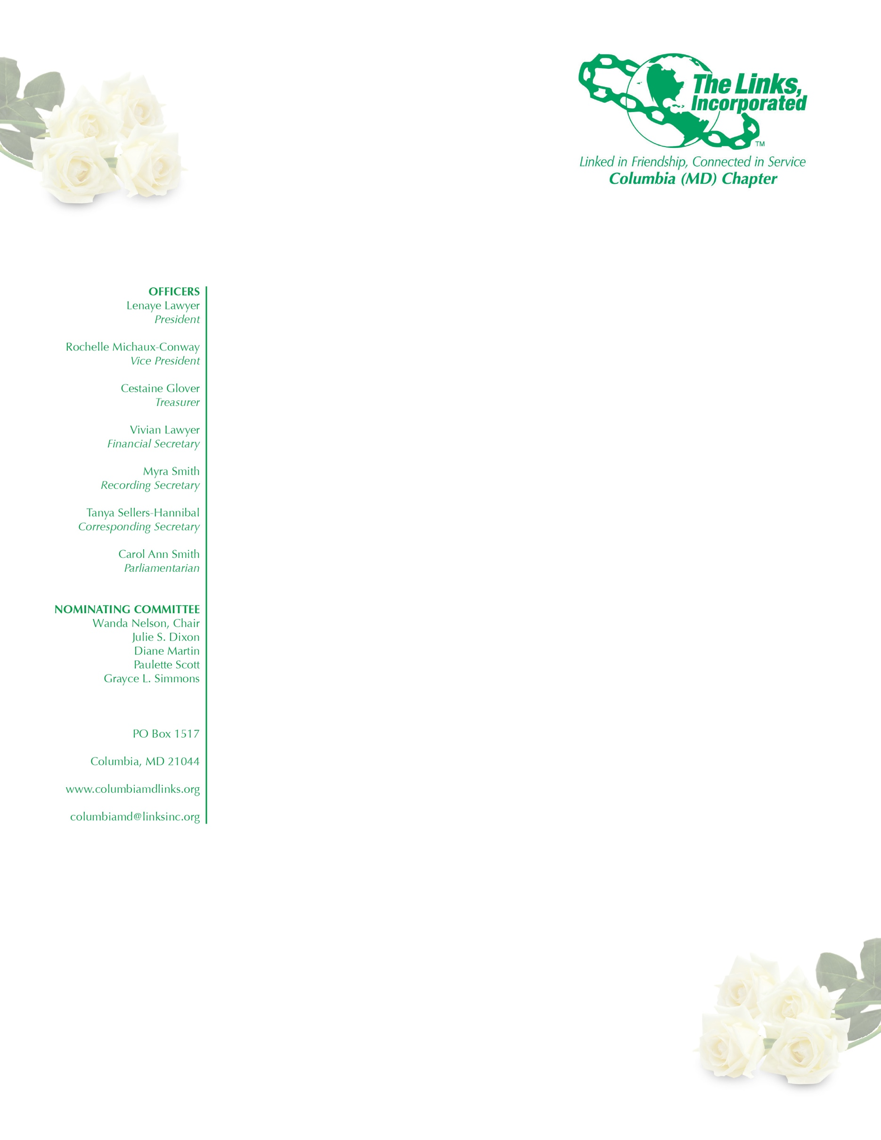
AGENDA

January 12, 2019
Chapter Meeting

Links Pledge and Song

Linkspiration

Adoption of the Agenda

Approval of the Minutes of the November 10, 2018 Meeting

Correspondence

President’s Report

Vice President’s Report

New Membership Business

Financial Secretary’s Report

Treasurer’s Report

Fundraising Committee

Strategic Planning Committee

The Arts

Health and Human Services

International Trends and Services

Services to Youth

New Business

Joys and Concerns

