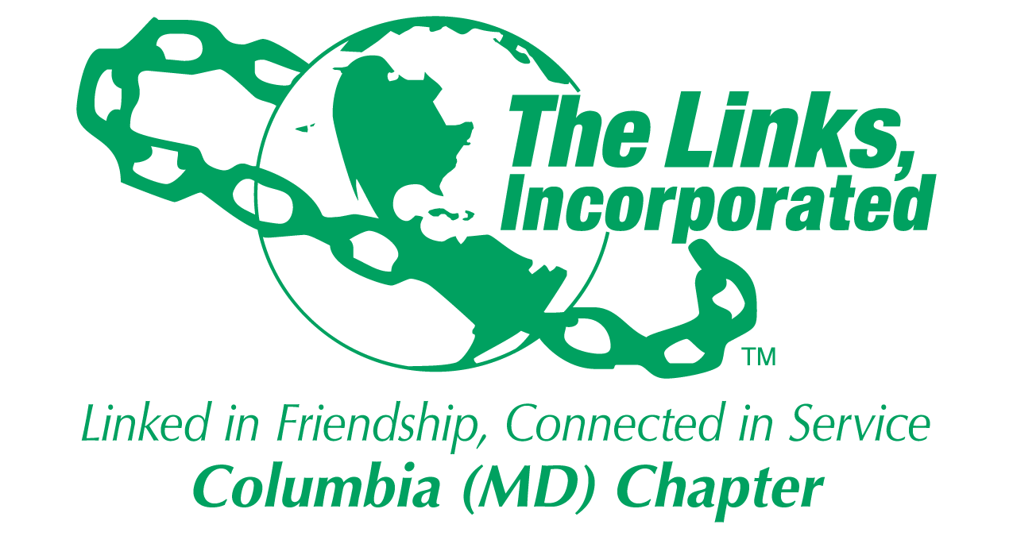
Facet/Committee Reporting Form
Name of Facet/Committee: Services to Youth Facet
Date/ Time/Location of Meeting: Phone conference
Members Present: Gail Clark, Cestaine Glover, Harriet Lee, Carolyn Brown-Jackson, Shanna Travis, Diane Martin
Summary of Meeting (Dot Points):
Goal  (Specify if Short, Mid or Long Term) | Activity Progress with Completion date | Assumption Changes | Progress on evaluation | Needs - Specify or Update on Resource Needs (Both Internal and External) | Action items/ Items (Please Specify If Chapter Vote Is Required)
The “For Girls Only participants engaged in a lesson on etiquette and table setting by participating in a tea. It was led by Links Shanna, Rhonda, Judy, Fran, and Carol A. Smith | A scholarship program was presented by Link Shanna’s alma mater and pearls were given to each participant by Link Judy Grant. |  |  | We need a Link sister to take the lead on the For Girls Only Program.  If interested, let Link Diane know. | No vote is needed.
All Chapter member chapter members were invited to participate in the selection of the next two scholarship recipients. | All scholarship applications were due on April 28, 2017. | The Scholarship committee met on Sunday, May 7, 2017 at 1:00 at Link Cestaine Glover’s home | One student will be selected, to attend Howard Com College and one will be selected to attend an Historically Black college. | Marcus Anderson was selected as our HBCU scholarship winner for $2500.00. He will attend Hampton U.  Ms. Kendall Purdue was awarded the Dana Bindra Scholarship and she will attend Spellman. | No vote is needed.
Our 26 MESA students at Jeffers Hill Elementary competed in the county-wide MESA day competitions on March 24th. | Our students finished in 2nd place in three categories: Effective communications after researching diabetes and obesity. The Scratch team’s work was related to cybersecurity, and the final team’s competition was a Storybook theme park ride developed after reading Jungle book. | An artist from the Columbia Art Center visited our MESA students and asked if they would like to participate in the Columbia 50 Center celebration. The students consented to meet an extra week to do an art project.  Their projects will be on display on Sunday, September 17th from 1-2:30 pm.  Please join us in celebrating our MESA students with STEAM! | MESA students developed art projects in conjunction with teachings from Monica Herber from the Columbia Art Center, which took place on April 26th. Their art projects were building a new village in Columbia in celebration of Columbia’s 50th! | Chryston Otubu, our HBCU recipient will attend University of Maryland Eastern Shore for Fall 2017.  Kiya Fields was our HCC recipient.  Kendall Davis and Keana Richards received book awards in the amount of $500.00. | Keana Richards graduated early from college. Our book award is for three years, so we need to vote on her receiving the book award as she enrolls in graduate study at University of Penn.  All scholarship recipients will be invited to submit a video discussing their accomplishments and future plans for showing at our Jazz Brunch. If you have seats at your table for them and/or their families, let me know.

Signature of Facet/Committee Chair: Date: ________May 2017_______________________________ Next meeting September 6, 2017 --6:30 pm @ Seasons 52
*Please submit this report at Chapter Executive Committee Meeting Or Email to Chapter President and to Chapter Recording Secretary

