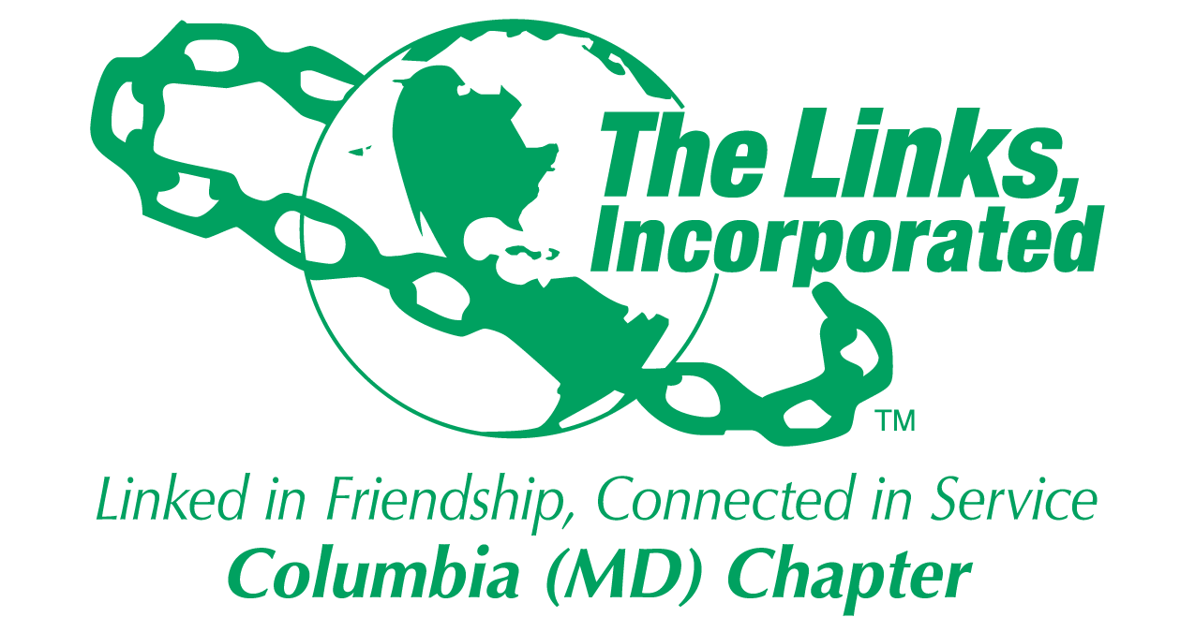
Facet/Committee Reporting Form
Name of Facet/Committee: Services to Youth Facet
Date/ Time/Location of Meeting: Seasons 52
Members Present: Harriet Lee, Carolyn Brown-Jackson, and Diane Martin Robin Steele met via phone conference
Summary of Meeting (Dot Points):
Goal  (Specify if Short, Mid or Long Term) | Activity Progress with Completion date | Assumption Changes | Progress on evaluation | Needs - Specify or Update on Resource Needs (Both Internal and External) | Action items/ Items (Please Specify If Chapter Vote Is Required)
The “For Girls Only participants will be engaged in a lesson on social responsibility and self-esteem building at the Teen Center of Oakland Mills. | Next For Girls Only Session is April 28th. Topic: The Beautiful Me Inside and Out  Led by Links Rhonda Ricks and Carolyn Brown-Jackson | Each activity session begins at 5:00 pm and ends at 6:30 pm. | The lesson is regarding self-governance and influence. Their activity will be centered around discussion and then writing about their own Constitution. | Must decide on Culminating Activity:  For Girls Only Spa Party  Fine Dining Workshop after an etiquette workshop at The Barn  A Jewelry Making Party | No vote is needed.
All Chapter members are invited to participate in the scholarship selection. One will be selected, who will attend Howard Community College and the second one will be selected to attend an Historically Black college. | All scholarship applications were due March 31, 2018. | The Scholarship committee met on Saturday, April 7, 2018 at Link Robin’s home. | The Scholarship recipients are: Kafayat Alli of Reservoir HS and Soffeyah Lloyd of Oakland Mills HS |  | No vote is needed.
Our 26 MESA students at Jeffers Hill Elementary will compete in the county-wide MESA day competitions on April 19, 2018 at The Meeting House in Oakland Mills.  The address for the competition is:  5885 Oliver Place  Columbia, MD 21045 | Their competitions include: Effective communications where students will raise awareness about a global, national or local issue or concern. The Scratch team’s work was related to cybersecurity, another competition is Storybook theme park ride and the last one is designing and building a bridge which will hold the most efficient (load/mass). | The next two MESA sessions at JHES are:  April 17th then….  The competition site is different from last year’s site at JHU APL.  It will be held at the Meeting House in Oakland Mills Village. | Several Links have participated in the training held on March 28th.  If you are interested in judging, let Diane Martin know. | Upcoming MESA events:  JHES Day of Taste  Can You Imagine Me?  Tuesday, April 24th  Can You Imagine Me?  Tuesday, May 1st  Closing Ceremony w/ parents – May 8th | No vote is needed.

Signature of Facet/Committee Chair: Date: ________April 12, 2018_______________________________ Next meeting May 1 , 2018 6:30 pm @ Seasons 52
*Please submit this report at Chapter Executive Committee Meeting Or Email to Chapter President and to Chapter Recording Secretary

Good Day,

Attached are the letters for those who were selected and those that were not selected. Lenaye, please let me know if I need to do labels for you to mail out. Diane has agreed to present the awards at the High School recognition programs once we find out the dates. The letter you sent over for Howard Community college recipient appears to be the one when you send the check to the recipient. I did not want to change it unless you need me to so that it looks similar to the HBCU scholarship recipient letter.

The deadline for the scholarship applications was March 31, 2018. The scholarship committee (Gail Clark, Carolyn Brown, Cathy Bell, Diane Martin and Robin Steele) met at the home of Robin Steele on Saturday, April 9, 2018 from 11:00 a.m. until 2:30 p.m. to review the applications. The committee received 26 applications from 9 out of 12 Howard County high schools. Two of the applications only had one recommendation versus the two that were required.

For the HBCU scholarship recipient, Kafayat Alli of Reservoir High School holds a 4.10 weighted GPA and unweighted GPA of 3.55. Captain of Track and Field (lots of great accomplishments in track for both indoor and outdoor) , student tutor and she participated in Upward Bound Math and Science program at Howard University. Member of Delta Scholars, Black Student Achievement Program, Reservoir African Student Association and Environmental Club. Honor Roll for the past 7 years and member of the National Honor Society for both 11th and 12th grades.

For the HCC scholarship recipient, Soffeyah Lloyd of Oakland Mills High School holds a 4.24 weighted GPA and unweighted GPA of 3.71. She is an SGA Representative, member of Chamber Choir, Concert Coir and GT Honor Choir. Leader of Black Student Union, National Honor Society member, 1st place winner of Champions of Courage Essay Contest on Dr. Martin Luther King, Jr., 3rd place winner of Congressional Black Caucus Essay Contest.

Diane please use this as part of your report on Saturday.

