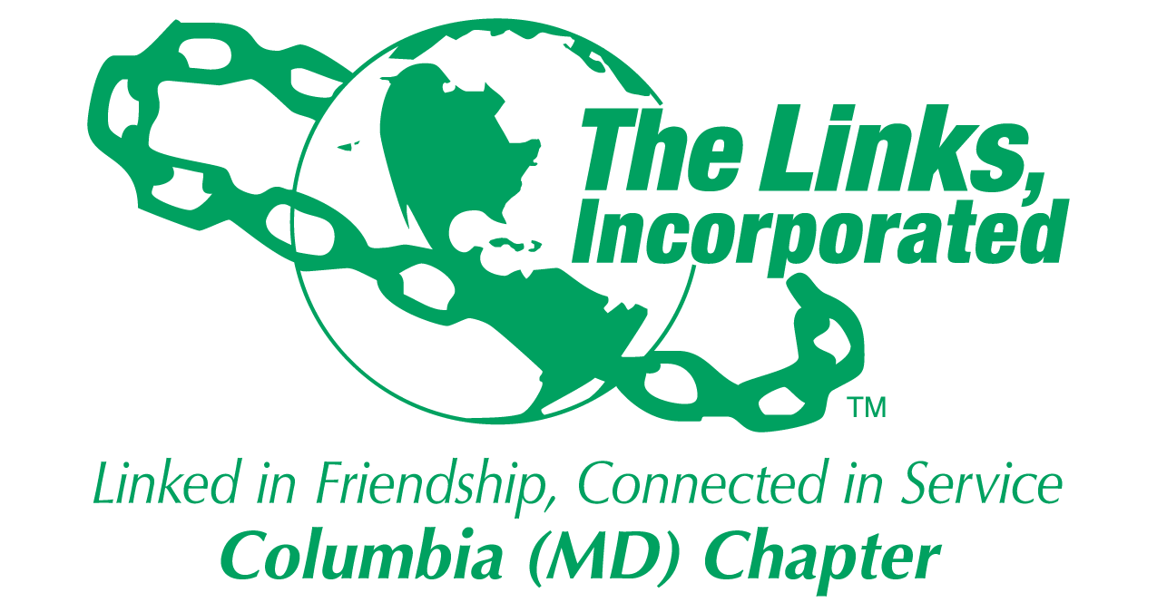
Facet/Committee Reporting Form
Name of Facet/Committee: Membership Committee
Date/ Time/Location of Meeting: February 26 Via Zoom
Members Present:
- February 26
Regina Clay, Tanya Sellers Hannibal, Rebecca Reed, Regina Little, Robin Steele, Jo Emily Knox, Paulette Scott, Chin Watson, Jewell Debnam

Summary of Meeting (Dot Points):

- Discussion about LOA Request from Link Lindiwe and Resignation from Link Yolanda Sonnier
- Discussed having Letters read to Chapter and the decision was to read the letters but advise the members that their letters will be read.
- Discussion about our next Monthly Activity
- Link Jewell shared about Next Gen initiatives
- There was discussion about hours and inputting into Track it Forward and that National is now requesting they be input Monthly

- Focus from now to April 2024
  - Calendar for Monthly Meeting activity
  - Track it Forward learning at the Chapter Meeting
  - Plan a closing Membership activity

Goal  (Specify if Short, Mid or Long Term) | Activity Progress with Completion date including Budget | Assumption Changes | Progress on evaluation | Needs - Specify or Update on Resource Needs (Both Internal and External) | Action items/ Items (Please Specify If Chapter Vote Is Required)
Membership Intake | Vote at August Membership Meeting based on Needs Assessment | None | Needs assessment reviewed | Begin discussion about Membership intake in April | Executive Board Vote Required and Chapter Vote Required
Membership Monthly Activities | Completed one monthly activity that was very well received | None |  | Tine | No Chapter Vote Required
Signature of Facet/Committee Chair: Regina Clay
Date: February 28,2024
Please Email to Chapter President, Chapter Vice President, Chapter Recording Secretary and Chapter Program Coordinator prior to Chapter Executive Committee Meeting

