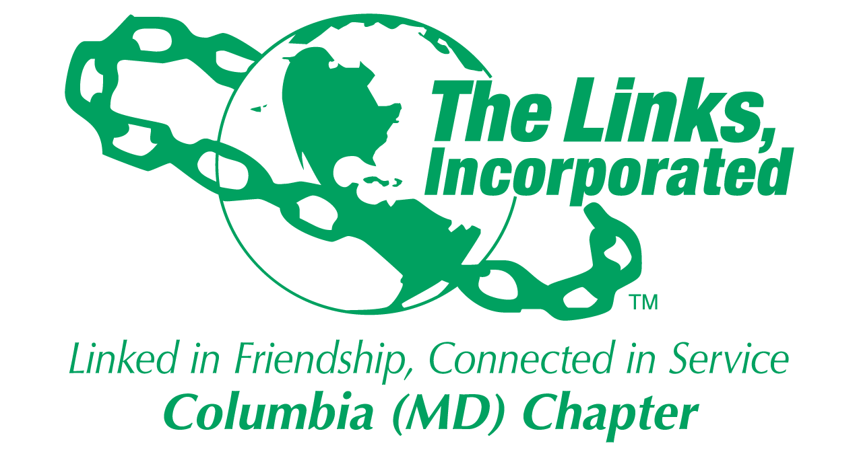
Committee Reporting Form
Name of Committee: Strategic Planning

Date/ Time/Location of Meeting/Activity
- Not applicable

Member Attendees (List)
- Not applicable

Committee Activities
Consent Agenda
- Prototyped the consent agenda during the January Chapter Meeting
- Launched the consent agenda during February Chapter Meeting
- Made refinements and adjustments in February, plan to implement those adjustments during the March Chapter Meeting
  - Voting to approve the consent agenda
  - Asking if there are any questions, etc. consistent with Robert Rules of Order

Chapter Newsletter
- Working with Madams President and Vice President to re-launch the Chapter newsletter
- Proposed process highlights:
  - Newsletter process owner is TBD
  - The newsletter will be sent out every two weeks
  - All facet, committee and member email, notices, and communications should be sent out via the newsletter
    - Exceptions to this guidance may be approved by the President or her designee
    - The Chapter president can send notices, email etc. at any time
  - All newsletter content should be reviewed, spell-checked and submitted in the proper format or the content will be returned to the sender for correction
  - Will be sent out on 2nd and 4th Mondays of each month. Content must be received by the newsletter task owner by the Saturday before the newsletter will be published. If the deadline is missed the content will be sent out in the following newsletter of the month
- More to follow once the process and other details are finalized

Chapter Training:
- What: Chapter-wide Team Building Training
- Who: All active Chapter members are asked to participate
- When: Tentatively scheduled to be conducted during the April Chapter Meeting (April 13, 2024)
- How: The training will be facilitated by Tracey Rogers and will be about 1 hour in duration
- Why: As a result of our engagement survey, the Chapter had a goal to create an environment that fosters engagement and Strategic Priority #4 is contributing to reaching that goal with team building training as one of the steps.
- In addition, during the upcoming weeks, please expect the following:
- Informational emails providing details of the upcoming training to include:
  - Training pre-work that is scheduled for some time in March
    - reading the training overview
    - 20 questions that each Chapter member must answer. Estimated duration is less than 30 minutes
  - Training to be administered during the April Chapter meeting

Chapter Strategic Planning:
- Strategic planning is starting to “gear up” the planning process
  - Trying to locate environmental data to send to each facet in preparation for an environmental assessment before we launch into planning for FY25 fiscal year.
  - Plan to send an information strategic planning email out to the facets and committees sometime in March

Activity Objective(s) | Total # of attendees:  - # of children:  - # of adults: | Resources Utilized | Outcomes
For Each Activity: NO Activities

Optional
- Additional Comments
- Testimonials
- Photos (attached)

Signature of Committee Chair: Judy L. Smith
Date: February 24, 2024
Please Email to Chapter President, Chapter Vice President, Chapter Recording Secretary and Chapter Program Coordinator prior to Chapter Executive Committee Meeting

