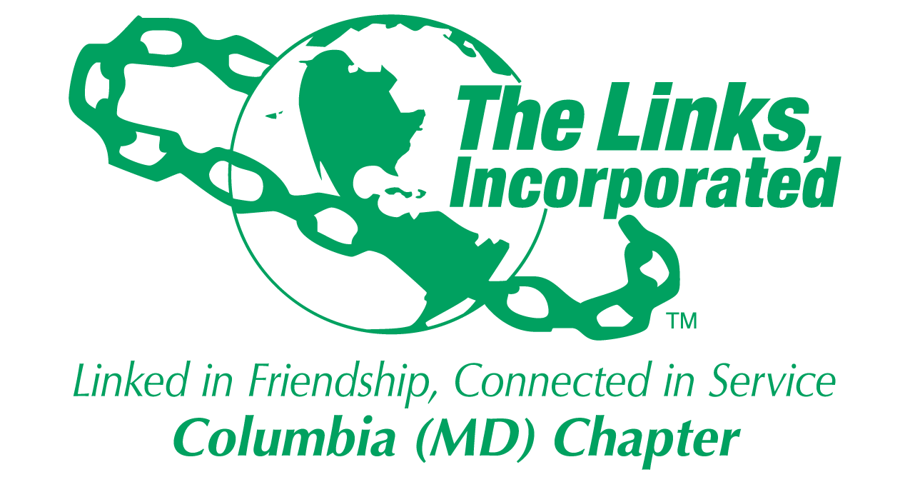
Facet and Committee Reporting Form
Name *Eastern Area Parliamentarians Monthly Meeting
Chapter Bylaws Committee
Date/ Time/Location of Meeting/Activity February 22, 2024, ZOOM
Member Attendees (List)
*VIVIAN MOORE LAWYER, PARLIAMENTARIAN AND 28 OTHER AREA PARLIAMENTARIANS
Summary of Meeting/Activities (Dot Points):
- EA Parliamentarians’ Meeting
    - Presentation on the Hierarchy of Governing Documents (video tape of the meeting is in this month’s folder

- Chapter Bylaws Committee Meeting to be Determined

Needs to have a discussion about recommendations made by the Eastern Area reviewer of the Chapter’s Bylaws
Needs to develop a plan (no later than April Chapter meeting) for making modifications to Chapter Bylaws and Standing Rules (March – October 2024)

- Consider Area recommendations
- Determine chapter members’ views and recommendations for modifications and possible amendments
- Consider chapter procedures developed in the past 2-3 years and customs from years past
- Review proposed amendments for the National Assembly and make recommendations to the chapter
- Review adopted amendments from the National Assembly and incorporate as appropriate
- Proposed modifications and amendments no later than National deadline for modifying based upon National Assembly actions

Activity Objective(s)  CONSISTENCY IN CHAPTER BYLAWS MEASURED BY THE TEMPLATE DESIGNED BY THE NATIONAL PARLIAMENTARIAN  Chapter Bylaws Committee meeting to be determined | Total # of attendees:  - # of children: NONE  - # of adults: 28 | Resources Utilized  TIME SPENT IN A ZOOM MEETING WITH UPDATES AND A PRESENTATION ON MOTIONS | Outcomes  CHAPTER PARLIAMENTARIANS ARE BROUGHT UP TO DATE ON NATIONAL DIRECTION FOR BYLAWS
For Each Activity

Optional
- Additional Comments
- Testimonials
- Photos (attached)

Signature: Vivian Moore Lawyer, PARLIAMENTARIANDate: February 27, 2024
Please Email to Chapter President, Chapter Vice President, Chapter Recording Secretary and Chapter Program Coordinator prior to Chapter Executive Committee Meeting

