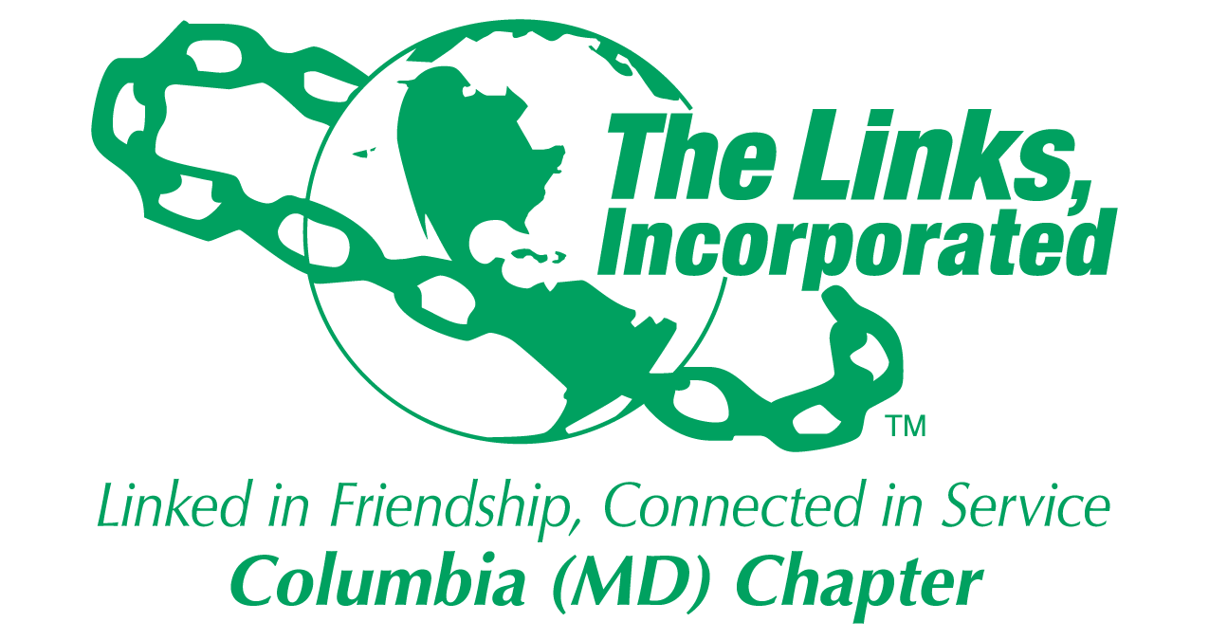
Facet Reporting Form: February 2024
Name of Facet: Services To Youth

Date/ Time/Location of Meeting/Activity: Wednesday, February 21, 8:00PM ET via Zoom, Monthly Facet Mtg

Member Attendees (List): Cathy Bell, Chinyere Watson, Donna Staton, Lucinda Marie Ware, Rebecca Reed, Regina Little Hollis, Audra Nixon, Greta Peoples

Summary of Meeting:

STY Budget: 2023 - 2024
Restricted (Scholarship/Programming) | Actual to Date | Budget
Scholarships | 20,000 | 20,000
MESA | 2,000 | 2,000
Other Programming | 1,186 | 2,000
HBCU | 1,350 | 1,350
TOTAL | 24,536 | 25,350
Expenses: $384.78 (Holiday Reception, 12/21/23), $429.20 (Summer Reception, 6/11/23)

Restricted (Scholarship/Programming) | Actual to Date | Budget
Horizon Foundation Grant | 5,000 | 5,000

Unrestricted (Operating) | Actual to Date | Budget
Scholarship Committee | 20.42 | 100
Expenses: $79.58 (Printing, Scholar Profile Cards, gold frames)

STY Budget: 2024 - 2025
 | Approved | 2023 – 2024
Scholarships | 25,000 | 20,000
MESA | 2,000 | 2,000
Other Programming | 2,000 | 2,000
HBCU | 1,350 | 1,350
TOTAL | 30,350 | 25,350

Restricted (Scholarship/Programming) | Actual to Date | YAG
Umbrella Program | 5,000 | 0

- Current balance for 2023/24 STY Other Programming is $1,186.02. Discussed how we would spend this balance by 4/30. After considering several options, including donating funds to HCC (e.g. R.I.S.E., Helping Hands Emergency Fund, current endowment fund), care packages for Scholars, EOY gifts for BSU leaders, and giveaways at Mental Health Forum, we agreed to use $1,000 for another scholarship award for Scholar Logan Forrest. We will notify her of this special award in March.
- Need to make sure we submit outstanding vouchers by 4/29. (All)
- Find out timing to submit for 25/26 budget to ensure we meet chapter deadlines. (TBD)

Umbrella Program
Mental Health Forum (Thursday, April 25, 3:00 – 6:00 p.m., HCC, Kittleman Room, Duncan Hall (DH100))
- Link Yvette Rooks will be leading this initiative. Expert panelists have been confirmed. STY will be working with HHS to finalise their involvement in this effort.
- The preliminary format of this in-person forum will be:
  - 3:00 - 3:15PM Welcome and Purpose
3:15 - 3:35PM Keynote Speaker: Sleep and the Impact on Mental Health and Academics (Dr. David Driver)
  - 3:40 - 4:05PM Break Out Session 1:
    - ADHD vs Anxiety: The Differences in Diagnosis and Treatment (Dr. Yvette Rooks)
    - Suicidality In The Young Adult (Dr. David Driver)
    - Therapy 101: How Can I Benefit? (Mr. Christopher Williams LCSM-C)
  - 4:05 - 4:15PM Refreshment Break
  - 4:15 - 4:35PM Mindfulness and Mediation As A Means of Managing Stress (Dr. Kristi Hall)
  - 4:40 - 5:05PM Break Out Session 2:
    - ADHD vs Anxiety: The Differences in Diagnosis and Treatment (Dr. Yvette Rooks)
    - Suicidality In The Young Adult (Dr. David Driver)
    - Therapy 101: How Can I Benefit? (Mr. Christopher Williams LCSM-C)
  - 5:05 - 5:15PM Refreshment Break
  - 5:15 - 5:45PM Panel Discussion: Dr. Driver, Dr. Rooks, Dr. Hall and Mr. Williams
  - 5:45 - 6:00PM Closing Remarks

- STY requested that students interested in attending this forum register in advance to help us finalize how many facilitators we will need, food/beverage we need to purchase, and final room set-up. We will discuss specifics on how to get/track registration at next meeting. The ideal date we will need to confirm headcount is 3/15.
- An invitation will be extended to EAD Lisa to participate in this forum (e.g. panel moderator)
HBCU Documentary Showing: “Tell Them They Are Rising: The Story of Black Colleges and Universities” (Wednesday, February 28, 5:00 – 7:30 p.m., HCC, Smith Theatre, Horowitz Visual & Performing Arts Bldg)

HCC BSU requested we assist in securing 2-3 HBCU recent alum to serve on a panel immediately following the documentary. STY has confirmed 3: Bailey Roberts, Emerson Daniel, and Robert Davis.

STY will provide healthy snacks for this event from Panera. Expected # attendees: 50.

Chapter members are welcome to attend. Need to identify volunteers to attend event for support purposes and snack set-up.

Linked To Success: Tools for Navigating the Search for Your Dream Career (Sunday, February 18, 4:00 – 5:30 p.m., via Zoom)
- BSU Students were invited to participate in this virtual career development session.

National Trends
- Food Drive: NTS has already donated $300 to the on-campus food panty to purchase necessary food items.
- Voter’s Registration: NTS will coordinate with the HCC Student Affairs office for voter registration.

MESA Update
- Currently sponsoring one teacher at Bryant Woods Elementary.
- Students are in competition mode with a deadline to submit their projects for judging by 11:29 PM, March 20th.
- The Howard County MESA Showcase and Awards Ceremony will be held on Saturday, April 6 at Howard High School.
- All participating elementary schools, including Bryant Woods, will have the opportunity to compete in 4 different competitions: Wearable Technology Challenge, Planetary Lander Challenge, Community Cleanup Challenge, or Storybook Theme Park Challenge

Scholarship Application Timeline
  - 01/31: 2024 Scholarship Final Application Released (see Attachment 1 for flyer)
  - 03/27: Scholarship Application Review Training
  - 04/01: Scholarship Application Deadline
  - w/o 4/14 Scholarship Review Process
  - 04/23: Final Scholarship Awards Selection
  - 05/11: Scholarship Award Announcement (Chapter)
  - May: Scholarship Award Announcement (In-School)
- The following members have volunteered to review scholarship applications: Links Cathy, Regina LH, Audra, Carol Ann, Melanie, Lucinda Marie, Carolyn, Marquita, Shaydra. Confirmation letters for volunteers will be distributed by 2/29.
Scholars Programming Calendar
  - 01/21: Virtual Session 1: Resume Writing (Links Donna, Cathy)
  - 02/18: Virtual Session 2: Interviewing/Networking (TBD)
  - 04/07: Virtual Session 3: Career Session (Link Donna)
  - 06/02: Summer Reception (back-up date: 06/10)
- Program evaluation summary for January event is attached (see Attachment 2). Evaluation forms for February event were forwarded to Scholars with a due date of 2/29.
HBCU
Link Chinyere reported on the 2024 DevCon (Development Connection) taking place March 6-8 at the Baltimore Hilton Inner Harbor. This program, in conjunction with the Thurgood Marshall College Fund, is designed to help students develop an executive presence. 400+ HBCU students from around the country will attend this all-expense paid weekend event which includes:

- Ensuring our Democracy (Voter Education): Link Anita Cooke Wells, Chair: (awells@rljlodgingtrust.com). The EA team will be holding voter registration and information for the students during the three day event.

- Lessons of Love (Mock Interviews and Resumes) March 7, 6:00PM – 7:00PM: Link Robin Williams, Chair: (rswilliams50@gmail.com). Students are asked to upload a four question video similar to an interview and answer questions about conflict, failure, and perseverance to be scored in a rubric that will be provided by the committee chair. Some students may require one on one conversations and attentions based upon the answers to their videos. Students can also upload resumes for review. Need completed by the event by March 1.

- The Art of Fine Dining: Link Robin Williams, Chair: (rswilliams50@gmail.com). Students will learn to eat, hold conversations, understand place settings, and how to order food in a professional business setting. The etiquette committee will be creating a booklet to assist with this. Additional assistance is needed.

We will discuss the EA ‘“adopt” an HBCU’ in the Area effort at our next facet meeting. Lead option: Coppin State.

HCC Update: Endowment
- Met Anne Johnson (Executive Director and Director of Development, HCC Education Foundation) and Jarrett Carter (Vice President of External Affairs, Communications and Advancement) on 2/16 to learn more about current Endowment and identify next steps.
- Next Steps:
  - Update current endowment agreement by March.
  - Determine if we will pursue other support opportunities: R.I.S.E., Helping Hands Emergency Fund
  - Plan to engage w/current endowment award recipients in 2024/25.
  - Consider inviting Anne Johnson and Jarrett Carter to give an overview of our relationship w/HCC at one of our upcoming facet and/or chapter meetings.
  - Promote upcoming HCC fundraisers within chapter.
Other
- Facet members encouraged to support upcoming HCC fundraisers (see Attachment 3).

Facet Meeting Calendar
- Wednesday, August 29, 7:30PM ET (Link Audra’s Home)
- Wednesday, September 27, 7:30PM ET (Zoom)
- Wednesday, October 25, 7:30PM ET (Zoom)
- Wednesday, November 29, 7:30PM ET (Zoom)
- Wednesday, January 24, 2024, 7:30PM ET (Zoom)
- Wednesday, February 21, 7:30PM ET (Zoom)
- Wednesday, March 27, 7:30PM ET (Zoom)
- Tuesday, April 23, 7:30PM ET (Zoom)
- Wednesday, May 29, 7:30PM ET (In-Person TBD)

Facet Members: Cathy Bell, Melanie Brown, Regina Little-Hollis, Audra Nixon (Chair), Greta Carey Peoples (Co-Chair), Rebecca Reed, Shaydra Robinson, Donna Hill Staton, Lucinda-Marie Ware, Chinyere Stinson Watson

Zoom Link: https://us06web.zoom.us/j/84652292117

Questions? Information? Contact Link Audra at akaaudra@gmail.com or 301.442.6588 or Link Greta at gretapeoples@gmail.com or 410.456.6566.

Signature of Facet Chair(s): Audra Nixon and Greta Peoples Date: 2/26/2024
Activity Objective(s):  12/21/23: Scholars and HCC Black Student Union (BSU) student holiday gathering. | Total # of attendees: 22  - 13 students - 9 adults | Resources Utilized  STY budgeted funds and donations from chapter members | Outcomes  The students mingled, networked, and shared their respective areas of academic interest.
Activity Summary
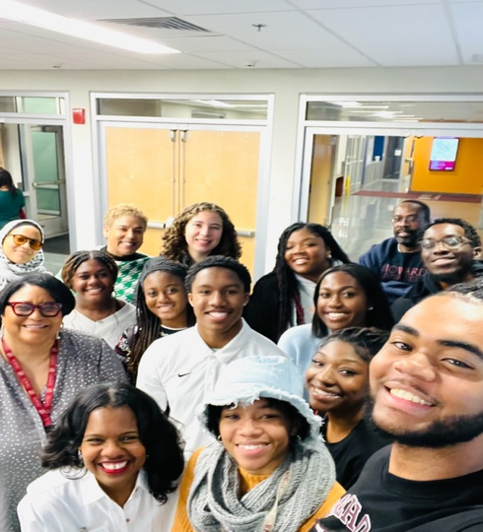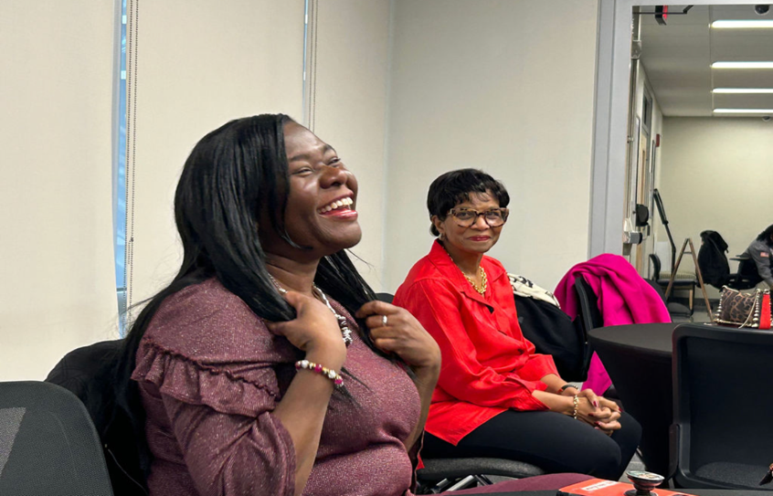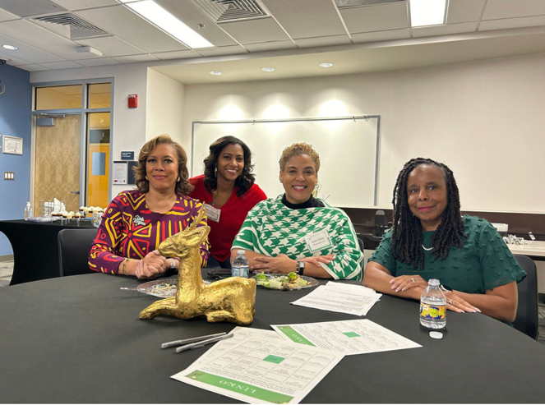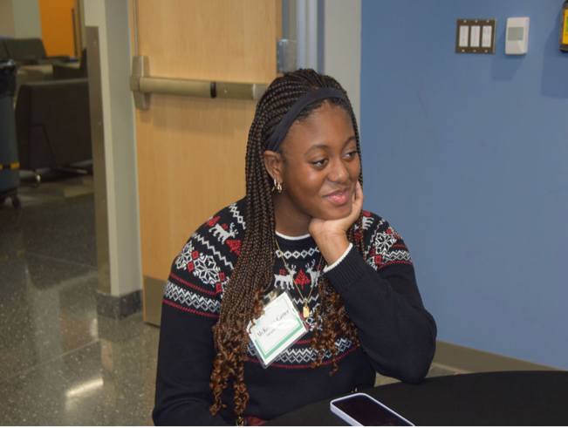
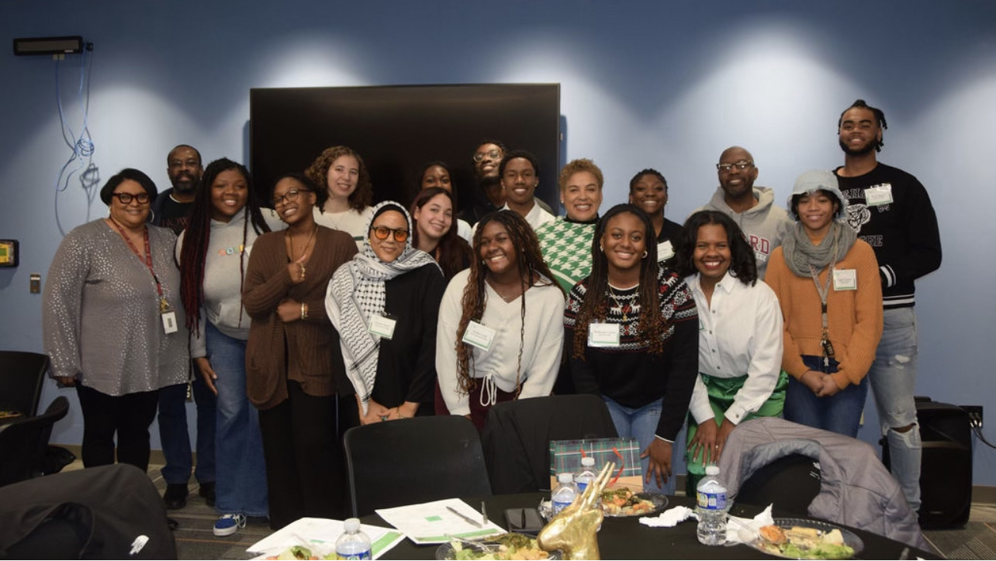
Activity Objective(s):  01/21/24: Linked to Success Series: Tools Of Engagement: Rock That Resume! | Total # of attendees: 15  - 7 students - 8 adults | Resources Utilized  External presenter: Dr. Yolander Albert-Smith; Volunteers to review resumes; Program evaluation was sent out to student attendees and results will be summarized upon receipt. | Outcomes  Students gained expert advice on how to search for, prepare for and engage in securing summer internships and full-time employment in their desired career fields, including professional feedback on their current resumes.

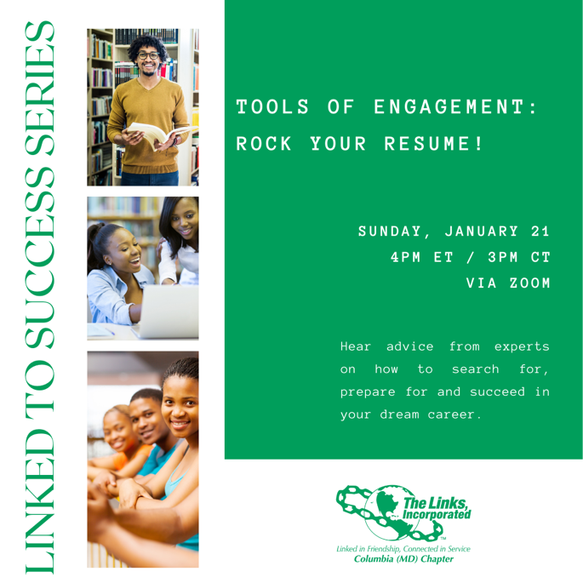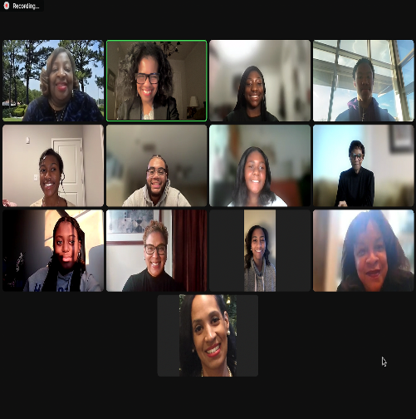

Activity Objective(s):  02/18/24: Linked to Success Series: Tools Of Engagement: Elevate Your Edge! | Total # of attendees: 12  - 6 students - 6 adults | Resources Utilized  External presenter: Dr. Yolander Albert-Smith; Volunteers to review resumes; Program evaluation was sent out to student attendees and results will be summarized upon receipt. | Outcomes  Students gained expert advice on strategies to make a lasting impression with potential employers and build valuable connections to propel your career forward, practical experience with interviewing for a summer internship or full-time employment, and useful tips to help students confidently navigate professional interactions.

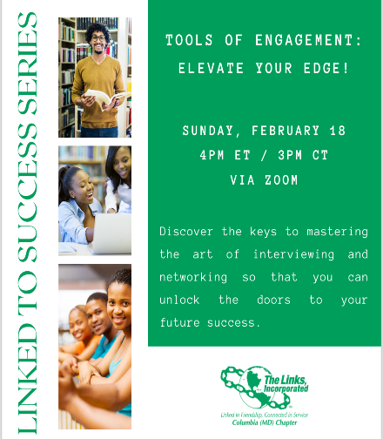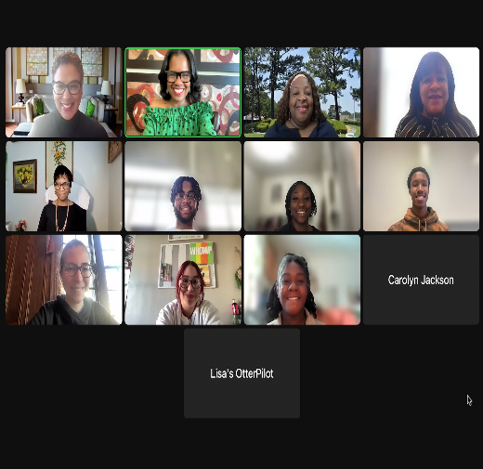

ATTACHMENT 1

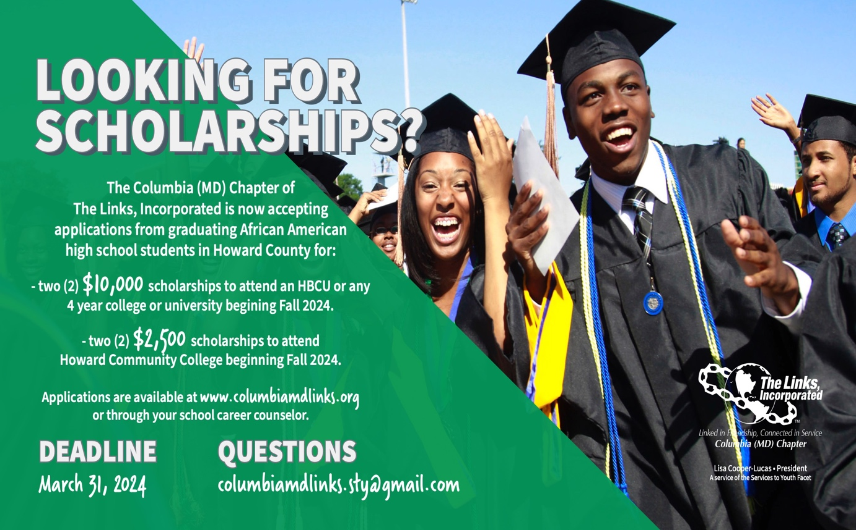

ATTACHMENT 2
PROGRAM EVALUATION SUMMARY: “Rock Your Resume! (1/21/24)”
Number of student attendees: 7
Number of evaluations received: 6
 | Poor | Fair | Good | Very Good | Outstanding
How would rate the value and usefulness of the tips, advice, and information presented during this session? |  |  | 1 | 1 | 4
How would you rate the presenter’s* communication style (e.g. pace, volume, professionalism)? |  |  |  | 2 | 4
How would you rate the quality of the visual materials the presenter* shared during this session (e.g. content, slides, videos, etc.)? |  |  |  | 3 | 3
How would you rate the length of time for this session? |  |  | 2 | 1 | 3
What is your overall rating of this session? |  |  | 1 | 2 | 3
*The presenter was Dr. Yolander Albert Smith.

How likely will you use the information or advice given in this session for your own personal career development?
1 Highly unlikely 0 Somewhat unlikely 0 Not sure 1 Somewhat likely 4 Highly likely

How helpful was this information compared to what you receive from your current campus career center?
0 Less helpful 2 Just as helpful 4 More helpful

The most important thing I learned in this session was:
“To utilize my ‘resume real estate.’ I learned to reduce and compact some areas of my resume that are not as relevant, as well as what to put there instead.”

“I learned that small details in your resume can take it to the next level. For example, Dr. Smith pointed out that word misalignment and uneven spacing was visually distracting. Another tip she gave me was to include the importance/impact of my tasks in my work experience section.”

“Spacing and aesthetics matter!”

“To prioritize relevant experience and course information.”

“How to organize the layout of my resume, highlighting the most important things like community service.”

“Going over the needed adjustments to my resume regarding the use of verbs in the present tense vs past, as well as the guidance for updating and revamping my LinkedIn profile.”

If I could change 3 things about this session, it would be:
“I wouldn’t change much about this session, except that everyone got a chance to be reviewed by Dr. Smith. She was an excellent on the spot resource. That’s really all I could think of to change.”

“I would like part of the resume presentation to talk about resume/CV for graduate schools. I would do more interaction with LinkedIn. I would look at bad resumes vs good resumes (spot the difference game).”

“Present more example resumes. More resume review as opposed to slides. Begin resume review earlier.”

“Nothing.”

“Split the time up equally between resume review and LinkedIn review. Have a job recruiter speak about what exactly they look for on their candidates resume, interview and social media.”

“Possibly showing exemplary resumes or LinkedIn accounts by people who are in our fields of interest. Information on CVs, although those are longer documents. Older Links scholars sharing their resume or LinkedIn growth over time.”

What topic(s) would you like us to cover in future workshops?
“I would love to gain insight into professional wear, interview tips and strategies, and networking tips.”

“How to plan for post-graduation (jobs, graduate schools, etc.)”

“Interview tips. Internship search.”

“I would enjoy hearing from older Links scholars who may be in graduate school or getting ready to transition from undergrad about things the rest of us should or should not do and lessons they learned going through their college experience outside of professional or academic spaces. I also want to explore how we are involved in our local communities through the Links chapters in our areas or as a Columbia MD Chapter. Finally, if the members of the Links could talk about how they use their careers to help others or how we can use our platforms once we reach our goals to create opportunity for others. For example, how can I as a future clinical psychologist venture outside of my practice, academia, or research and into creating more Black mental health professionals.”

“Interview questions, but I know that will be covered in the next workshop.”

“Curriculum Vitae (CV) review.”

ATTACHMENT 3

Upcoming HCC Fundraiser Events

