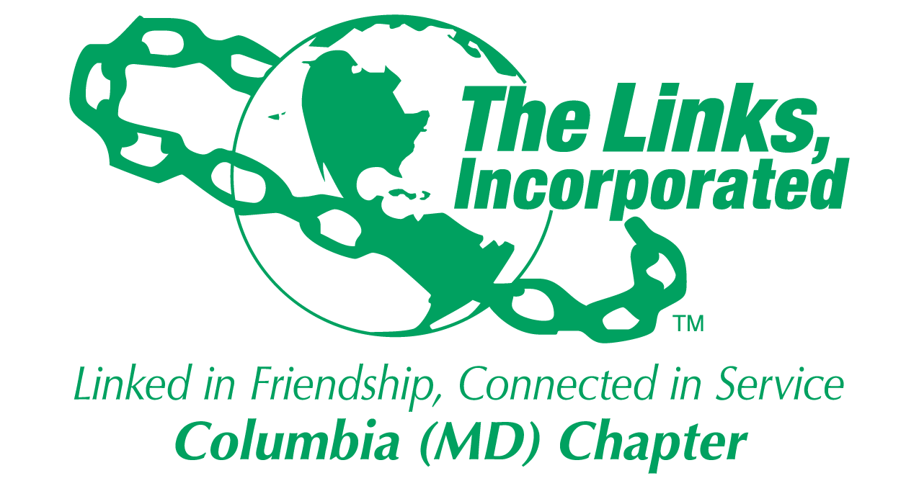
Committee Reporting Form
Name of Committee: Strategic Planning

Date/ Time/Location of Meeting/Activity
- Not applicable

Member Attendees (List)
- Not applicable

Committee Activities
Consent Agenda
  - Developed and shared a transition plan
    - The prototype ends on April 30, 2024
    - Beginning May 1, the responsibilities outlined in the transition plan will shift as outlined in the transition plan

Chapter Newsletter
- Working with Madams President and Vice President to re-launch the Chapter newsletter
  - Developed and shared a timeline for the newsletter prototype that will begin in May and ending in September 2024
    - Continue to research the MailChimp application's capability - March 22 to April 30, 2024
    - Begin the newsletter socialization process within the Chapter - May 1, 2024 through May 31, 2024
    - Prototype the "Internal" Chapter newsletter (internal to the Chapter) - June 1, 2024 through July 31, 2024
    - Collect Lessons learned and Update newsletter process - August 1, 0224 through August 31, 2024
    - Use the newsletter and the associated process for internal use - Beginning September 1, 2024
    - Simultaneously, try to prototype MailChimp for "External Audiences" using the Fundraising Committee target audience for the prototype - July 1, 2024 through July 31, 2024
    - Collect lessons learned from "External Prototype - August 1 - August 31, 2024
    - Begin to use a newsletter for "External Outreach to Jazz Brunch target audience - Beginning September 1, 2024
  - Proposed process highlights:
    - Newsletter process owner is TBD
    - The newsletter will be sent out every two weeks
    - All facet, committee and member email, notices, and communications should be sent out via the newsletter
      - Exceptions to this guidance may be approved by the President or her designee
      - The Chapter president can send notices, email etc. at any time
    - All newsletter content should be reviewed, spell-checked and submitted in the proper format or the content will be returned to the sender for correction
    - Will be sent out on 2nd and 4th Sundays of each month. Content must be received by the newsletter task owner by the Wednesday before the newsletter will be published. If the deadline is missed the content will be sent out in the following newsletter of the month
  - More to follow once the process and other details are finalized

Chapter Training:
- The DOPE Test will be administered on April 13, 2024
- Tod date about 21 of the 54(?) Chapter members have taken the test

Chapter Strategic Planning:
- Strategic Planning Committee is starting to “gear up” the planning process
  - We will revalidate the mission and vision during the Executive and Chapter meetings
  - We will be working with the Membership Chair to obtain details on the Chapter assessment
  - Anticipate that strategic planning meetings will be planned for June, July and August
  - Goal is to have a strategic planning session to share the draft plan with the Chapter in September 2024

Activity Objective(s) | Total # of attendees:  - # of children:  - # of adults: | Resources Utilized | Outcomes
For Each Activity: NO Activities

Optional
- Additional Comments
- Testimonials
- Photos (attached)

Signature of Committee Chair: Judy L. Smith
Date: March 30, 2024
Please Email to Chapter President, Chapter Vice President, Chapter Recording Secretary and Chapter Program Coordinator prior to Chapter Executive Committee Meeting

