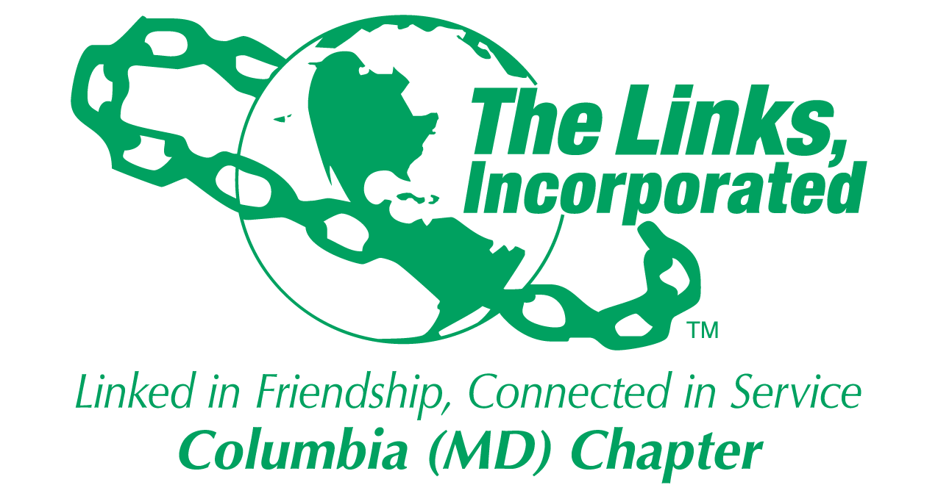
Facet/Committee Reporting Form
Name of Facet/Committee: Arts Facet
Date/ Time/Location of Meeting: July 26, 2024 (Friday) Via Zoom
Members Attendance:
- July 26, 2024
  - Gretta Garner, Melanie Brown, Judy Smith
  - Candace Dodson Reed (absent), Lucinda Ware (absent)

Summary of Meeting (Dot Points):
  - Arts Facet will meet on the 2nd Saturday of the month at 8AM (prior to the Chapter meeting)
    - This may change once a Facet Chair is announced
  - The Arts Facet agreed to participate in the Umbrella Program
    - Participate during the 3rd quarter (Jan/Feb/Mar time frame) listed in the "Proposed Umbrella Program" notes
    - Possible Ideas:
      - Have a table/booth at the Black Expo in February
        - Hand out information on the benefits of the Arts with Behavioral Health
        - Have Art activities for table visitors to participate in
      - Co-partner with STY/HHS for the Mental Health Forum in the 3rd quarter (Jan/Feb/Mar)
        - Determine the partnership with the proposed Artist who is also a wellness and community educator director at a local Columbia organization. The Artist can support an art activity and present on the intersection of art and mental health)
          - Awaiting the Bio of the Artist who may be willing to support our activities
        - Have an activity at the mental health forum, a table, etc. but will need to coordinate this idea with STY and HHS
        - Determine if having Peabody students perform at this event (in coordination with STY/HHS)
      - Any event prior to the Peabody Concert where we have the Peabody students perform could act also as advertisement for the Peabody Concert (depends on the timing of the activities)
      - There are always "Awareness Months" throughout the year, for example, February is "Teen Dating Violence Awareness Month" where we can engage with the sponsoring group and offer:
        - Handouts
        - Art activities
        - etc.
- Focus from now to Dec 2024
  - Continue to support the Programming Committee Meetings and provide input to the Umbrella Program
    - Next Programming Committee Meeting is August 12th at 8PM
  - Continue to meet monthly to finalize all Arts Committee activities to include supporting the Umbrella Program. Conduct the next Arts Facet meeting on September 14th at 8AM

Goal  (Specify if Short, Mid or Long Term) | Activity Progress with Completion date including Budget | Assumption Changes | Progress on evaluation | Needs - Specify or Update on Resource Needs (Both Internal and External) | Action items/ Items (Please Specify If Chapter Vote Is Required)
Short | Finalize Arts Facet Umbrella Program Activities
Short | Identify Arts/behavior Health Professional
Signature of Facet/Committee Chair: Judy L. Smith (July 2024 monthly meeting point of contact)
Date: July 29, 2024
Please Email to Chapter President, Chapter Vice President, Chapter Recording Secretary and Chapter Program Coordinator prior to Chapter Executive Committee Meeting

