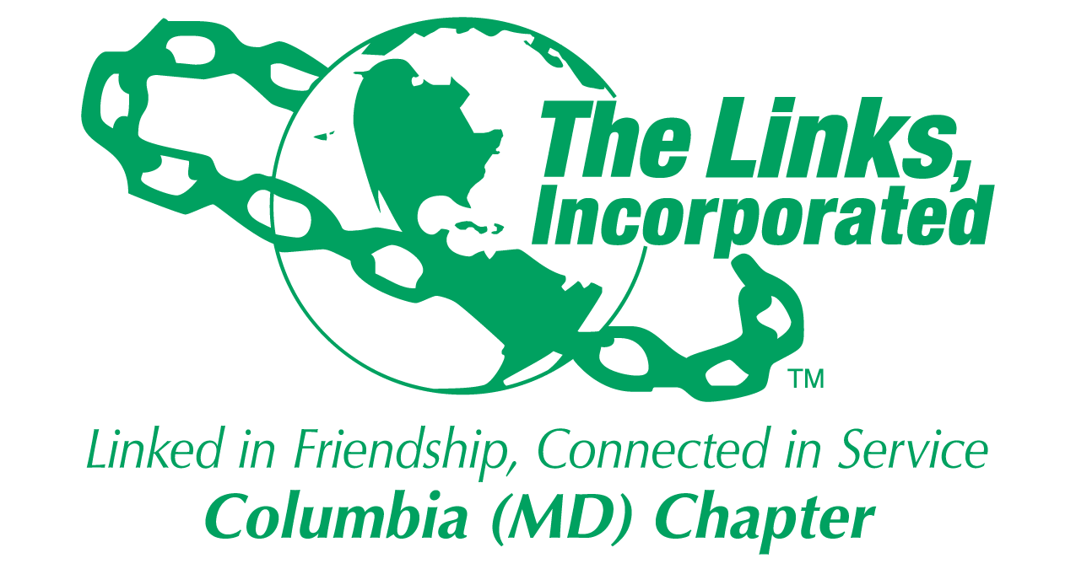
Facet/Committee Reporting Form
Name of Facet/Committee: Arts Facet
Date/ Time/Location of Meeting: September 10 2024 (In-person) at the HCC RCF 400
Members Attendance:
- September 10, 2024
  - Gretta Garner, Melanie Brown, Judy Smith
  - Candace Dodson Reed (absent), Lucinda Ware

Summary of Meeting (Dot Points):
  - Arts Facet will meet on the 2nd Saturday of the month at 8AM (prior to the Chapter meeting)
    - This may change once a Facet Chair is announced
  - The Arts Facet agreed to participate in the Umbrella Program
    - Participate during the 3rd quarter (Jan/Feb/Mar time frame) listed in the "Proposed Umbrella Program" notes
    - Possible Ideas:
      - Co-partner with STY/HHS for the Mental Health Forum in the 3rd quarter (March/April)
        - Determine the partnership with the proposed Artist who is also a wellness and community educator director at a local Columbia organization. The Artist can support an art activity and present on the intersection of art and mental health)
          - Received the bio and information from Vanita Leatherwood
          - Ms. Leatherwood is willing to support the Mental Health Forum and the cost will be only the cost associated with the art supplies
      - Link Gretta will lead the Peabody Concerts efforts again this year
- Focus from now to Dec 2024
  - Continue to support the Programming Committee Meetings and provide input to the Umbrella Program
    - Attended the Programming Committee Meeting On September 16th
    - Next Programming Meeting is in October and the date is TBD
  - Continue to meet monthly to finalize all Arts Committee activities to include supporting the Umbrella Program. Conduct the next Arts Facet meeting on October 12th at 8AM

Goal  (Specify if Short, Mid or Long Term) | Activity Progress with Completion date including Budget | Assumption Changes | Progress on evaluation | Needs - Specify or Update on Resource Needs (Both Internal and External) | Action items/ Items (Please Specify If Chapter Vote Is Required)
Short | Finalize Arts Facet Umbrella Program Activities
Short | Identify Arts/behavior Health Professional
Signature of Facet/Committee Chair: Judy L. Smith (Septemebr 2024 monthly meeting point of contact)
Date: September 22, 2024
Please Email to Chapter President, Chapter Vice President, Chapter Recording Secretary and Chapter Program Coordinator prior to Chapter Executive Committee Meeting

