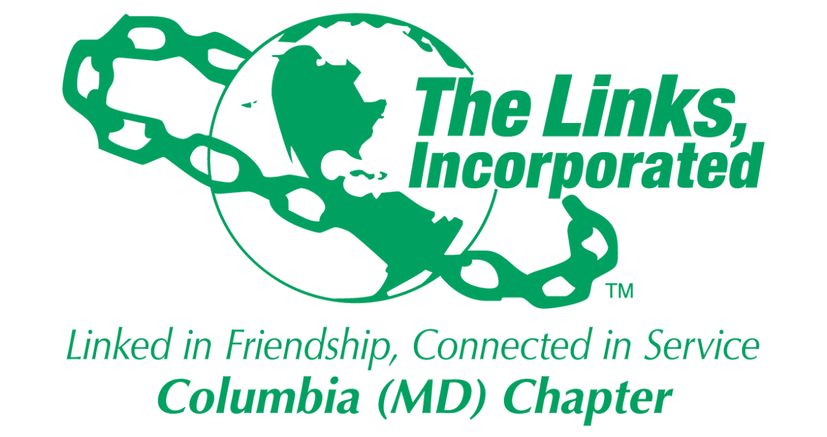

Bylaws Committee Recommendations
Proposed Amendments to the Constitution and Bylaws
44th National Assembly

Charge:

The Bylaws Committee is charged with considering and recommending changes to the Bylaws and Standing Rules and reviewing proposed amendments to the National Constitution and Bylaws and make recommendations to the chapter.

Background Work:

The Bylaws Committee met on May 6, 2024 by video conference, with Chair Vivian Moore Lawyer presiding.

Those members present reviewed and discussed each proposed bylaws amendment to The Links, Incorporated Constitution and Bylaws that will be considered for adoption at the 44th National Assembly as well as the corresponding vote recommendation from the National Constitution and Bylaws Committee (the “National Committee”). Additional electronic discussions were held on May 10, 2024. The following are the recommendations of the Bylaws Committee for consideration by the chapter to provide guidance to the delegate and alternate for voting at the Assembly.

Constitution

Amendment #1 – Recommends adoption (accepts National Committee’s recommendation)

Bylaws

- Amendment # 1 – Recommends not adopt (accepts National Committee’s recommendation)
- Amendment # 2 – Recommends adoption (does not accept the National Committee’s recommendation) Columbia (MD) Chapter submitted this proposed amendment.
- Amendment # 3 – Recommends adoption (accepts the National Committee’s recommendation)
- Amendment # 4 -- Recommends adoption (accepts the National Committee’s recommendation)
- Amendment # 5 -- Recommends not adopt (accepts the National Committee’s recommendation)
- Amendment # 6 -- Recommends adopt (does not accept the National Committee’s recommendation)
- Amendment # 7 -- Recommends not adopt (does not accept the National Committee’s recommendation)
- Amendment # 8 -- Recommends not adopt (accepts the National Committee’s recommendation)
- Amendment # 9 -- Recommends adoption (accepts the National Committee’s recommendation)
- Amendment # 10 – Recommends adoption (accepts National Committee’s recommendation)
- Amendment # 11 – Recommends adoption (accepts National Committee’s recommendation)
- Amendment # 12 – Recommends not adopt (accepts the National Committee recommendation
- Amendment # 13 – Recommends not adopt (accepts the National Committee’s recommendation)
- Amendment # 14 – Recommends adoption (does not accept National Committee’s recommendation)
- Amendment # 15 -- Recommends adoption (accepts the National Committee’s recommendation)
- Amendment # 16 – Recommends not adopt (accepts the National Committee’s recommendation)
- Amendment # 17 – Recommends adoption (accepts the National Committee’s recommendation)
- Amendment # 18 – Recommends adoption (accepts the National Committee’s recommendation)
- Amendment # 19 -- Recommends adoption (accepts the National Committee’s recommendation)
- Amendment # 20 -- Recommends adoption (accepts the National Committee’s recommendation)
- Amendment # 21 -- Recommends adoption (accepts the National Committee’s recommendation)
- Amendment # 22 -- Recommends adoption (accepts the National Committee’s recommendation)
- Amendment # 23 -- Recommends adoption (accepts the National Committee’s recommendation)
- Amendment # 24 -- Recommends adoption (accepts the National Committee’s recommendation)
- Amendment # 25 -- Recommends adoption (accepts the National Committee’s recommendation)

