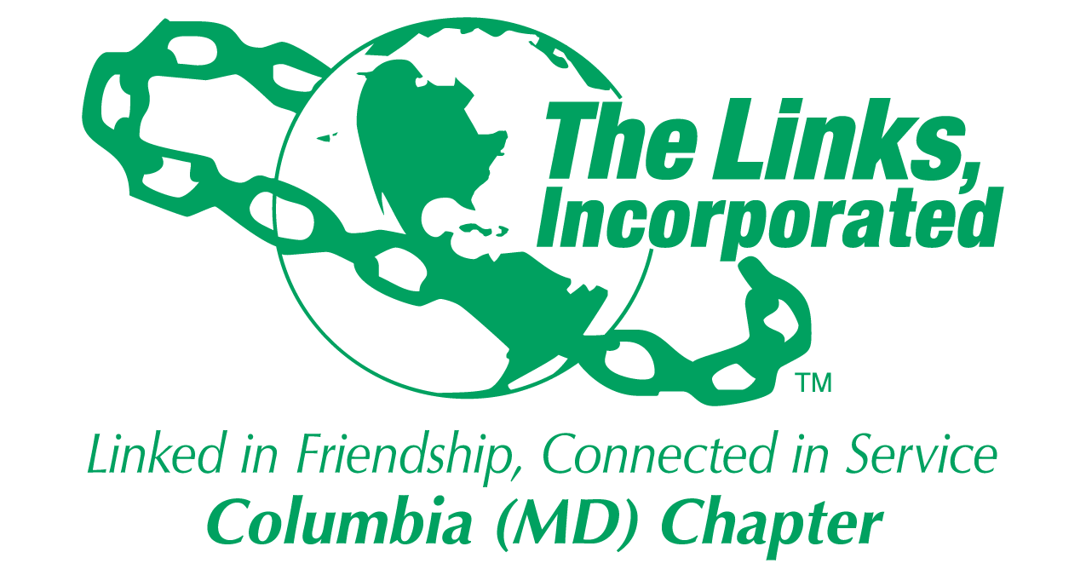
Facet/Committee Reporting Form
Name of Facet/Committee: Bylaws Committee
Date/ Time/Location of Meeting: Meetings were not held. Communication via Email.
Members Present: All Members - Shavon Arline-Bradley, Regina Clay, Lucinda-Marie Ware, Carol Ann Smith, and Gretta Gardner
Summary of Meeting (Dot Points):
Activity Objective(s) | Total # of attendees | Resources Utilized | Outcomes |  | Action items/ Items
- To update Chapter Bylaws in regard to the Chapter budget  - Further review of the Strategic Planning/Budget Timeline Process in the January 8, 2025 Executive Committee meeting suggested review of the proposed Excess Fund Guidance (Draft)  - Consolidating Chapter Standing Rules, Hospitality Guidelines and other Chapter Processes and key information into one document | N/A | Direct emails to committee members and chapter newsletter by email to chapter members  Facet, committee chairs and officer guidelines | Motion to amend Article IX, Section 4  Motion:  I move that ARTICLE IX Standing Committees and The Five Facets be amended  Section 4 by striking by October of the current fiscal year. and inserting in accordance with the Columbia (MD) Chapter Strategic Planning /Budget Timeline process approved (date of approval and any modifications made thereafter). | Collection and review continue for final document completion by April 30, 2025. | Presented to Bylaws Committee and Executive Committee January 6 and 8.  Present to Chapter January 11 for review. Not presented.  Present to Chapter for vote on February 8, 2025.  Distribute to chapter members in January 2025.  Bylaws Committee review and make a final recommendation to the chapter for vote in February to be included with other Chapter Governance documents.  Chapter vote will be needed for new modifications to the Standing Rules and Hospitality Guidelines

Next Meeting: March 3, 2025
Signature of Facet/Committee Chair: Vivian Moore Lawyer, Chair
Date: January 10, 2025
*Please submit this report at Chapter Executive Committee Meeting Or Email to Chapter President, Chapter Vice President, Chapter Recording Secretary and Chapter Program Coordinator prior to the Chapter Executive Committee Meeting.

