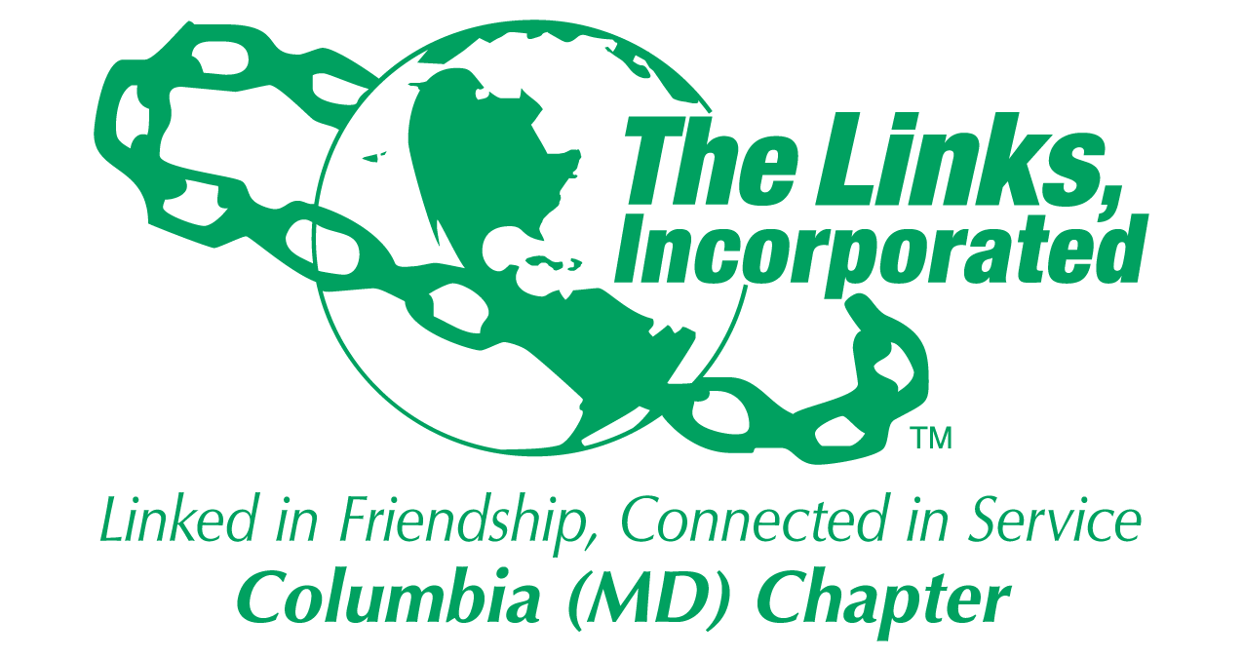
Facet Reporting Form
Name of Facet Fundraising Committee_________
Date/ Time/Location of Meeting/Activity-
The Fundraising Committee met on Thursday, September 26, 2024, via Zoom.
Fundraising Committee Meeting

Scheduled: March 26, 2024, at 8:00 PM to 9:00 PM, EST
Location: https://us06web.zoom.us/j/6107348895?pwd=RGFVcmZ0N0lrR2V3ZHFmK0hEWFdhUT09&omn=85640545789
https://us06web.zoom.us/j/6107348895?pwd=RGFVcmZ0N0lrR2V3ZHFmK0hEWFdhUT09&omn=85640545789
Rebecca Reed is inviting you to a scheduled Zoom meeting.

Join Zoom Meeting
https://us06web.zoom.us/j/6107348895?pwd=RGFVcmZ0N0lrR2V3ZHFmK0hEWFdhUT09&omn=85640545789

Meeting ID: 610 734 8895
Passcode: 8Pn3Mw

Member Attendees (List): Link Rebecca, Link Vivian, Link Carolyn, Link Judy Smith, Link Tracey, Link Audra, Link Rochelle and Madam President (LCL).
Summary of Meeting/Activities (Dot Points):
- Confirmed Extraordinary 360 photobooth was paid.
- Confirmed Epic Photography- Andre Dunston was paid.
- Confirmed Invitation Letters to Howard County Dignitaries were emailed by Madam President.
- Discussed updates of paid sponsorships.
- Discussed updates of paid vendors and outstanding payments from verbally committed vendors.
- Confirmed we will not have an official photo chapter- too disruptive. We will use the photo taken last year.
- Confirmed we will have 60 tables (600 Guests).
- Confirmed all chapter members will wear black with white fabric rose. Each member’s rose will have a name tag to ensure everyone receives a flower.
- Discussed securing AV tech from LIVE! for PP slide and IT assistance.
- Discussed vendors' meal breaks and ability to eat from the buffet and use the designated vendor table directly outside of the Grand Ballroom.
- Discussed requiring each chapter member to confirm/ submit a sheet with table guests at the October meeting.

Activity Objective(s)  Status update on all things Jazz Brunch; payments logistics etc. | Total # of attendees:8  - # of children:0  - # of adults:8 | Resources Utilized  Zoom | Outcomes  Understanding the event timeline items that have been completed and Action items going forward.
For Each Activity

Signature of Facet Chair: Rebecca Reed
Date: 9/29/2024

Please Email to Chapter President, Chapter Vice President, Chapter Recording Secretary and Chapter Program Coordinator prior to Chapter Executive Committee Meeting.
Optional
- Additional Comments- Action Items
- Create a donate button for the chapter website with assistance from the technology committee.
- Testimonials- N/A
- Photos (attached)

