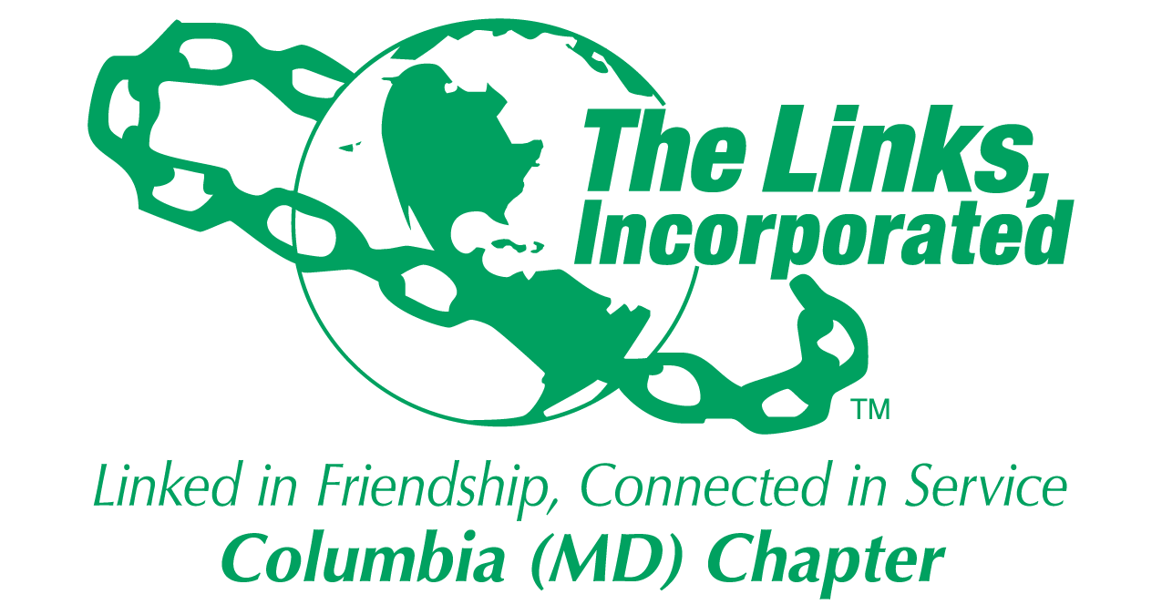
Facet Reporting Form
Name of Facet Fundraising Committee_________
Date/ Time/Location of Meeting/Activity-
The Fundraising Committee met on Sunday, November 24, 2024- Dok Khao Thai Eatery in Columbia, MD.
Fundraising Committee Meeting
Dok Khao Thai Eatery in Columbia, MD.
6000 Merriweather Dr. Unit B155 Columbia, MD 21044

Member Attendees (List): Link Rebecca, Link Judy Smith, Link Tracey, Link Audra, Link Rochelle, Link Yvette, Regina Little Hollis, and Madam President (LCL).
Summary of Meeting/Activities (Dot Points):
- Please see the attached document- Fundraising Committee 15th Annual Jazz Brunch Review.

Activity Objective(s)  Debrief on the Jazz Brunch - Identify Challenges and Opportunities for improvement. | Total # of attendees:8  - # of children:0  - # of adults:8 | Resources Utilized  Zoom | Outcomes  Review the event and discuss how we will move forward for the next Jazz Brunch or other Fundraising events.
For Each Activity

Signature of Facet Chair: Rebecca Reed
Date: 11/25/2024

Please Email to Chapter President, Chapter Vice President, Chapter Recording Secretary and Chapter Program Coordinator prior to Chapter Executive Committee Meeting.
Optional
- Additional Comments- Action Items
- Created a donation link on Eventbrite to continue to receive donations until the end of the program year (April 30th).

- Photos (attached)

