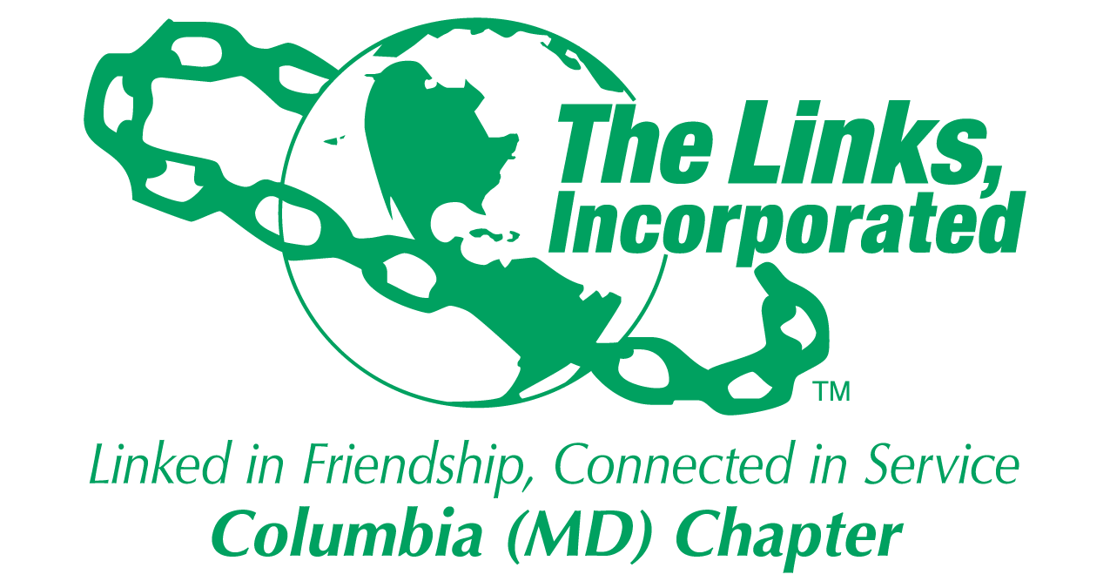
Committee Reporting Form
Name of Committee: Strategic Planning

Date/ Time/Location of Meeting/Activity
- September 11, 2024 7PM
- Zoom Meeting

Member Attendees (List)
- Chinyere Watson, Vivian Lawyer, Melanie Brown and Judy Smith
- Link Tracey was on travel

Committee Activities

Chapter Strategic Planning:
- Strategic Planning Committee has completed the first third of the strategic planning process and the focus is now on finalizing the FY24-FY25 implementation plan
- The strategic planning presentation for the September 14th retreat was reviewed and the feedback was incorporated
- The focus through October will be:
  - Work with Strategic Priorities #4-6 POCs to complete the activities for these goals
    - Link Lisa CL for Strategic Priority #4: Amplify a Culture of Organizational Excellence and Alignment
    - Link Cathy, Germaine and Roslyn for Strategic Priority #5: Amplify a Culture of Brand Awareness
    - Link Tracey for Strategic Priority #6: Amplify a Culture of Leadership and Professional Development
  - Begin working on our Fy25-FY30 Strategic Plan

Activity Objective(s) | Total # of attendees:  - # of children:  - # of adults: | Resources Utilized | Outcomes
For Each Activity: NO Activities

Optional
- Additional Comments
- Testimonials
- Photos (attached)

Signature of Committee Chair: Judy L. Smith
Date: September 22, 2024
Please Email to Chapter President, Chapter Vice President, Chapter Recording Secretary and Chapter Program Coordinator prior to Chapter Executive Committee Meeting

