Program name: “Linked To Wellness” Virtual Series

Please provide a brief overview of program: The “Linked To Wellness” virtual series is a monthly conversation featuring expert speakers who cover topics relevant to college students (see attached flyer for reference). These sessions are FREE, held via Zoom, open to college students (with a primary focus on African American college students), and last one hour. In FY27, we seek to expand this virtual series to local high school students.

New or existing: Existing

Target audience: College students, High school juniors and seniors

Expected target audience size: 200 (100 college, 100 high school)

Describe the expected outcome of this program: To provide a safe space that will engage students in rich, meaningful discussions on relevant topics that will help them navigate key areas of their life, and provide them with tips, information and resources to help enhance their personal and professional development as young adults. This will be measured by:
- Attendance (total, trend, repeat participation)
- Qualitative feedback/satisfaction ratings (participants, facilitators)

How does this program align with Chapter’s strategic plan? This program aligns with Priority #2: Amplify our culture of transformational community service. Specifically, this program is community relevant, need based, and has a measurable positive impact. Additionally, it promotes enhanced collaboration across chapters and with community partners. For perspective, the FY26 LTW virtual series was hosted in partnership with the Potomac (VA) Chapter.

How is this program still relevant to the Chapter’s work and mission? This program continues to support the Chapter’s mission of strengthening and improving health and well-being outcomes of youth in Howard County by equipping them with information, strategies and resources that will positively impact their mental, physical and emotional well-being (with a particular focus on mental health and women’s health issues).

Is this program in alignment with a National or Eastern Area Links Incorporated Program or Initiative? If so, which one(s)? Yes, this program is consistent with National’s strategic focus on umbrella programming and mental health/wellness.

Is this Program designed to fit within the Chapter’s Umbrella Program? Yes

If not, how could the proposed/existing program be combined or modified to become an Integrated or Umbrella Program? n/a

What are the budget and resource needs for the program?
"Linked To Wellness" Virtual Series | Number | Cost Per | FY27  Budget | FY26  Budget
Facilitator Fees | 6 | $200 | $1,200 | $1,200 | Assumes paying facilitators for time or purchasing their materials/book for virtual sessions

Please add supporting documents as appropriate.
Return to littleregina056@gmail.com.

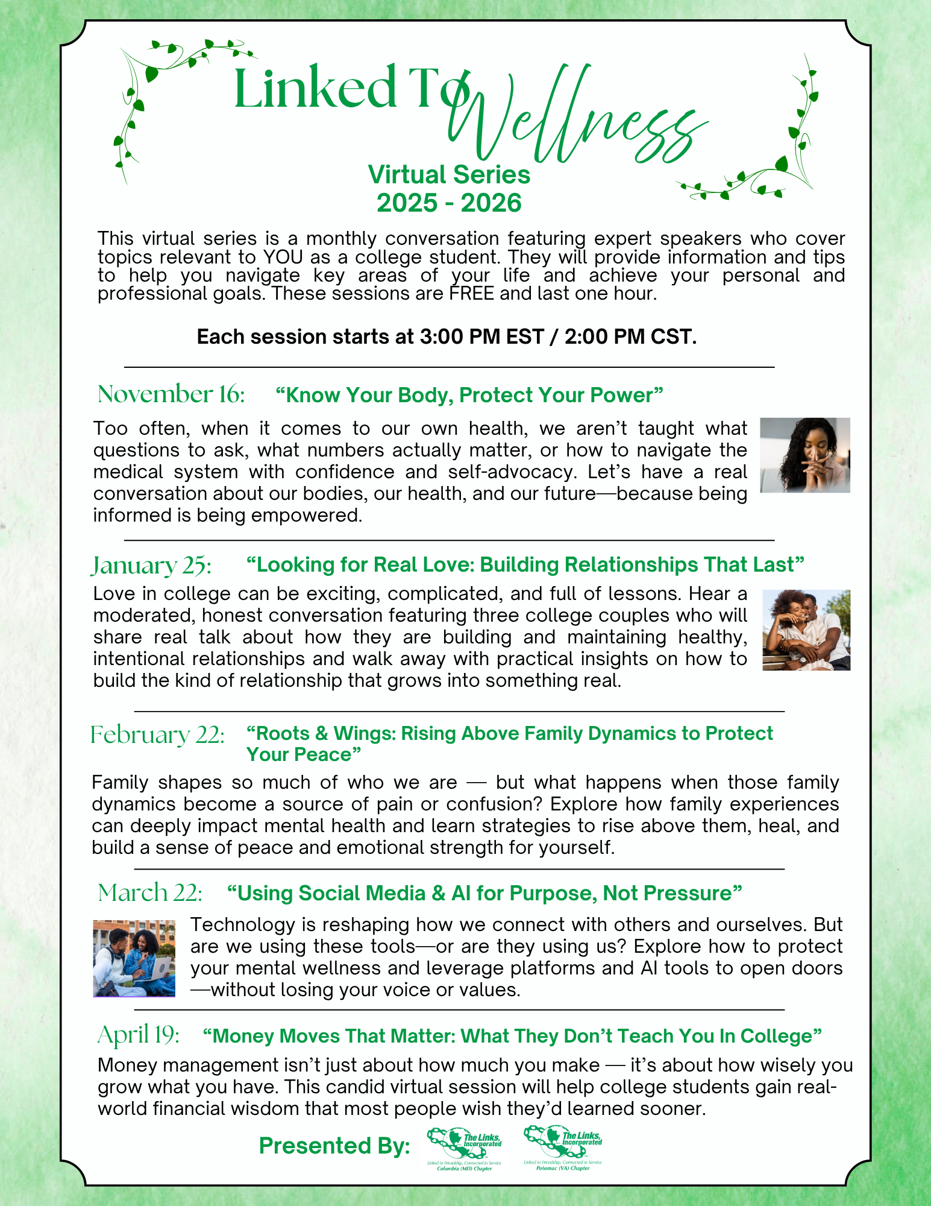
Program name: “Linked To Success” Series

Please provide a brief overview of program: The “Linked To Success” Series is a hybrid mentoring program that offers students personal guidance and support, and helps them build the skills to navigate today’s career landscape (see attached flyer for reference). Participants engage in sessions led by professional experts that are focused not only on essential career-building topics, like resume-writing, interview preparation, networking, and personal branding, but on community building and collaboration. These sessions are FREE to students and held in-person and via Zoom.

New or existing: Existing
Target audience: College students (with emphasis on Columbia (MD) Links Scholars, HCC R.I.S.E. students)
Expected target audience size: 25 – 50
Describe the expected outcome of this program: To help students experience meaningful mentoring opportunities and confidently prepare for the workforce. This will be measured by:
- Attendance (total, trend, repeat participation)
- Qualitative feedback/satisfaction ratings (participants, facilitators)
- % of students that enter workforce upon graduation

How does this program align with Chapter’s strategic plan? This program aligns with Priority #2: Amplify our culture of transformational community service. Specifically, this program is community relevant, need based, and has a measurable positive impact. Additionally, it promotes enhanced collaboration across chapters and with community partners, like Howard Community College.

How is this program still relevant to the Chapter’s work and mission? This program supports the Chapter’s mission of positively impacting the workforce readiness of students in Howard County and beyond by equipping them with information, strategies and resources that will help them succeed in their desired careers.

Is this program in alignment with a National or Eastern Area Links Incorporated Program or Initiative? If so, which one(s)? Yes, this program is consistent with National’s Mentoring Initiative. This initiative seeks to offer youth the guidance and support of a caring, responsible adults to help improve their academic performance, increase self-esteem, and engage in healthier lifestyles. The goals of this series (as well as this program) include:
- Offering students more local black mentors,
- Stressing competence and character building, and
- Focusing on closing the academic achievement gap, workforce readiness and healthy lifestyles

Is this Program designed to fit within the Chapter’s Umbrella Program? No
If not, how could the proposed/existing program be combined or modified to become an Integrated or Umbrella Program? This series can easily be integrated with other facets. For example, STY hosted a virtual session that brought together professional experts currently working in a variety of fields that were of interest to the participants. Participants were able to speak 1:1 with these experts in Zoom breakouts. The facets could, therefore, lead sessions that discuss:
- HHS: Healthcare related careers
- NTS: Careers in various trade fields
- Arts: Careers in art-related fields
- ITS: How to prepare yourself for global careers
What are the budget and resource needs for the program?
"Linked to Success" Series (College) | Number | Cost Per | FY27  Budget | FY26  Budget
Food/Venue/Transportation | 3 | $935 | $2,800 | $2,800 | Based on historic costs (food/venue ($2,400), transportation costs (400)).
Facilitator Fees | 6 | $100 | $600 | $600 | Assumes paying at least half of ttl # of facilitators needed. Any remaining facilitators are volunteers.
Supplies | 1 | $100 | $100 | $100 | Includes nametags, prizes/gifts/care packages, and other materials
Programming (Internship) | 2 | $0 | $0 | n/a | Funding through Keith Campbell Fdn and other local sources (e.g. Brown Advisory)

Please add supporting documents as appropriate.
Return to littleregina056@gmail.com



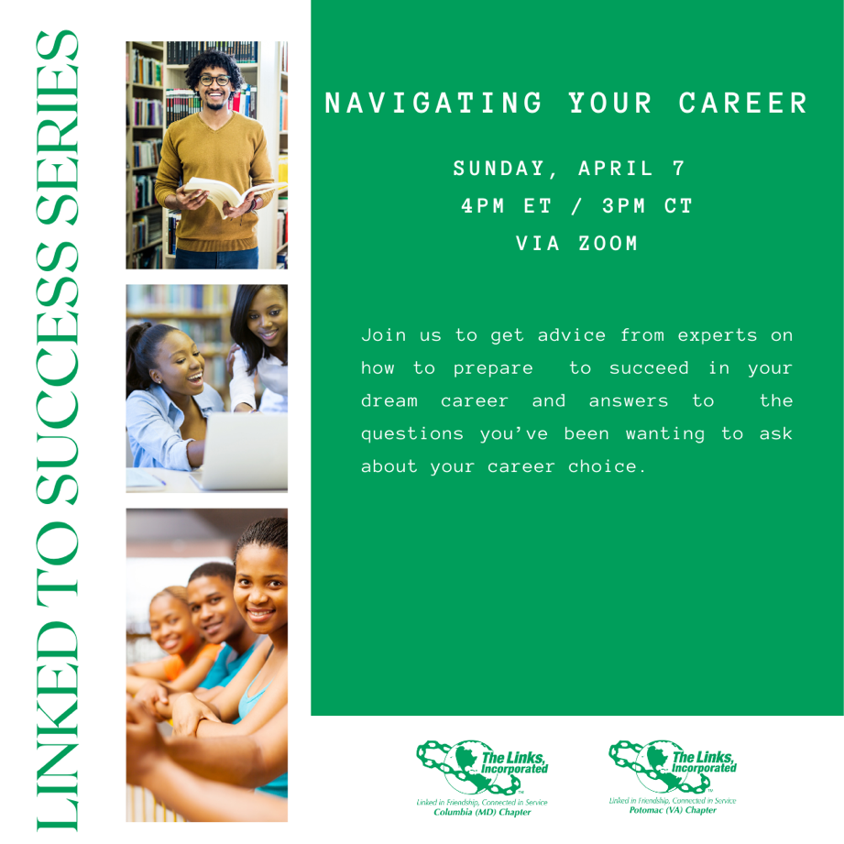

Program name: “Young Achievers” Program

Please provide a brief overview of program: The Young Achievers program addresses issues and challenges facing high school aged black youth. Through a series of workshops and interactive programs, Young Achievers supports a seamless and successful transition to and through high school, successful entry to college and into chosen careers by:
- Implementing mentoring programs for youth
- Closing the high school academic achievement gap
- Implementing science, technology, engineering, and mathematics related career awareness programs
- Introducing college and career readiness programs
- Promoting historically black colleges and universities as viable options
- Introducing financial literacy programs, and
- Awarding college scholarships

New or existing: New
Target audience: High school juniors and seniors (with emphasis on the Youth Workforce/Apprenticeship Program)
Expected target audience size: 100 - 150
Describe the expected outcome of this program: To help students successfully complete their high school program, experience meaningful mentoring opportunities, and confidently prepare for the workforce. This will be measured by:
- Attendance (total, trend, repeat participation)
- Qualitative feedback/satisfaction ratings (participants, facilitators)
- % of students that enter workforce upon graduation

How does this program align with Chapter’s strategic plan? This program aligns with Priority #2: Amplify our culture of transformational community service. Specifically, this program is community relevant, need based, and has a long-term, measurable positive impact. Additionally, it promotes enhanced collaboration opportunities with community partners.

How is this program still relevant to the Chapter’s work and mission? This program supports the Chapter’s mission of positively impacting the workforce readiness of students in Howard County by equipping them with information, strategies and resources that will help them succeed in their desired careers.

Is this program in alignment with a National or Eastern Area Links Incorporated Program or Initiative? If so, which one(s)? Yes, this program is consistent with the National “Young Achievers” Signature Program.

Is this Program designed to fit within the Chapter’s Umbrella Program? Yes
If not, how could the proposed/existing program be combined or modified to become an Integrated or Umbrella Program? n/a

What are the budget and resource needs for the program?
Young Achievers  (Grades 11 - 12) | Number | Cost Per | FY27 Budget | FY26  Budget
Programming (Other) | 150 | $20 | 3,000 | $0 | Estimated facilitator (600), food (1,500), supplies (100), transportation costs (800).
Scholarship Awards
White Rose Award | 2 | $10,000 | $20,000 | $20,000 | Consistent with prior year.
Chain of Excellence Award | 2 | $2,500 | $5,000 | $5,000 | Consistent with prior year.

Please add supporting documents as appropriate.
Return to littleregina056@gmail.com.

Program name: “Links Love HBCUs”

Please provide a brief overview of program: The goal of the National HBCU Initiative is to increase the retention and graduation rates of students attending HBCUs. While emphasizing the relevance of HBCUs’ past, present and future, this initiative strives to create synergy and complement program initiatives already underway at schools. The Links, Incorporated supports HBCUs and encourages chapters to (i) partner with other national organizations, (ii) host (or support) HBCU college fairs and other events, (iii) mentor and recruit students to attend HBCUs, (iv) promote and encourage a connection with an HBCU and its STEM programs, (v) identify opportunities to support faculty research and/or professional development, and/or (vi) contribute to the sustainability of HBCU institutions.

New or existing: New

Target audience: High school students

Expected target audience size: 200 – 250

Describe the expected outcome of this program: To increase the awareness and interest of Howard County students in attending HBCUs. This will be measured by:
- Attendance (total, trend, repeat participation)
- Qualitative feedback/satisfaction ratings (participants, facilitators)
- % of students enrolled in HBCUs upon graduation

How does this program align with Chapter’s strategic plan? This program aligns with Priority #2: Amplify our culture of transformational community service. Specifically, this program is community relevant, need based, and has a measurable positive impact. Additionally, it promotes enhanced collaboration across chapters and with community partners, like HCPSS and local HBCU alumni chapters.

How is this program still relevant to the Chapter’s work and mission? This program continues to support the Chapter’s mission of strengthening and improving health and well-being outcomes of youth in Howard County by equipping them with information, strategies and resources that will positively impact their mental, physical and emotional well-being (with a particular focus on mental health and women’s health issues).

Is this program in alignment with a National or Eastern Area Links Incorporated Program or Initiative? If so, which one(s)? Yes, the “Links Love HBCU” National HBCU Initiative.

Is this Program designed to fit within the Chapter’s Umbrella Program? No

If not, how could the proposed/existing program be combined or modified to become an Integrated or Umbrella Program? HHS could consider leveraging this event as a partnership opportunity to host the chapter’s FY27 Black Family Wellness Fair since it already attracts Black families and is held in the month of March.

What are the budget and resource needs for the program? How will this program be funded?
"Links Love HBCUs" | Number | Cost Per | FY27  Budget | FY26  Budget
Chapter Contribution | 50 | 50 | $2,500 | $1,500 | Fund at an award-winning/recognition level
Programming | 250 | 10 | $2,500 | $0 | Estimated food, materials, and facilitator costs for local HBCU and college fairs

Please add supporting documents as appropriate.
Return to littleregina056@gmail.com.

Program name: Masonville Cove Links WildSTEM Partnership

Please provide a brief overview of program: The Masonville Cove Links WildSTEM Program is designed for students pursuing education in science, technology, engineering and math to explore the diverse field of environmental conservation careers. Led by the Maryland Port Authority, in partnership with other local businesses and business leaders, WildSTEM fosters educational and personal development opportunities for students attending Historically Black Colleges and Universities and pursuing a variety of majors to apply their skillsets to conservation projects. The core of this program is a six-week paid summer internship in which students are exposed to meaningful environmental conservation experiences, and gain practical work experience in a wide variety of conservation jobs (see attached flyer for reference). Additionally, Masonville Cove offers a variety of career-oriented and personal development resources and innovative programs and activities that help strengthen students leadership and career-readiness skills within a STEM-based context, like port tours, leadership training, and nature/art therapy experiences.

New or existing: New

Target audience: College students, high school students

Expected target audience size: 210 - 260 (100 college students, 10 Scholars, 100-150 high school juniors/seniors)

Describe the expected outcome of this program: Supplement our “Young Achievers” Program, “Linked To Wellness” Virtual Series and “Linked To Success” Series by leveraging the existing Masonville Cove programs and resources to strengthen our goals of ensuring Howard County students are sufficiently and confidently poised for personal and professional success and workforce readiness. This will be measured by:
- Attendance (total, trend, repeat participation)
- Qualitative feedback/satisfaction ratings (participants, facilitators)
- % of interns who pursue further STEM-related research or career opportunities post-graduation

How does this program align with Chapter’s strategic plan? This program aligns with Priority #2: Amplify our culture of transformational community service. Specifically, this program is community relevant, need based, and has a measurable positive impact. Additionally, it promotes enhanced collaboration with community partners, like HCPSS and HCC.

How is this program still relevant to the Chapter’s work and mission? This program continues to support the Chapter’s mission of strengthening and improving the overall well-being of youth in Howard County by equipping them with information, strategies and resources that will positively impact their career readiness and personal growth and development.

Is this program in alignment with a National or Eastern Area Links Incorporated Program or Initiative? If so, which one(s)? Yes, this partnership is in alignment with the National strategic focus on STEM, HBCUs, and the respective STY Signature Programs.

Is this Program designed to fit within the Chapter’s Umbrella Program? No

If not, how could the proposed/existing program be combined or modified to become an Integrated or Umbrella Program? This series can easily be integrated with other facets in several ways, including, but no limited to the following:
- HHS: Mental Health Forum session on nature/art/sound therapy
- NTS: Nature/art/sound therapy session or Port tour with Youth Workforce Apprenticeship Students
- Arts/ITS: Nature/art therapy or Backyard Bird Count session with HCC R.I.S.E. or international students

What are the budget and resource needs for the program? How will this program be funded? This partnership requires no additional funding as the program is already funded through Keith Campbell Foundation and other local sources (e.g. Brown Advisory) and managed by the Maryland Port Authority. The Chapter contribution includes promoting the Masonville Cove internship program to eligible Howard County students (particularly those at HBCUs), leading selected personal development sessions, and volunteering to assist with the internship closing ceremony. Any potential fees for utilizing Masonville Cove facilitators, etc. is already covered in the respective STY program budget requests.

Please add supporting documents as appropriate.
Return to littleregina056@gmail.com.

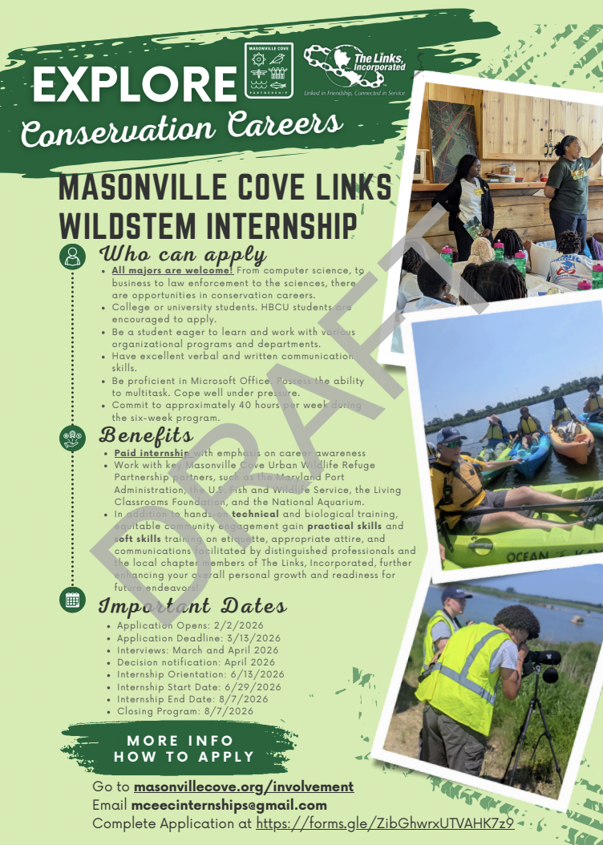

Program name: DevCon Partnership

Please provide a brief overview of program: DevCon is a dynamic three-day immersive experience designed to equip freshman and sophomore students from public and private historically Black colleges and universities (HBCUs) with the tools, resources and insights needed to explore career pathways, develop essential professional skills and engage with top industry leaders. In FY25, this event will be held at the Baltimore Hilton on February 18 – 21, 2026. For more information, visit https://tmcf.org/programs/devcon/. Based on the results of this event, STY will seek to incorporate this into its FY27 programming plans.

New or existing: New
Target audience: College students (freshmen and sophomores)
Expected target audience size: 400
Describe the expected outcome of this program: Supplement our “Linked To Success” (LTS) and “Linked To Wellness” (LTW) Series with this DevCon event to (i) build the target audience for these chapter programs, and (ii) assist TMCF in promoting this program to Howard County HBCU (and possibly HCC) students so more of them can benefit from this opportunity to be more sufficiently and confidently poised for personal and professional success and career readiness. This outcome will be measured by:
- % of LTW and LTS attendees from DevCon
- Qualitative feedback/satisfaction ratings
- % DevCon attendees from Howard County (need to confirm that this information can be gathered)

How does this program align with Chapter’s strategic plan? This program aligns with Priority #2: Amplify our culture of transformational community service. Specifically, this program is community relevant, need based, and has a measurable positive impact. Additionally, it promotes enhanced collaboration with community partners, like TMCF and HCC.

How is this program still relevant to the Chapter’s work and mission? This program supports the Chapter’s mission of positively impacting the career readiness of students in Howard County and beyond by equipping them with information, strategies and resources that will help them succeed in their academic and desired professional careers.

Is this program in alignment with a National or Eastern Area Links Incorporated Program or Initiative? If so, which one(s)? Yes, it has recently been adopted as an Eastern Area initiative in conjunction with the TMCF.

Is this Program designed to fit within the Chapter’s Umbrella Program? No
If not, how could the proposed/existing program be combined or modified to become an Integrated or Umbrella Program? This series can easily be integrated with other facets in several ways, including, but no limited to the following:
- STY: Promoting and inviting student participants to attend the “Linked To Wellness” Virtual Series.
- HHS: Conducting a mental wellness session during DevCon.
- NTS: Assist with the clothing drive during DevCon by providing clothing donations and styling students, lead/support voter registration effort.

What are the budget and resource needs for the program? How will this program be funded? This partnership requires no additional funding as the program is already funded through the Thurgood Marshall College Fund. The Chapter contribution includes promoting this opportunity to eligible Howard County students (particularly those at HBCUs), and volunteering to assist with specific sessions and activities during this 3 day event:
- Wednesday, 2/18, Noon-4PM: Voter Registration and Civic Engagement Session (30 min sessions)
- Wednesday, 2/18: “Linked In Style” Boutique. Need professional and business clothing for men and women and travel size hygiene products. Links sisters would be personal brand coaches for the students assisting them with appropriate body type clothing. We also need help with a 30-minute personal brand session from 12-4PM on Wednesday. The boutique would need to run from 2/18-2/21. Anyone able to send clothing for the boutique may send to the Baltimore Hilton 2/15 – 2/17. Send to the attention on Thurgood Marshall College Fund/ DevCon.
- Thursday, 2/19, 5:30-7:30PM: Professional Etiquette Dinner (“Dine Like a Diplomat”). Need minimum of 30 Link sisters to sit at student tables and appropriately dine with students.

Please add supporting documents as appropriate.
Return to littleregina056@gmail.com.

