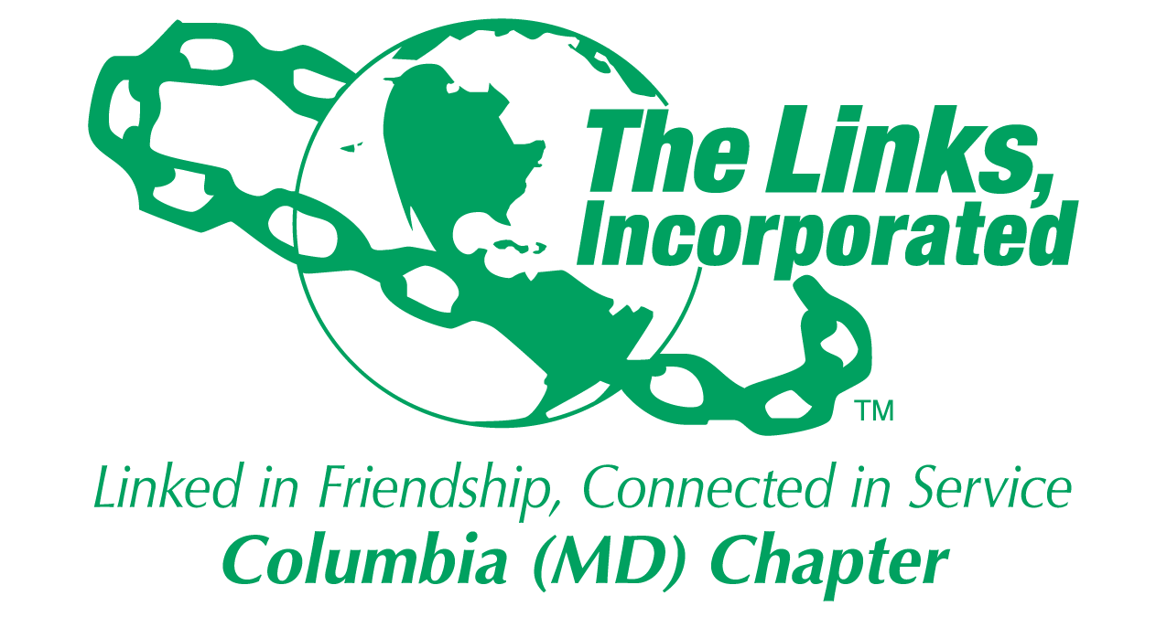
Facet Meeting Summary: August 2025
Name of Facet Services To Youth

Date/ Time/Location of Meeting/Activity: Wednesday, August 27, 8:00PM ET via Zoom

Member Attendees: Carol Ann Smith, Carolyn Jackson, Cathy Bell, Rebecca Reed, Regina Little Hollis,
Vivian Lawyer, Greta Carey Peoples (Chair)

MEETING SUMMARY:
Facet Co-Chair Needed: We need a STY Facet Co-chair to share in committee leadership responsibilities. If you are willing to serve in this role this program year, please contact Link Greta as soon as possible. Link Carol Ann expressed preliminary interest. Will follow-up to finalize this assignment.

Chapter Resources & Information
- Reviewed general chapter information (e.g. chapter website, chapter address, STY facet email address) with committee members and encouraged members to use chapter technology assets (e.g. TeamUp and TrackItForward).
- Reminded committee members to input 1.5 hour for tonight’s meeting.

Facet Budget: Next month, we will begin reviewing facet (restricted) budget monthly to ensure we are tracking spending and proactively making any necessary adjustments or recommendations throughout the year. Shared Scholarship (restricted) budget below for reference and indicated that the Scholarship Committee will be recommending how the ending balance will be used.

Restricted: Scholarship
Starting budget: $ 25,000
Less: Isaiah Thomas 10,000
Jason Young 10,000
Ending balance: $ 5,000

STY Programming Principles and Focus Areas
The principles that will guide our programming for this year are:
  - Increase engagement and ownership of programming elements within facet
  - Expand community impact and external visibility of facet programming
  - Seek more partnerships within community and across chapters
  - Ensure alignment with National priorities

The focus areas for this program year will be as follows:
  - Umbrella Program: Mental Health Forum
    - Support In-person Forum in conjunction with HCC
    - Expand monthly virtual series (beginning in Oct/Nov through April 2026)
  - “Linked to Success” Scholars Program
    - Coordinate in-person events (Summer reception, Holiday, EOY event)
    - Continue mentoring efforts
    - Update chapter website with more content-rich information
  - HBCU
    - Enhance chapter contribution effort and support
    - Support Howard County HBCU Forum
    - Develop HBCU partnership

Umbrella Program: Mental Health Forum
- Will review plans for Mental Health Forum once details have been released. We need a volunteer to serve as a liaison for this effort. This means attending the Umbrella program meetings, reporting any key information and needs to the facet, sharing facet ideas and attending the Forum.
- STY will supplement the umbrella program with the expansion of the monthly college virtual series pilot. This series will be renamed the “Linked To Wellness” virtual series to reinforce it as an extension of the umbrella program. The goal is to launch this monthly program to an expanded college student audience starting no later than November 2025 through April 2026. The tentative topics that will be discussed are:
  - Love & Relationships
  - Financial Management / Investments / Stocks
  - Entrepreneurship
  - Adulting: Bills, Insurance, Life after graduation
  - Networking / Interpersonal training
  - Healthy Relationships w/Technology / Social media / Dating apps
  - Family Dynamics and Mental Health
- We need volunteers to serve as the virtual series coordinator and topic discussion leaders.

“Linked to Success” Scholars Program
- See Attachment 1 for the current roster of Scholars.
- Successfully held two of the three in-person events for our Scholars planned for this program year. The EOY Reception was held on Friday, June 6 at the home of Link Greta. See Attachment 2 for photos from this event. The purpose of this event was to welcome the new Scholars in our program and celebrate the academic and personal accomplishments of our Scholars, particularly our graduating Scholars. The Scholars Summer Reception was held on Wednesday, August 13 at Candles by Candy, an African American owned candle-making studio in Savage Mill. See Attachment 3 for photos from this event. The students enjoyed engaging in the creative process of creating their own scented candle and thoughtful discussions about their college experiences. The last in-person event that needs to be planned is the Holiday event. Will need a volunteer to help coordinate this experience for our Scholars.
- We will continue our mentoring efforts with our Scholars. Need to coordinate the mentoring orientation and make sure all Scholars have assigned mentors.
- We will work with the chapter Technology team to update our chapter website with more content-rich information so that our website become a destination for community youth to identify relevant and key information about post-secondary opportunities, scholarships, etc.

“Links Love HBCUs” National Initiative
- Link Chin will continue her role as our HBCU liaison for our facet.
- Our chapter has budgeted to continue donating $25 per active member to the EA national HBCU campaign. We will look for ways to enhance that contribution as a means of strengthening our impact.
- Still awaiting further direction on the EA plans for adopting an HBCU. Will share EA STY meeting dates and times once published so that those who are interested in hearing EA STY information first-hand. Any key takeaways will be discussed during our facet meeting.
- This year, we will explore ways to support HCPSS HBCU Fair that is scheduled for March 2026. The HCPSS leads for this effort are Kareem Penn, Assistant Principal, Guilford Park HS and Monica Stevens, Community School Site Coordinator, Hammond HS. Communication has been sent to these individuals to schedule a preliminary meeting. A summary of that meeting will be published. To learn more about the inaugural fair that happened earlier this year, visit https://sites.google.com/hcpss.org/hcpsshbcufair/

Future Opportunities
- Expand programming and impact to high school and middle school youth through Boys & Girls Club of Howard County (HCC) and HCPSS (see Attachment 4 for flyer for upcoming event).
- Determine feasibility of Masonville Cove partnership.
- Consider if/when to incorporate STEM into programming plans.
- Explore UK/HBCU partnership opportunity.

Next Steps
- Identify facet Co-Chair. (Greta)
- Confirm STY facet budget for FYE2026. (Greta)
- Identify volunteer for Umbrella program liaison. (All)
- Identify volunteer for virtual series coordinator and volunteer to serve as LTW virtual series topic discussion leaders. (All)
- Finalize mentor assignments for Scholars and plan mentoring orientation. (Greta)
- Identify volunteer(s) to plan and execute the Holiday event for Scholars. (Greta)
- Identify volunteer to write STY newsletter articles for FYE2026. (All)
- Encourage facet members to attend HCPSS event on 9/27 (see Attachment 4 for flyer). (All)

************

Facet Meeting Calendar
General Schedule: 4th Wednesday of each month, 8:00 p.m. EST
Next Meeting Date: Wednesday, 9/24 Virtual
Future Meeting Dates: Friday, 9/26 Meet-up (18th & 21st, 5:30PM)
Wednesday, 10/22 Virtual
Wednesday, 11/19* Virtual
Friday, December 19 In-person Social (w/Scholars)
Wednesday, 1/28 Virtual
Wednesday, 2/25 Virtual
Wednesday, 3/25 Virtual
Wednesday, 4/22 Virtual
Wednesday, 5/27 Virtual
Friday, 6/5 In-person Social

Committee Members: Carol Ann Smith, Carolyn Jackson, Cathy Bell, Chinyere Watson, Laura Crandon, Melanie
Brown, Rebecca Reed, Vivian Lawyer, Greta Carey Peoples (Chair)
Zoom Link: https://us06web.zoom.us/j/87630296215
Questions? Information? Contact Link Greta at gretapeoples@gmail.com or 410.456.6566.

Signature of Facet Chair(s):  Date: 09/11/2025

ATTACHMENT 1

2025 – 2026 COLUMBIA (MD) CHAPTER LINKS SCHOLARS

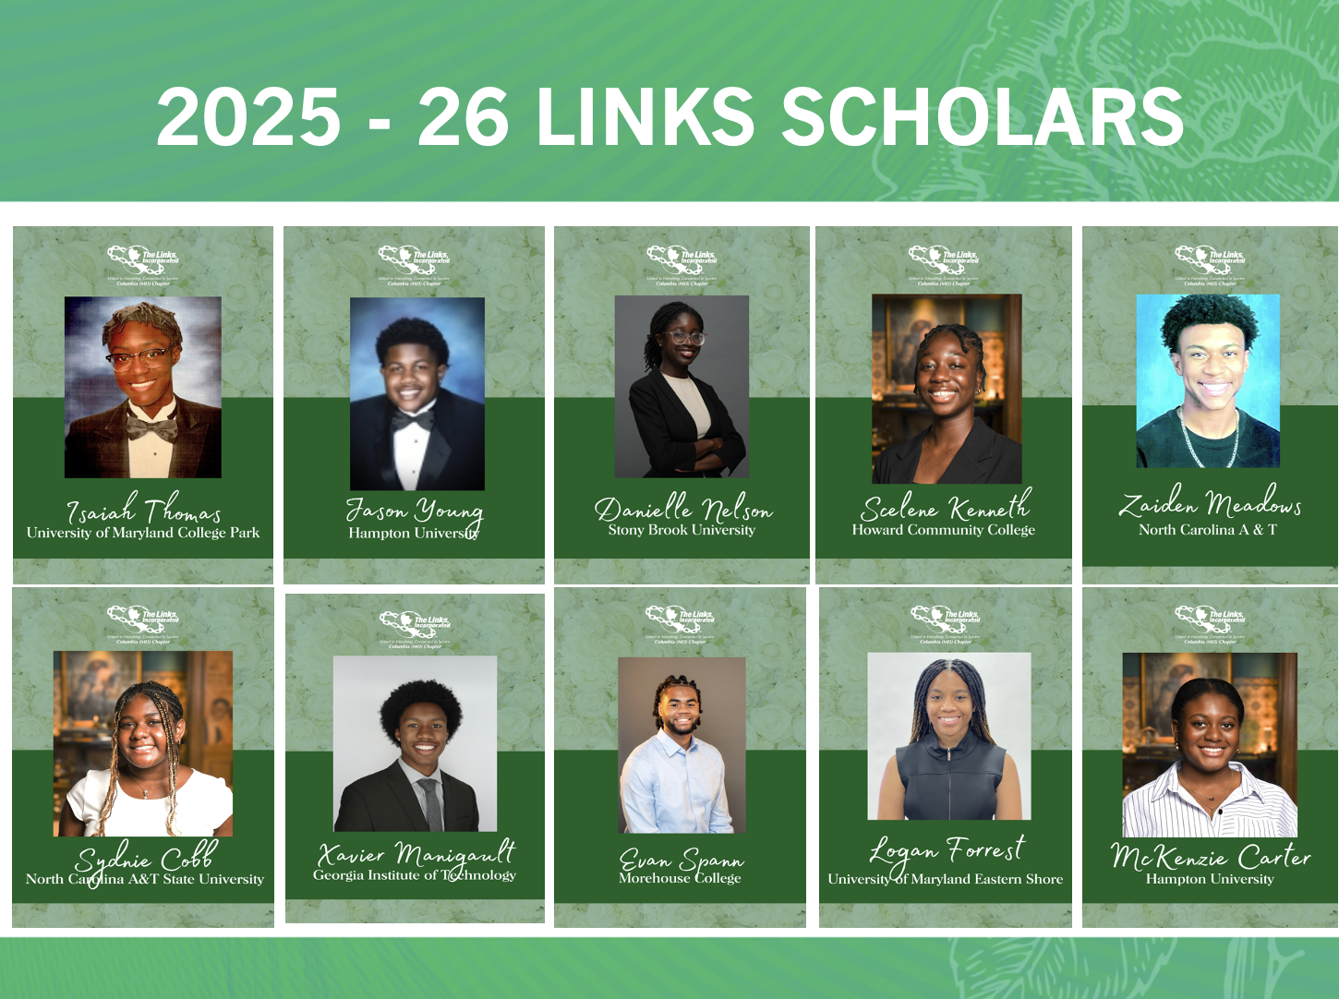

ATTACHMENT 2

SCHOLARS END OF YEAR RECEPTION
Friday, June 6
Home of Link Greta Carey Peoples, Fulton, MD

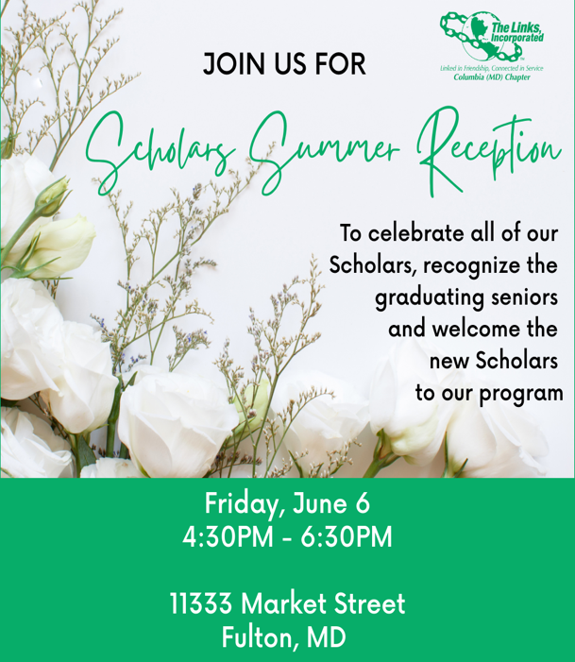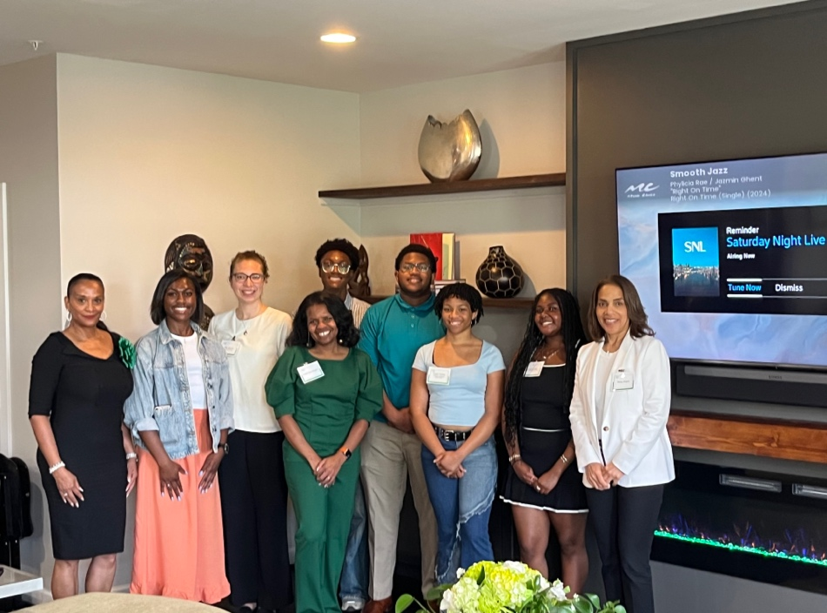

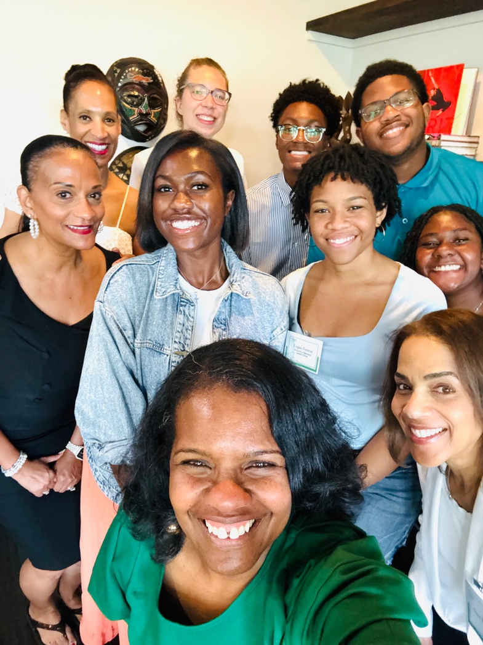

ATTACHMENT 3

SCHOLARS SUMMER RECEPTION
Wednesday, August 13
Candles by Candy (New Weave Building, 8600 Foundry St, Savage, MD 20763)

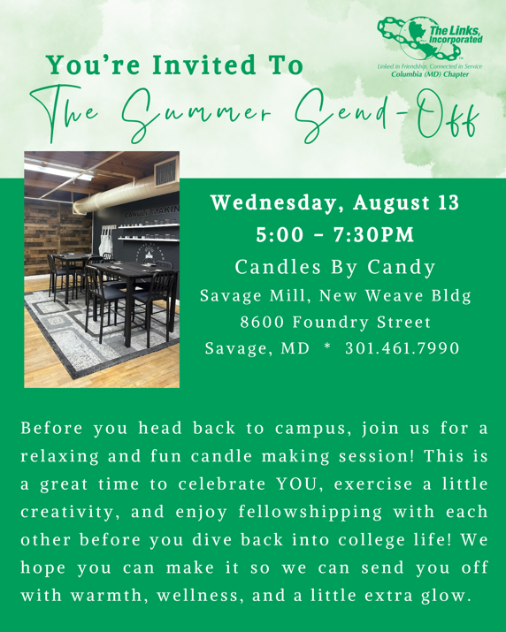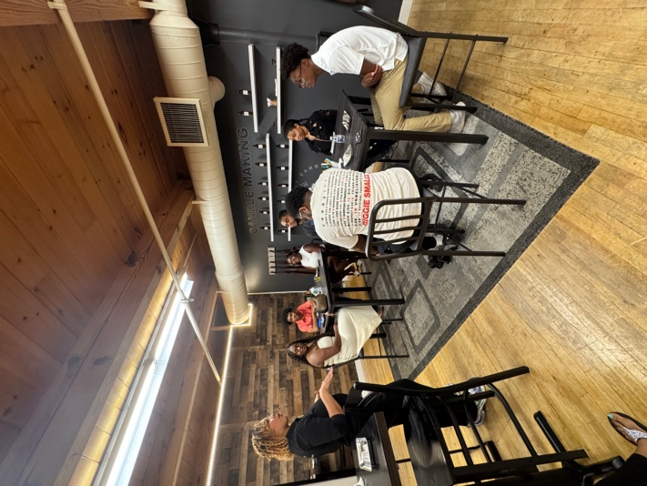

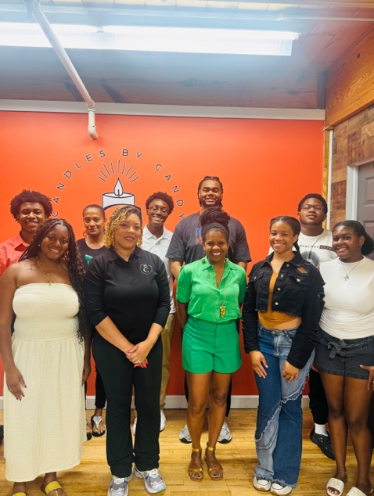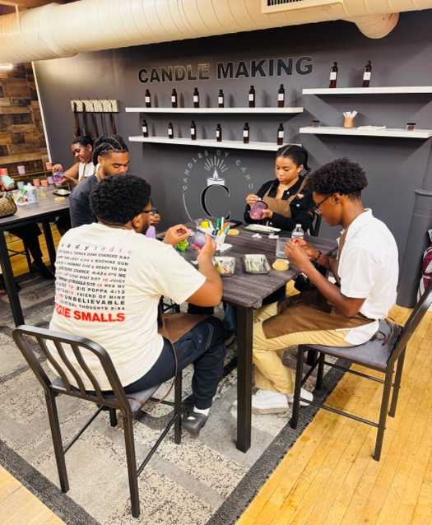

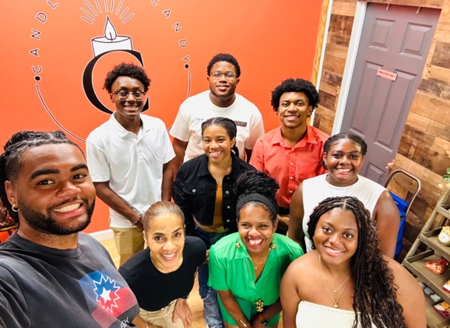

ATTACHMENT 4

HCPSS FAMILY ACADEMY KICK-OFF

