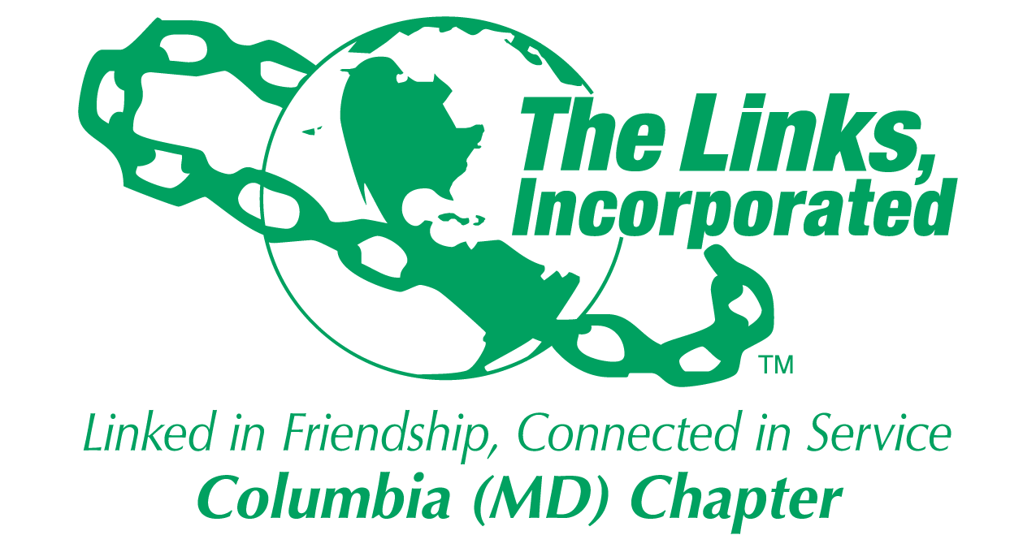
Facet Meeting Summary: September 2025
Name of Facet Services to Youth

Date/ Time/Location of Meeting: Wednesday, September 24, 8:00PM ET via Zoom

Member Attendees: Carol Ann Smith, Carolyn Jackson, Cathy Bell, Laura Crandon, Rebecca Reed, Regina Little Hollis, Vivian Lawyer, Greta Carey Peoples (Chair)

MEETING SUMMARY:
Facet Co-Chair: Link Carol Ann has agreed to serve as the STY Facet Co-Chair. Her energy and commitment to the cause of serving our youth will have a significant impact on the work we do in the community. I am grateful for her willingness to share her time and talents in this important role and look forward to us all making a meaningful difference for our students together.

Fundraising Committee Representation: Link Cathy Bell is the Chair of the Fundraising Committee so she will be able to share any relevant fundraising activity information or allocation discussions with the Facet and forward any input we might have to the Fundraising Committee on our behalf.

EA Updates: Here are the updates that were provided in the first EA STY for this program year:
- EA meeting schedules were provided (see Attachment 1)
- 2025 – 2026 EA HBCU Capital Campaign begins 10/1. EA Goal is to raise $200,000. More details are forthcoming. (see Attachment 2)
- EA STEM National Programs were provided (see Attachment 3)

Facet Budget: Link Carol Ann reviewed the budget which confirms we are on-track with STY facet spending. The Scholarship Committee will report to the Executive Committee and to the Chapter a recommendation on how to reallocate the $5,000 remaining balance and seek Chapter alignment to this plan.

Restricted: Services to Youth
Mentoring: Linked to Success Program:
Programming: $ 3,500
Less: EOY Reception 535
Summer Reception 530
Current balance: $ 2,435

Young Achievers:
Scholarship: $ 25,000
Less: Isaiah Thomas 10,000
Jason Young 10,000
Current balance: $ 5,000

HBCU:
Links Love HBCUs: $ 1,500
Current balance: $ 1,500

Restricted: Scholarship
Starting budget: $ 25,000
Less: Isaiah Thomas 10,000
Jason Young 10,000
Ending balance: $ 5,000

Programming Plan: A draft of the 2025 – 2026 STY programming plan was reviewed (see below). Goal is to finalize this plan by 10/31 which includes finalizing dates, times, locations and success measures for all programming activities. Volunteers will be needed to assist with the development and execution of these program plans. Facet agreed more work needs to be done in publicizing our programming both internally and externally.
STY Volunteers Needs:
Volunteers are needed to assist in the following areas. Each facet member should sign up for at least one of these volunteer areas:
- Serve as a liaison for the Umbrella program. This means attending the Umbrella program meetings, reporting any key information and needs to the facet, sharing facet ideas and attending the Forum.
- Lead or find a discussion leader for the upcoming “Linked To Wellness” virtual mental health series on the following topics:
  - Love & Relationships
  - Financial Management / Investments / Stocks
  - Entrepreneurship
  - Adulting: Bills, Insurance, Life after graduation
  - Networking / Interpersonal training
  - Healthy Relationships w/Technology / Social media / Dating apps
  - Family Dynamics and Mental Health
- Plan and execute the in-person Holiday event for our Scholars.
- Serve as a mentor for one of our Scholars.
- Serve as photographer and social media content creator for STY.
- Work with the chapter Technology team to update our chapter website with more content-rich information so that our website become a destination for community youth to identify relevant and key information about post-secondary opportunities, scholarships, etc.
- Create a monthly newsletter for our Scholars to promote upcoming programs and share relevant information and launch by no later than 12/31.
- Write, gain approval, and submit monthly STY articles for chapter newsletter.
- Serve as the chapter HBCU liaison which means attending the EA HBCU calls, reporting EA HBCU update to Facet, attending relevant local HBCU efforts, and recommending how to strengthen our HBCU efforts, including identifying the chapter’s HBCU partner.
- Serve as the chapter STEM liaison which means attending the EA STEM calls, reporting EA STEM update to Facet, attending relevant local STEM efforts, as necessary, and recommending how to strengthen our STEM efforts.
- Attend HCPSS College Fair on 10/15/25, 6:00 – 8:00 p.m. at HCC for observational purposes and report to Facet potential opportunities for STY to support this effort next program year, particularly as it relates to any of our core strategic areas (e.g. HBCU, Young Achievers)
- Develop a student care package plan for our Scholars for 2026-2027, including content ideas and costs, delivery packaging and shipping options and costs, and suggested delivery timing.

Scholar Spotlight: https://youtu.be/78Qo8qovgds
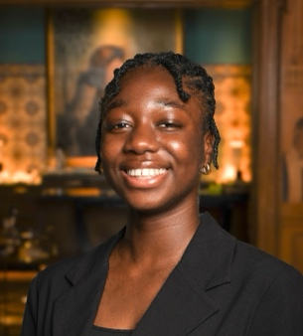
Scelene Kenneth (Howard Community College)

“Links Love HBCUs” National Initiative
- Our chapter has committed $1,500 to contribute to the EA national HBCU campaign. We will look for ways to enhance that contribution as a means of strengthening our impact. Mentioned idea of wearing HBCU gear to the October meeting in support of this campaign. Question was raised to find out if any of the monies raised for this campaign come back to the chapter or back to the local areas, and if so, how. Will f/up on this question and report back to facet. AACR was also mentioned as a potential partner in this effort, but will need to explore more details on how.
- This year, we will attend and explore ways to support HCPSS HBCU Fair that is scheduled for March 2026. The HCPSS leads for this effort are Kareem Penn, Assistant Principal, Guilford Park HS and Monica Stevens, Community School Site Coordinator, Hammond HS. To learn more about the inaugural fair that happened earlier this year, visit https://sites.google.com/hcpss.org/hcpsshbcufair/
- Still awaiting further direction on the EA plans for adopting an HBCU.

Next Steps
- Sign up for at least one STY volunteer need. (All)
- Finalize STY programming plan and agree on success measures by 10/31. (All)
- F/up on question regarding if/how funds raised in HBCU campaign come back to the local areas. (Greta)
- F/up w/NTS re: Holiday community service opportunity for Scholars. (Greta)
- F/up w/Exec Comm to see if we can wear HBCU gear for October chapter mtg in support of EA HBCU Campaign. (Greta)
- Submit STY article for chapter newsletter by 10/10 and 10/25. (Greta)
- F/up w/Exec Comm to suggest facet and committee sign-up take place in April. (Greta)
- Confirm STY Chair and Co-Chair have been updated in MMS system. (Greta)
- Finalize mentor assignments for Scholars and plan mentoring orientation. (Greta)
- Encourage facet members to attend HCPSS event on 9/27 (see Attachment 4 for flyer). (All)
- Input 1.5 hour for tonight’s meeting. (All)

************

Facet Meeting Calendar
General Schedule: 4th Wednesday of each month, 8:00 p.m. EST
Next Meeting Date: Wednesday, 10/22 Virtual
Future Meeting Dates: Wednesday, 11/19* Virtual
Friday, December 19 In-person Social (w/Scholars)
Wednesday, 1/28 Virtual
Wednesday, 2/25 Virtual
Wednesday, 3/25 Virtual
Wednesday, 4/22 Virtual
Wednesday, 5/27 Virtual
Friday, 6/5 In-person Social

Committee Members: Carol Ann Smith, Carolyn Jackson, Cathy Bell, Chinyere Watson, Laura Crandon, Melanie
Brown, Rebecca Reed, Vivian Lawyer, Greta Carey Peoples (Chair)

EA STY Members: Link Lamyra Clarke-White, STY Chair, Raritan Valley (NJ), sty@ealinks.org, 201.424.0899
Link Carolyn Streets, EA STY Co-Chair, New Haven (CT), sty@ealinks.org, 203.508.2204
Link Robin S. Williams, EA HBCU Lead, Washington (DC), hbcu@ealinks.org, 828.729.2693
Link Cheri Amado, EA STEM Lead, Milford (CT), stem@ealinks.org, 203.449.6786

Zoom Link: https://us06web.zoom.us/j/87630296215
Questions? Information? Contact Link Greta at gretapeoples@gmail.com or 410.456.6566.

Signature of Facet Chair(s): 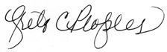 Date: 10/02/2025

ATTACHMENT 1

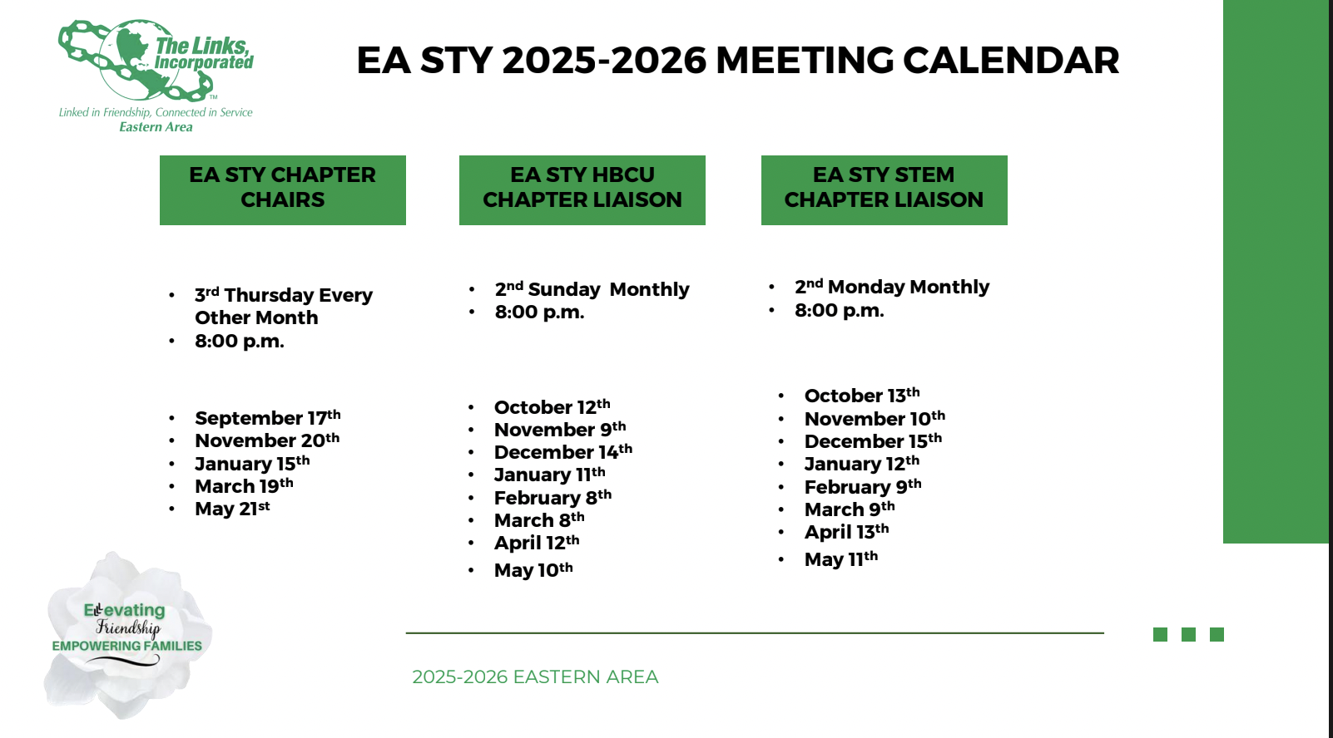

ATTACHMENT 2

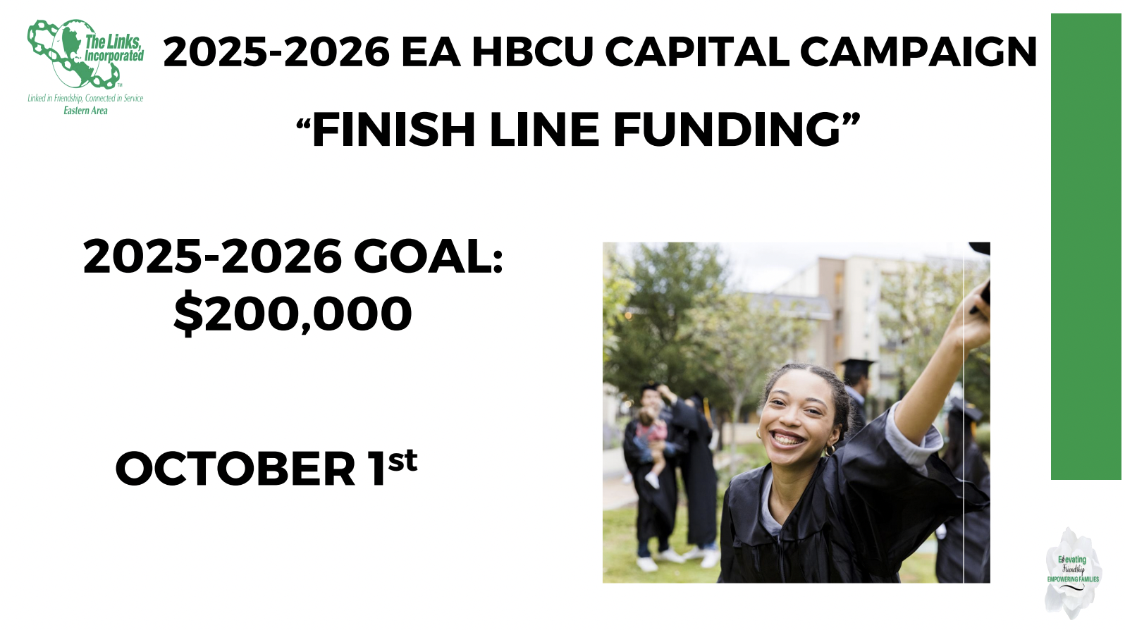
ATTACHMENT 3

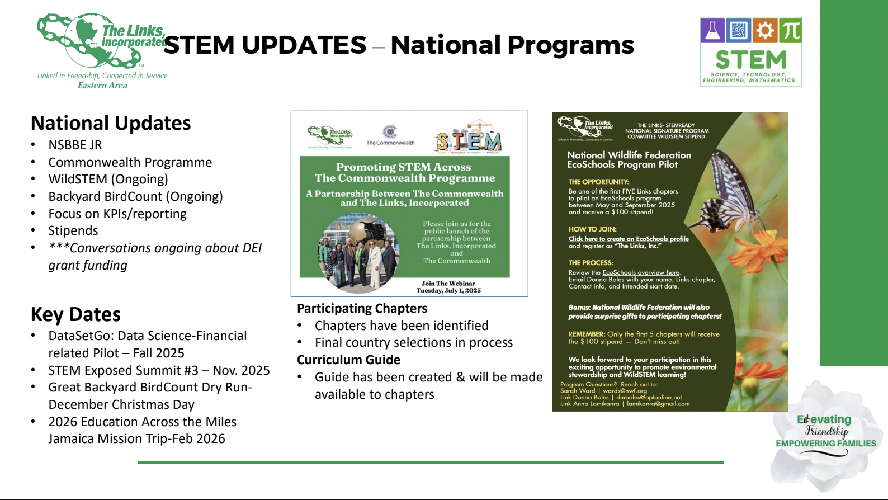

ATTACHMENT 4

HCPSS FAMILY ACADEMY KICK-OFF

