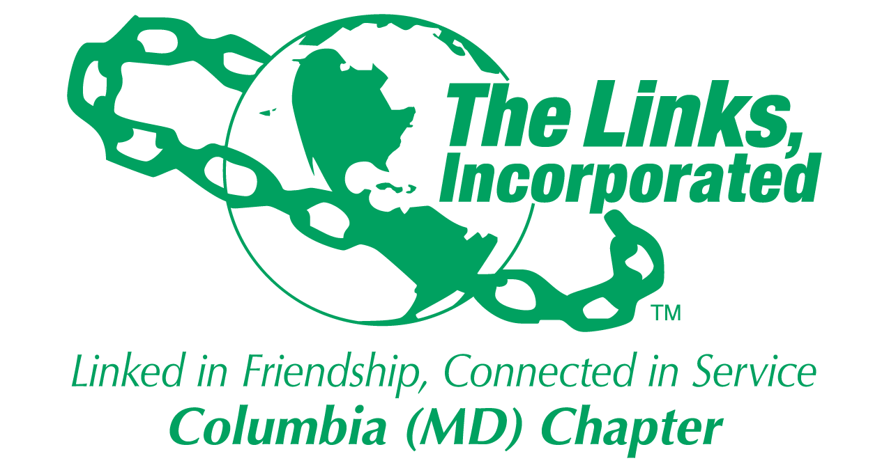
Facet Meeting Summary: October 2025
Name of Facet Services to Youth

Date/ Time/Location of Meeting: Wednesday, October 22, 8:00PM ET via Zoom

Member Attendees: Carol Ann Smith, Carolyn Jackson, Cathy Bell, Chinyere Watson, Laura Crandon, Greta Carey Peoples

MEETING SUMMARY:
Facet Budget: STY is on-track with its FYE26 spending. Scholarship Committee will present a recommendation to Executive Committee on how to reallocate the $5,000 balance and seek Chapter alignment to this plan at the November meeting.

Restricted: Services to Youth
Mentoring: Linked to Success Program:
Programming: $ 3,500
Less: EOY Reception 535
Summer Reception 530
Current balance: $ 2,435

Young Achievers:
Scholarship: $ 25,000
Less: Isaiah Thomas 10,000
Jason Young 10,000
Current balance: $ 5,000

HBCU:
Links Love HBCUs: $ 1,500
Current balance: $ 1,500

Restricted: Scholarship
Starting budget: $ 25,000
Less: Isaiah Thomas 10,000
Jason Young 10,000
Ending balance: $ 5,000

“Links Love HBCUs” National Initiative
- EA Goal: $200,000. Chapter Goal: $5,000 (minimum: $2,500). Agreed to idea of creating a thermometer goal tracker to show chapter $ results vs. goal (example included below).
- We agreed to the idea of finding a date next month to have 8-10 chapter members take a photo in HBCU gear to use for internal and external marketing purposes, ideally with a presentation check indicating how much we raised this year for the HBCU Finish Line Funding campaign. Link Greta will follow-up on this idea.
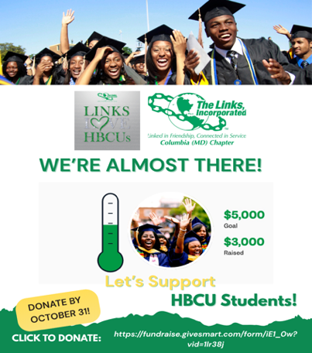
Programming Plan: A revised draft of the 2025 – 2026 STY programming plan was reviewed (see below). Goal is to finalize this plan by 10/31 which includes finalizing dates, times, locations and success measures for all programming activities.
STY Volunteer Needs:
Volunteers are needed to assist in the following areas. Each facet member should sign up for at least one of these volunteer areas:

Umbrella Program
- Serve as a liaison for the Umbrella program. This means attending the Umbrella program meetings, reporting any key information and needs to the facet, sharing facet ideas and attending the Forum.
- Lead or find a discussion leader for the upcoming “Linked To Wellness” virtual mental health series on the following topics:
  - Love & Relationships
  - Financial Management / Investments / Stocks
  - Entrepreneurship (Link Cathy)
  - Adulting: Bills, Insurance, Life after graduation
  - Networking / Interpersonal training
  - Healthy Relationships w/Technology / Social media / Dating apps
  - Family Dynamics and Mental Health (Link Carol Ann)

Scholars Program:
Volunteers are needed to assist in the following areas. Each facet member should sign up for at least one of these volunteer areas:
- Plan and execute the in-person Holiday event for our Scholars.
- Serve as a mentor for one of our Scholars. (Link Carolyn)
- Assist with STY website enhancement (i.e. Scholarship page)

Links Love HBCUs:
- Serve as the chapter HBCU liaison which means attending the EA HBCU calls, reporting EA HBCU update to Facet, attending relevant local HBCU efforts, leading the development and execution of chapter HBCU efforts, and recommending how to strengthen our HBCU efforts, including identifying the chapter’s HBCU partner. (Link Chin TBD)
- Attend local College Fairs for observational purposes and report to Facet potential opportunities for STY to support this effort next program year, particularly as it relates to any of our core strategic areas (e.g. HBCU, Young Achievers)

STEM:
- Serve as the chapter STEM liaison which means attending the EA STEM calls, reporting EA STEM update to Facet, attending relevant local STEM efforts, as necessary, and recommending how to strengthen our STEM efforts.
Other:
- Serve as photographer and social media content creator for STY.
- Work w/Technology team to update STY page on our chapter website.
- Create a monthly newsletter for our Scholars to promote upcoming programs and share relevant info and launch by 12/31.
- Write, gain approval, and submit monthly STY articles for chapter newsletter.
- Develop a student care package plan for our Scholars for 2026-2027. (Link Vivian)
- Expand our Young Achievers program to include middle and high school
- Boys & Girls Club of Howard County (HCC)/HCPSS
- Masonville Cove partnership (Link Chin)
- Explore UK/HBCU partnership

Linked to Wellness (Umbrella Program)
The kick-off virtual session, in partnership with the Potomac (VA) Chapter, “Mind Over Major: Mental Wellness for College Students,” was held on 10/19 and was an overall success. This session brought together 20 participants, including about 15 students from colleges and HBCUs across the country for an open and honest conversation about what it really means to care for your mental health during the college years. Students shared their own experiences of managing stress, navigating uncertainty, and finding balance in demanding academic and personal environments. Led by Dr. Nicole Cutts, the discussion focused on practical strategies for managing stress and strengthening your mindset.

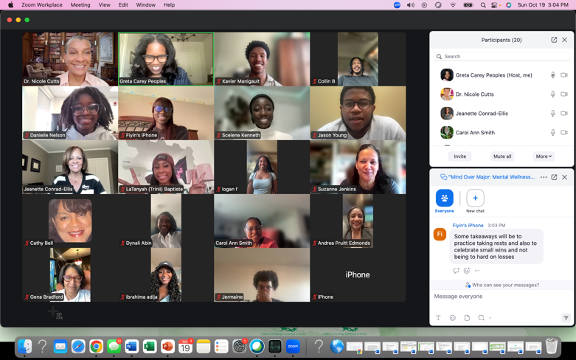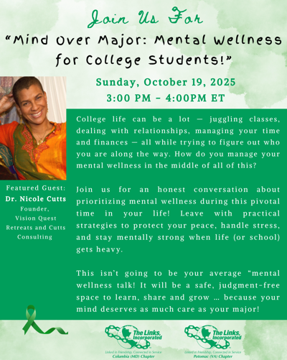

Scholar Spotlight: https://youtu.be/32-rVPqbzB4
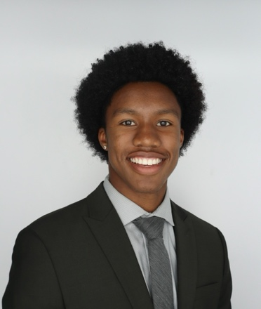
Xavier Manigault (Georgia Institute of Technology)

Next Steps
- Sign up for at least one STY volunteer need. (All)
- Follow-up w/facet members who have already signed up to discuss next steps (Link Greta)
- Finalize STY programming plan and agree on success measures by 10/31. (All)
- Share HBCU Thank You video with STY Facet and Chapter. (Link Greta)
- F/up w/NTS re: Holiday community service opportunity for Scholars. (Link Greta)
- Schedule HBCU photo date in support of EA HBCU Campaign. (Link Greta)
- Submit STY article for chapter newsletter by 10/25. (Link Greta)
- Forward EA HBCU dates to Link Chin. (Link Greta)
- Finalize mentor assignments for Scholars and plan mentoring orientation. (Link Greta)
- Input 1 hour for tonight’s meeting. (All)

************
Facet Meeting Calendar
General Schedule: 4th Wednesday of each month, 8:00 p.m. EST
Next Meeting Date: Wednesday, 11/19* Virtual
Future Meeting Dates: Friday, December 19 In-person Social (w/Scholars)
Wednesday, 1/28 Virtual
Wednesday, 2/25 Virtual
Wednesday, 3/25 Virtual
Wednesday, 4/22 Virtual
Wednesday, 5/27 Virtual
Friday, 6/5 In-person Social

Committee Members: Carol Ann Smith, Carolyn Jackson, Cathy Bell, Chinyere Watson, Laura Crandon, Melanie
Brown, Rebecca Reed, Vivian Lawyer, Greta Carey Peoples (Chair)

EA STY Members: Link Lamyra Clarke-White, STY Chair, Raritan Valley (NJ), sty@ealinks.org, 201.424.0899
Link Carolyn Streets, EA STY Co-Chair, New Haven (CT), sty@ealinks.org, 203.508.2204
Link Robin S. Williams, EA HBCU Lead, Washington (DC), hbcu@ealinks.org, 828.729.2693
Link Cheri Amado, EA STEM Lead, Milford (CT), stem@ealinks.org, 203.449.6786

Zoom Link: https://us06web.zoom.us/j/87630296215
Questions? Information? Contact Link Greta at gretapeoples@gmail.com or 410.456.6566.

Signature of Facet Chair(s): 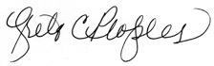 Date: 10/30/2025

