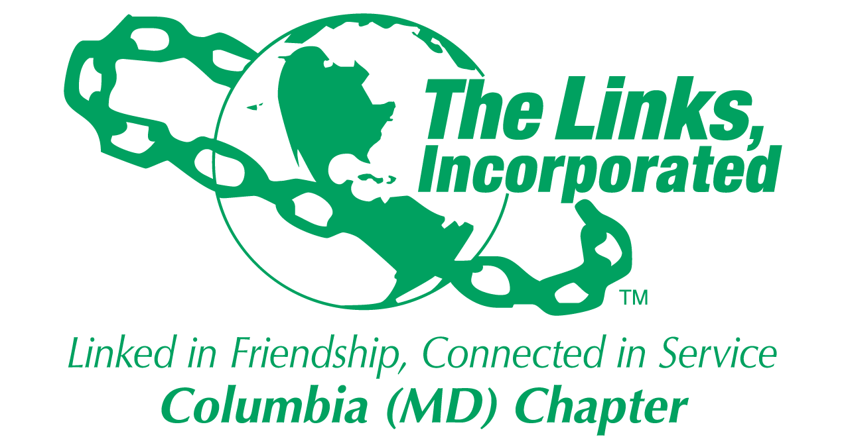
Facet Meeting Summary: November 2025
Name of Facet Services to Youth

Date/ Time/Location of Meeting: Wednesday, November 19, 8:00PM ET via Zoom

Member Attendees: Carol Ann Smith, Carolyn Jackson, Cathy Bell, Chinyere Watson, Laura Crandon, Melanie Brown, Raven Hill, Greta Carey Peoples

MEETING SUMMARY:
Facet Budget: STY is on-track with its FYE26 spending. HBCU budget is overspent by $98 due to the cost of the presentation check printing/mounting. This amount will be absorbed in the total budget as we expect to cover this from the STY mentoring budget.

Restricted: Services to Youth
Mentoring: Linked to Success Program:
Programming: $ 3,500
Less: EOY Reception 535
Summer Reception 530
Hol Gifts Schlrs 244
BCS: Shuttle 0* (cost covered by Arts Facet)
BCS Tixs Scholars 203
Food/Bev: BCS 78
Current balance: $ 1,910

Young Achievers:
Scholarship: $ 25,000
Less: Isaiah Thomas 10,000
Jason Young 10,000
Current balance: $ 5,000

HBCU:
HBCU: $ 1,500
Less: Links Love HBCUs: 1,500
Presentation Check 98
Current balance: $ (98)

“Links Love HBCUs” National Initiative
- Final chapter donation amount ($5,150) exceeded chapter goal ($5,000). (NOTE: As a result of this donation, the Columbia (MD) Chapter was recognized in the EA STY November call as 1 of only 2 chapters in the EA that reached the highest recognition level in October for this campaign).
- The date to take the group HBCU photo still needs to be determined. Goal is to complete this by January.
- The HCPSS HBCU Fair is scheduled to take place on 3/7/26, 9:00 a.m. – Noon, at Guilford Park HS. More details are forthcoming on our involvement in this effort.
- The next EA HBCU calls are scheduled on 12/14, 1/11, 2/8

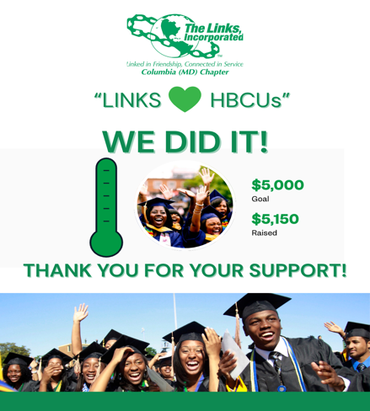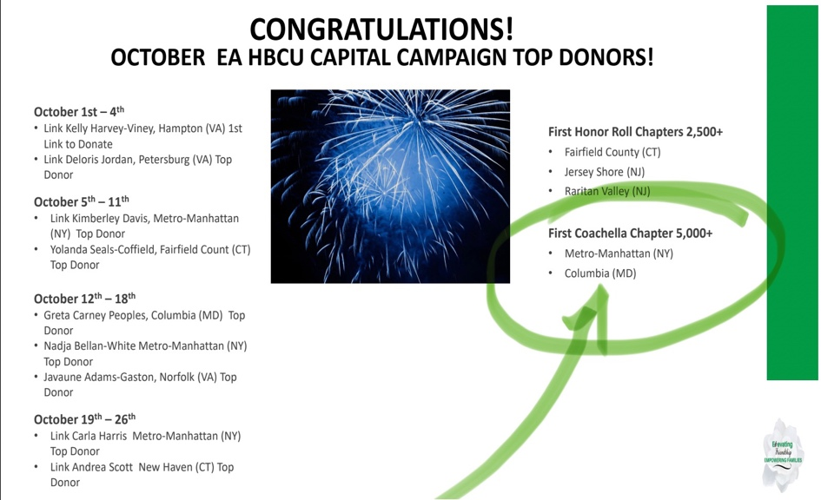

Linked to Wellness (Umbrella Program)
The second virtual mental wellness session, in partnership with the Potomac (VA) Chapter, “Know Your Body, Protect Your Power,” was held on 11/16. and led by Dr. Marci and was an overall success. This session brought together 20 participants, including about 15 students from colleges and HBCUs across the country for an open and honest conversation about what it really means to care for your mental health during the college years. Students shared their own experiences of managing stress, navigating uncertainty, and finding balance in demanding academic and personal environments. Led by Dr. Nicole Cutts, the discussion focused on practical strategies for managing stress and strengthening your mindset.

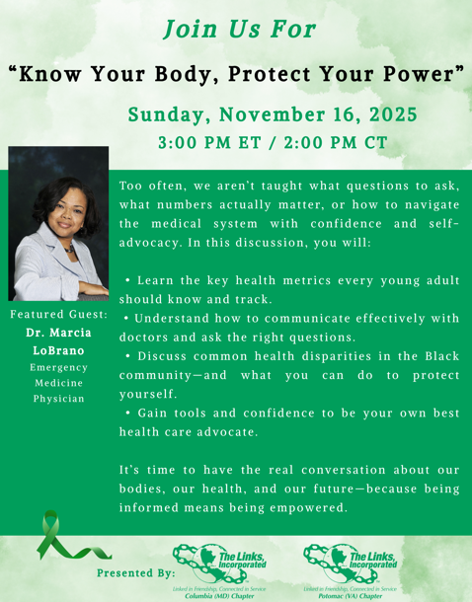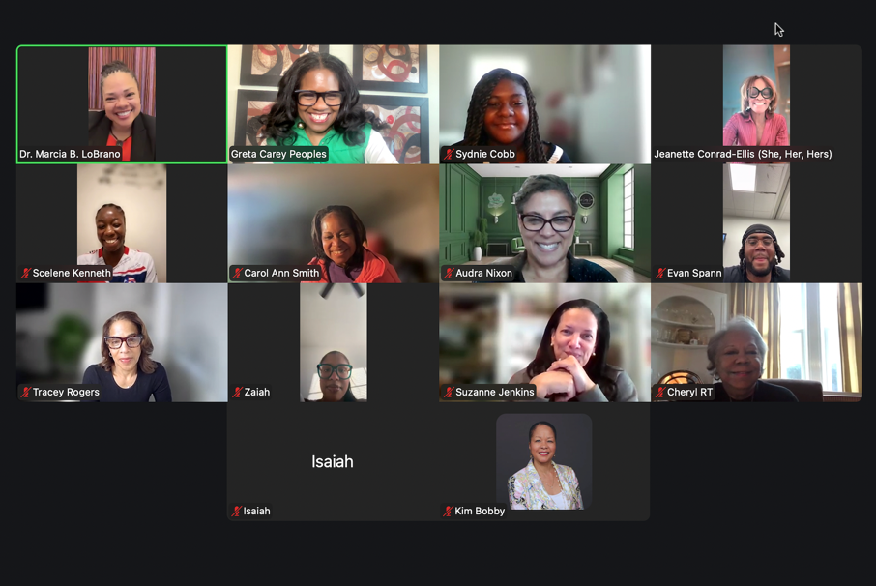

Scholar Spotlight:
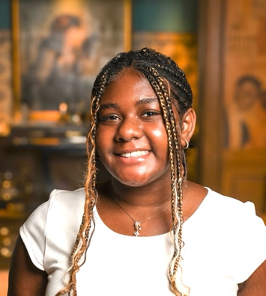
Sydnie Cobb: https://youtube.com/shorts/8_nQFTYypLo
(North Carolina A&T)

Next Steps
- Sign up for at least one STY volunteer need. (All)
- Follow-up w/facet members who have already signed up to discuss next steps (Link Greta)
- Finalize STY programming plan and agree on success measures by 10/31. (All)
- Share HBCU Thank You video with STY Facet and Chapter. (Link Greta)
- F/up w/NTS re: Holiday community service opportunity for Scholars. (Link Greta)
- Schedule HBCU photo date in support of EA HBCU Campaign. (Link Greta)
- Submit STY article for chapter newsletter by 10/25. (Link Greta)
- Forward EA HBCU dates to Link Chin. (Link Greta)
- Finalize mentor assignments for Scholars and plan mentoring orientation. (Link Greta)
- Input 1 hour for tonight’s meeting. (All)

************
Facet Meeting Calendar
General Schedule: 4th Wednesday of each month, 8:00 p.m. EST
Next Meeting Date: Wednesday, 1/28 Virtual
Future Meeting Dates: Wednesday, 2/25 Virtual
Wednesday, 3/25 Virtual
Wednesday, 4/22 Virtual
Wednesday, 5/27 Virtual
Friday, 6/5 In-person Social

Committee Members: Carol Ann Smith, Carolyn Jackson, Cathy Bell, Chinyere Watson, Laura Crandon, Melanie
Brown, Raven Hill, Rebecca Reed, Vivian Lawyer, Greta Carey Peoples (Chair)

EA STY Members: Link Lamyra Clarke-White, STY Chair, Raritan Valley (NJ), sty@ealinks.org, 201.424.0899
Link Carolyn Streets, EA STY Co-Chair, New Haven (CT), sty@ealinks.org, 203.508.2204
Link Robin S. Williams, EA HBCU Lead, Washington (DC), hbcu@ealinks.org, 828.729.2693
Link Cheri Amado, EA STEM Lead, Milford (CT), stem@ealinks.org, 203.449.6786

Zoom Link: https://us06web.zoom.us/j/87630296215
Questions? Information? Contact Link Greta at gretapeoples@gmail.com or 410.456.6566.

Signature of Facet Chair(s): 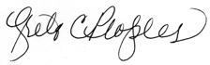 Date: 12/11/2025

