DRAFT
Executive Committee Meeting Wednesday,
January 07, 2026 | 7:30 PM – 9:00 PM Zoom Meeting https://us02web.zoom.us/j/85495395336 Meeting ID: 854 9539 5336

Administration
The meeting started at 7:40 pm, with Madam President reading a Linkspiration on Wellness, Sisterhood, and Friendship. Link Melanie Brown provided the Wellness moment. She led the group through the 4-7-8 breathing exercise to relieve stress. Agenda approved by Link Judy and seconded by Link Diane Martin
Governance ·
President’s Report · National Update and Eastern Area updates were shared, including Alumni status update and a Town Hall at Morgan State on January 22nd. The Links Foundation has approved the proposal to send the $130K for the HCPSS Apprenticeship Program. The chapter is 100% complete with the Ethics and Standard training. National dues are due this month. More updates were shared.
Vice President’s Report ·
Membership Intake Update · The Membership Intake information was shared and the process was reviewed. There are 6 candidates and 1 daughter of link that will be presented at the next chapter meeting. The calendar of Intake events was reviewed. First session on Feb 14th, the estimated fees and dues that will be communicated to the candidates were also shared. There is a proposed change to a Candidate sponsor from Link Laura Cranden to Link Audra Nixon as Link Laura is on Provisory status. The Membership Chair will review this change for acceptability.
Communication will be sent to members on leave requesting their intent for May 2026 (FY27) status.
Corresponding & Recording Secretary Report
Link Chinyere provided an update from the Area Secretaries meeting. Link Kim Michelle will include some information in the newsletter related to the postmark change in the National Postal Service, and this may affect dues payment.

Financial ·
Financial Secretary Report ·
Link Melanie shared the report, and the National dues and fee are $325. Chapter dues and fees are due end of February. Check, Cash, or Money Order are the only acceptable forms of payment. All dues for 25-26 year have been paid now.
Treasurer Report
Link Liz and Link Lucinda shared and discussed the report. The November treasurer report was shared. The committee provided payment options for discussion PayPal, Eventbrite, M&T Bank
Strategy, Programming, & Policy
Strategic Planning Update · Link Judy reviewed the draft operating budget and there was some discussion.
Programming Update · Link Regina provided the update.
Parliamentarian Update- Link Vivan provided an update, and the Easter Area bylaws committee has given 3 items we need to review and incorporate in the chapter bylaws.
FACETS (5 minutes each)
HHS ·Link Robin provided high-level updates, including the Red Dress event and upcoming family wellness day for the chapter and St. John Baptist Church.
ITS · Link Diane provided an update, including the work with HCC and the umbrella program
NTS · Link Rochelle provided an update on the work with Grassroots efforts.
STY · Link Greta provided an update on the holiday activities with Scholars and several upcoming events.
Arts Link Lisa Cooper-Lucas provided an update on the Peabody event on Feb 15th and the mental health summit.
Joys & Concerns
Happy Birthday Link Vivian
Link Donna shared that the chapter is transitioning from Sharepoint to the “Members Only” section of the website.

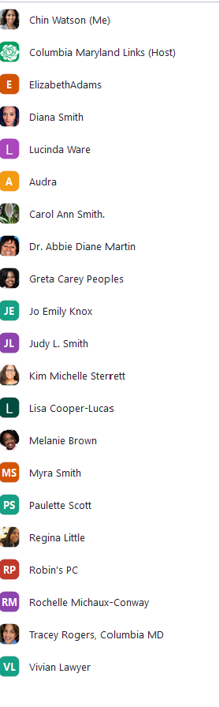
The meeting was hosted by Link Donna

