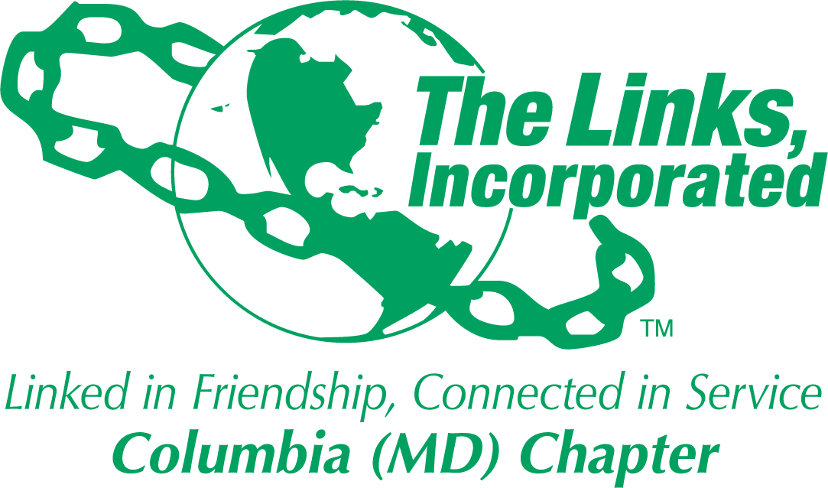

Chapter Operations Manual
Adopted October 11, 2025

