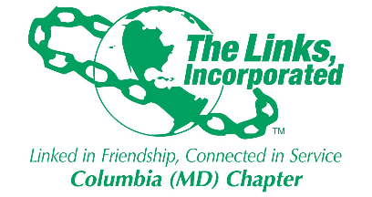

Columbia Maryland Links, Inc.
Financial Secretary Report
May 2026

Welcome to the start of a new program year from the finance committee!

March Total Funds Received: $12,685.00
March Total Funds to the Chapter: $12,685.00
March Total Funds to the Foundation: $0

Additional Updates:
- The year end report will be available on the members only website
- You will receive the link to your invoice/receipts for the 26-27 program year.
- 26-27 program assessment is $494 payable to the chapter and is due August 31st 2026

