SERVICES TO YOUTH

Scholarship Applications: The 2026 Chapter Scholarship application deadline has been extended to Friday, April 17! We urge you to help us spread the word to eligible students across Howard County by sharing this information broadly with:
• High school seniors
• Guidance counselors and school administrators
• Youth organizations, churches and community groups
The form to apply for one of the four (4) scholarships awards can be found on the chapter website: https://www.columbiamdlinks.org/scholarship.

Applicants must:
• Be a resident of Howard County, Maryland
• Be a high school senior graduating by June 2026
• Be enrolled full-time at Howard Community College in the Fall 2026

Your outreach will make a real difference in helping local students access higher education.

“Linked To Wellness” Mental Wellness Virtual Series: What if you could avoid the money mistakes most people don’t realize until well after they graduate from college? Students will find out how during the last “Linked to Wellness” virtual session, "Money Moves That Matter: What They Don’t Teach You in College” which will be held on Sunday, April 19 at 3PM EST / 2PM CST. During this conversation, the featured guest will facilitate a candid conversation about:
• Smart money habits to start now
• Common financial mistakes to avoid
• Simple moves that can set you up for real independence

Please reach out to personally invite a college student(s) or share this opportunity with parents of college students in your network. A quick text, email, or conversation could make the difference in helping them engage in this important topic. The flyer, registration link, and speaker bio for this session is below.

Let’s end the program year strong and work together to ensure this important conversation reaches as many students as possible!

Registration Link: https://LinkedToWellnessAprSession.eventbrite.com



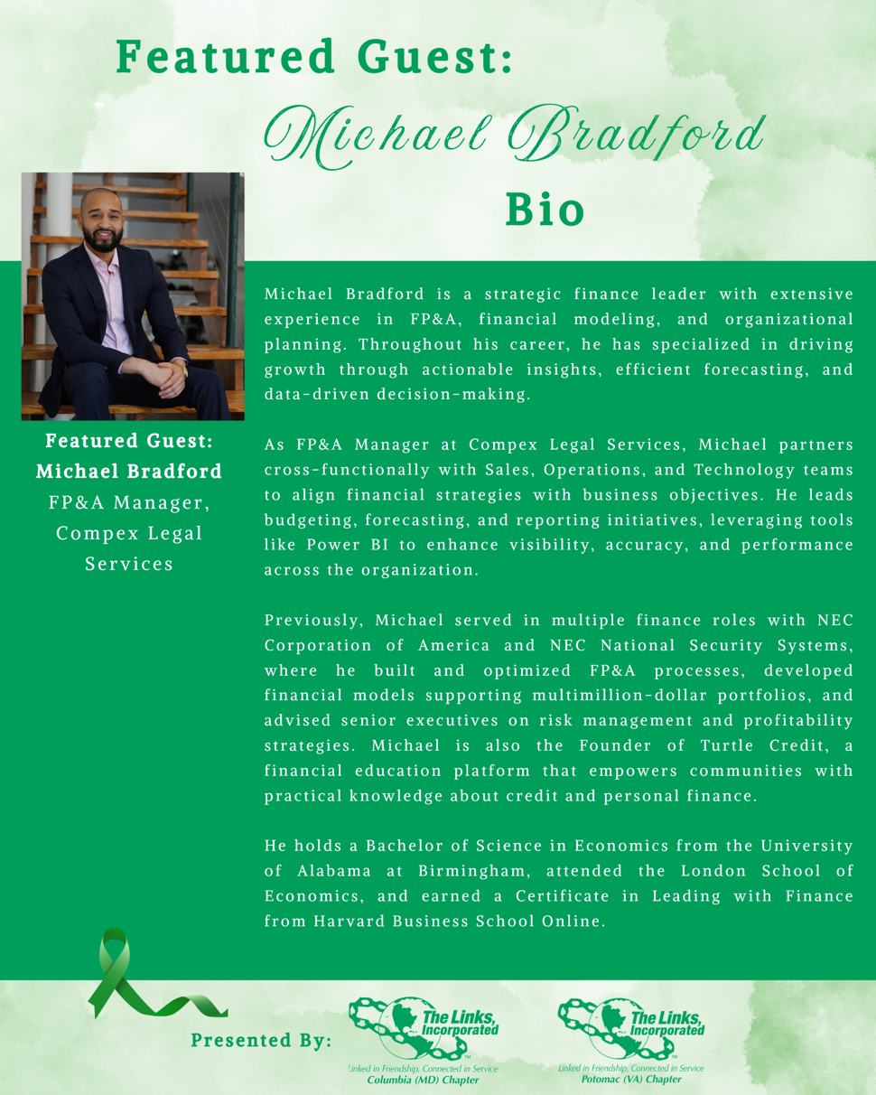

Link Scholars Spring End Of Year Reception: We are delighted to host one of the most meaningful and inspiring moments of our program year, the Links Scholars Spring End-of-Year Reception. This gathering will be held on Saturday, May 30, from 2:00 p.m. to 4:30 p.m. at the beautiful Robinson Nature Center in Columbia, MD. This special afternoon will celebrate our four graduating Scholars, recognizing their accomplishments, resilience, and bright futures ahead. At the same time, we will warmly welcome our newest cohort of Scholars, marking the continuation of our chapter’s commitment to education, mentorship, and service.

In alignment with our chapter’s strategic focus on our Linked to Wellness umbrella program, this year’s reception will feature an expanded and intentional emphasis on mental wellness. We are excited to partner with Masonville Cove Environmental Education Center to offer a guided nature art therapy experience for attendees. This interactive session will engage the students and chapter members with nature as a source of reflection, creativity, and restoration -- using artistic expression as a pathway to reduce stress, build emotional awareness, and foster connection. Invitations will go out to chapter members by the end of the month. We hope you will plan to attend!

